TOOTHPICK PATTERNS Name ___________________



Use toothpicks to build the fourth pattern in this sequence and draw it below:

1. Fill in the table showing the number of squares, *s* , and the number of toothpicks needed, *t.*

|  |  |  |  |  |  |  |  |
| --- | --- | --- | --- | --- | --- | --- | --- |
| *s* | 1 | 2 | 3 | 4 | 5 | 6 | 7 |
| *t* |  |  |  |  |  |  |  |

2) Graph your data that fit. Put your points at the grid intersections (not inside the boxes)

|  |  |  |  |  |  |  |  |  |  |  |  |  |  |  |  |  |  |  |  |  |  |
| --- | --- | --- | --- | --- | --- | --- | --- | --- | --- | --- | --- | --- | --- | --- | --- | --- | --- | --- | --- | --- | --- |
| 0 5 Number of Toothpicks 15 20 |  |  |  |  |  |  |  |  |  |  |  |  |  |  |  |  |  |  |  |  |  |
|  |  |  |  |  |  |  |  |  |  |  |  |  |  |  |  |  |  |  |  |  |
|  |  |  |  |  |  |  |  |  |  |  |  |  |  |  |  |  |  |  |  |  |
|  |  |  |  |  |  |  |  |  |  |  |  |  |  |  |  |  |  |  |  |  |
|  |  |  |  |  |  |  |  |  |  |  |  |  |  |  |  |  |  |  |  |  |
|  |  |  |  |  |  |  |  |  |  |  |  |  |  |  |  |  |  |  |  |  |
|  |  |  |  |  |  |  |  |  |  |  |  |  |  |  |  |  |  |  |  |  |
|  |  |  |  |  |  |  |  |  |  |  |  |  |  |  |  |  |  |  |  |  |
|  |  |  |  |  |  |  |  |  |  |  |  |  |  |  |  |  |  |  |  |  |
|  |  |  |  |  |  |  |  |  |  |  |  |  |  |  |  |  |  |  |  |  |
|  |  |  |  |  |  |  |  |  |  |  |  |  |  |  |  |  |  |  |  |  |
|  |  |  |  |  |  |  |  |  |  |  |  |  |  |  |  |  |  |  |  |  |
|  |  |  |  |  |  |  |  |  |  |  |  |  |  |  |  |  |  |  |  |  |
|  |  |  |  |  |  |  |  |  |  |  |  |  |  |  |  |  |  |  |  |  |
|  |  |  |  |  |  |  |  |  |  |  |  |  |  |  |  |  |  |  |  |  |
|  |  |  |  |  |  |  |  |  |  |  |  |  |  |  |  |  |  |  |  |  |
|  |  |  |  |  |  |  |  |  |  |  |  |  |  |  |  |  |  |  |  |  |
|  |  |  |  |  |  |  |  |  |  |  |  |  |  |  |  |  |  |  |  |  |
|  |  |  |  |  |  |  |  |  |  |  |  |  |  |  |  |  |  |  |  |  |
|  |  |  |  |  |  |  |  |  |  |  |  |  |  |  |  |  |  |  |  |  |
|  |  |  |  |  |  |  |  |  |  |  |  |  |  |  |  |  |  |  |  |  |
| 5 Number of Squares 15 20 | | | | | | | | | | | | | | | | | | | | |

3) How many toothpicks would you need to make 10 squares?

4) How many toothpicks would you need to make 23 squares?

5) How many toothpicks would you need to make 347 squares?

(Think about what you did above to figure out what operations you were using.)

6) How many toothpicks would you need to make *n* squares? Again, do just what you did for 5).

7) How many squares are made with 61 toothpicks? See picture for a hint 🡺

8) How many squares are made with 199 toothpicks?

9) How many squares are made with 333 toothpicks?

10) How many squares are made with *t* toothpicks?

LOTS OF TOOTHPICKS

There is a grid *m* boxes wide and *n* boxes high made of toothpicks. Study the example below and think of efficient ways to count all of the toothpicks.

|  |  |  |  |
| --- | --- | --- | --- |
|  |  |  |  |
|  |  |  |  |
|  |  |  |  |

* How many toothpicks are needed to make the above shape?
* How many are needed to make an *m* boxes wide by *n* boxes high grid? Does your formula correctly predict your answer for the 4x3 grid?
* Explain the derivation of your formula.
* A pattern uses no more than 500 toothpicks. What is the maximum for the number of boxes it can contain?
* There is a 3-Dimensional structure made of toothpicks m boxes by n boxes by p boxes. How many toothpicks is it made of? Explain how you derived your formula.

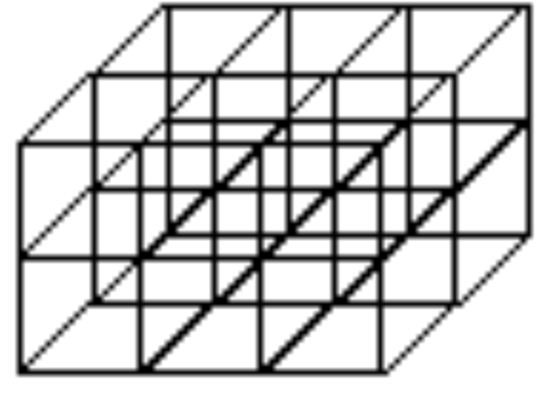

© 2025 by Joshua Abrams/Making Math is licensed under [CC BY-NC-SA 4.0](https://creativecommons.org/licenses/by-nc-sa/4.0/)