Volumes of Revolution Name ________________

You will experiment with the WisWeb Lathe application.

- Go to this site: https://app.dwo.nl/wisweb/?header=less&hash=#s:603083

- Click on the Applets link toward the top of the window.
- Click on the little British flag at the top of the window and then the Lathe applet.
To use the applet, click to draw segments in the white upper region. Those segments are revolved around the line separating the white and black areas of the grid. The resulting three-dimensional shape can be rotated and examined by clicking and dragging near the shape. The WisWeb site was developed in the Netherlands with English versions that sometimes don’t translate every word. The “Terug” button means back up one step (it undoes the last segment added) and “Wis” means clear and gives a fresh lathe window.
Try to make each of the shapes below and sketch the cross section that produces it.


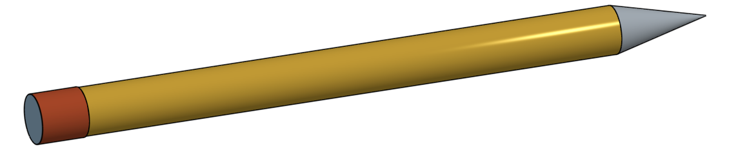


A can | A sharpened pencil
A washer (see metal disk with hole above) | A hat with a brim
A penny | A cone
A cup | A frilly table leg
A ball (sphere) | Your idea ______________________

