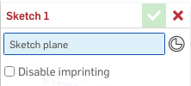
5 Click on the Sketch button which will bring up a window like the blue box at right. Click in the blue “Sketch plane” box in the window, then click on the button in the features panel at left, and then click on the top face of the Orientation Cube.

1 Click on this icon, choose Workspace Units, and make sure lengths are in centimeters.

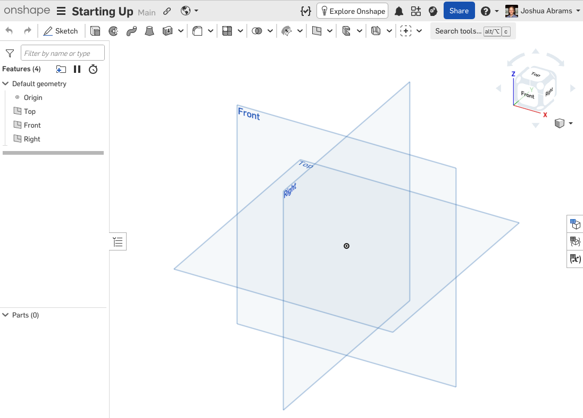
4 You can also rotate the view with a two finger click and drag or zoom in or out by dragging two fingers (no click). You will zoom relative to the point where you start dragging in the window. Experiment doing this in different starting points of the main window.
2 Click on a reference plane, and it will highlight in the main window. You can drag the circles at its corners to make it bigger.
6 Once you are in sketch mode, sketch tools will appear on the menu bar. When you click on the cube, your view faces the plane in which you are going to sketch. You are ready to make two-dimensional diagrams!
3 Click on the faces and corners of the Orientation Cube or any of the arrows about it to reorient the main view.

OnShape Sketch Tools Name _______________

To learn about a tool, hover over it and will tell you the name of the tool first and then a second or so later how to use it. Click on a tool and you will remain in that tool mode until you click it off or choose a different tool. If no tool is selected, your cursor will be an arrow and can be used to select and modify shapes that you have added to your sketch.
When you are in the mode to draw a shape, the cursor will be the crosshairs shape +.
When the cursor is an arrow, you can use it to move key points and whole shapes depending on what you select. You can select multiple items by clicking on them in turn. If you click in white space, they will deselect.

Begin by experimenting with the different shape tools. Below are a few to start with some of which will be found in the drop-down menus indicated by the down arrow: .
Pick a 2-D drawing to create such as a house, car, face, etc. You can remove steps you take with the undo arrow in the upper left corner . You can also click on shapes and hit your Delete key to delete them or two finger click (or right-click) on an object and choose “Delete sketch entity” at the bottom of the menu.

Shapes
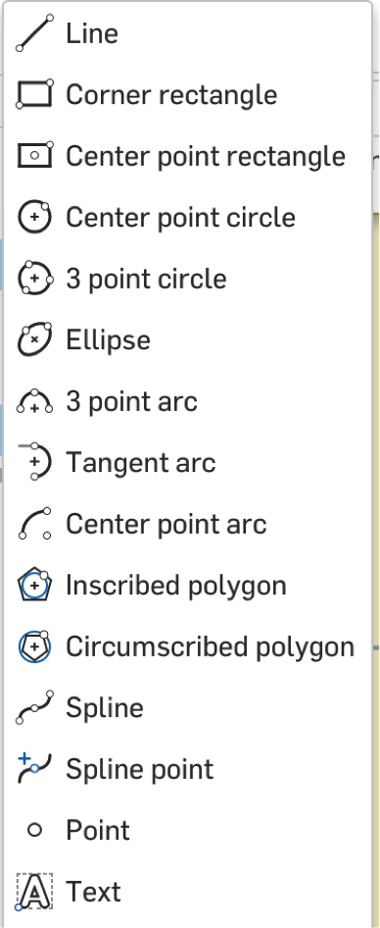


If a design has pieces of shapes you don’t want, you can use the trim tool () to remove them. Choose the tool and then click on a segment or arc and it will be removed right up to where it next intersects a different shape in each direction.
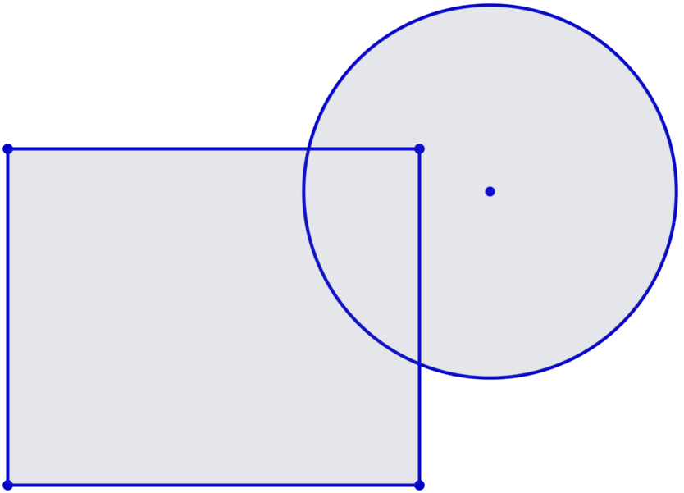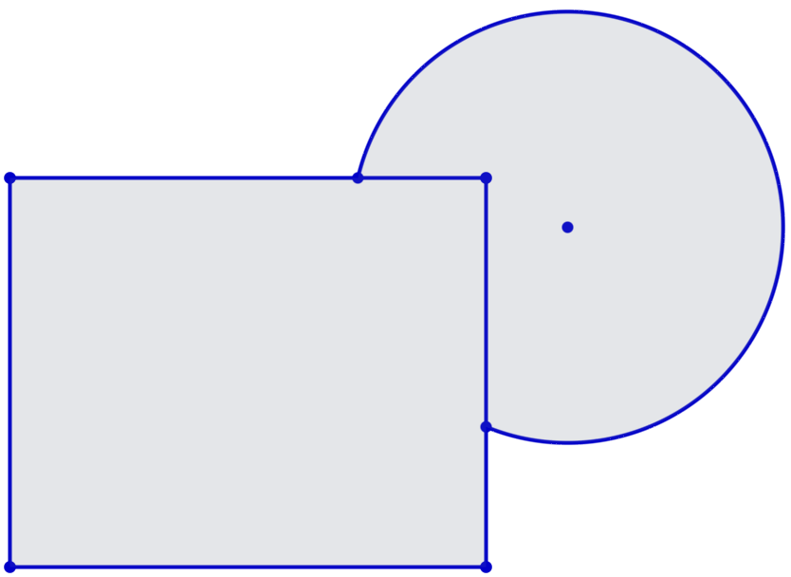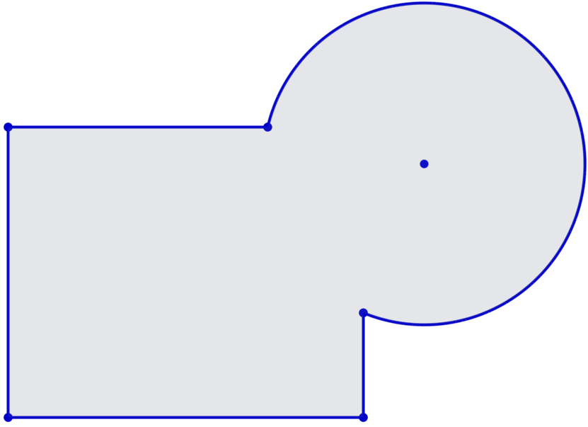

Constraints
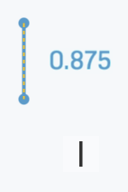
Constraints are an important way to get sketches to be exactly the way you want. Many constraints are implied – they occur as you sketch. For example, if you draw a line segment vertically, you will see a little vertical constraint marker and that line will be adjustable in terms of length but will always be fixed in a vertical orientation. Similarly, if you use the point tool and hover around the center of a segment, you will see the midpoint symbol and, if you click near there, that point will always mark the middle of the segment (this is very helpful when you want to set up symmetry lines and other symmetrical arrangements).
You can also impose a constraint after drawing shapes. The drop-down menu on the far right of the sketch tool bar includes the following constraint tools:
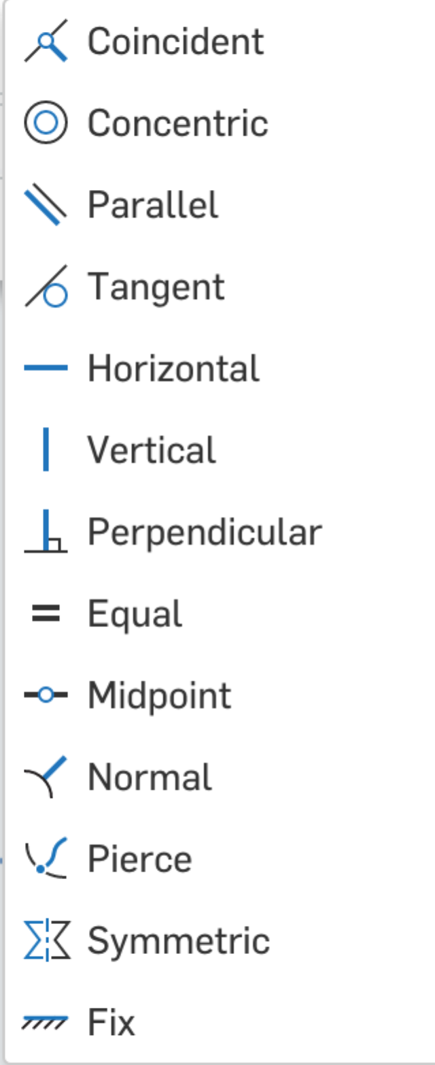
Force two points to be in the same location Forces two segments to be congruent (same length)

Make circles have the same center Forces a point to be located at the center of a segment

Make lines parallel
Tip: We sometimes want two segments to be in line with each other. In this case, they are called collinear (together on
the same line). In OnShape, you can use the
Coincident tool to constrain two segments to be
collinear by clicking on each with the tool.

Make a line and circle touch at one point

Force a line to be sideways

Force a line to be up and down only

Force two lines to meet at 90° (note, they may not meet at all, but, if extended, they would meet at a right angle)


Tools for Modifying and Duplicating Shapes Name __________________________

Fillet (pronounced with a hard “t” sound, not like fish fillets) – round corners by clicking on a vertex and setting a radius for the arc. Chamfer – click on a vertex to cut it off (also called beveling). You can control how much is cut in both directions by clicking on the values shown.

Trim a segment or curve to its nearest point of intersection

Create a second curve offset from the original

Create a mirror copy of a shape (or collection of selected shapes)

Linear Patterns Tool – Create a line or grid of copies of selected shapes

Once you select a shape and the linear pattern tool, you will get a set of controls for the number of copies and their placement. To see a video demonstration of how to use them, visit https://cad.onshape.com/help/Content/sketch-tools-sketch-pattern.htm?Highlight=linear and then play the Video example. Once you have made all of the choices that you need for your pattern, click anywhere on the sketch plane away from the pattern (in blank space) to confirm your choices.
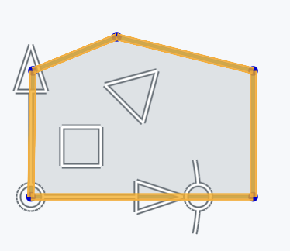

Transform (translate/slide, rotate, or scale/magnify) selected shapes

At right is a picture of a selected house-shaped pentagon and the handles you can use to transform a shape. Dragging the arrow heads translates (slides) the shape in those two directions. Moving the square shifts the shape freely in any direction. Drag the triangle to scale (enlarge of reduce) the shape, and the circle-arc handle rotates the shape. As you make these changes, an outline of where your shape will end up is shown in the sketch. To confirm your choices, click anywhere on the sketch plane away from the shapes (in blank space).
Visit https://cad.onshape.com/help/Content/transform-sketch.htm to see a video.

