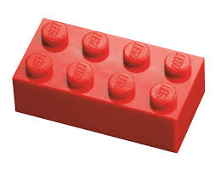
CAD Steps for Making a Building Brick Name _______________

In OnShape, we begin with 2D sketches to create 3D models. OnShape and other CAD programs are used by students, designers, engineers, and other professionals to produce complex products.

Creating a New Document
Create
- In the OnShape home page, a new document.
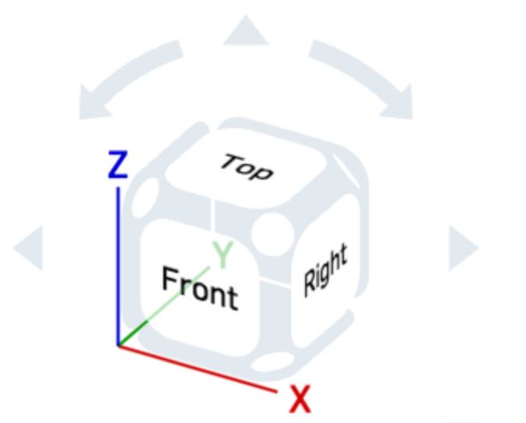
- In the Document Menu, rename the document “2x4 Brick”.
- In the Document Menu, under Workspace units…, set the default length to be centimeters.
- Start a new sketch in the Top plane and then orient normal (perpendicular or facing) to the sketch plane by clicking on the Top face in the control cube (shown at right).
Create the Base Shape

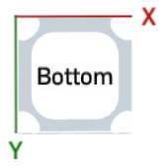

- Draw a rectangle and dimension it to be 16 cm wide by 8 cm high and hit return. (Yes, that is a very big brick, but we can always shrink it as needed afterwards.)
2.

3.

4.
- Click on the extrude button and extrude the rectangle 4 cm.
- Click on the green check mark to complete the extrusion.
- Click on the Bottom view of the control cube.

- Start a new sketch and click on the bottom of the brick. The Sketch plane box should say “Face of Extrude 1”.
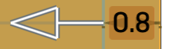
- Click on the Offset tool and then on the bottom rectangle of the brick (or all four sides of the rectangle). Enter 0.8 cm for the offset and hit return. A new smaller rectangle should appear inside the original one. If it is bigger, drag the white arrow inside the rectangle.


- Slightly rotate the view again using the up arrow or a two-finger drag. Click the extrude button and, in the extrude dialog box, choose Remove (instead of new), and then set the depth to 3 cm.

- These settings should hollow out the box. If the extrusion appears to be outside of, and not into, the first extruded box, you can reverse the direction of the extrusion by clicking on the reverse direction button in the dialog box or the white extrusion arrow.
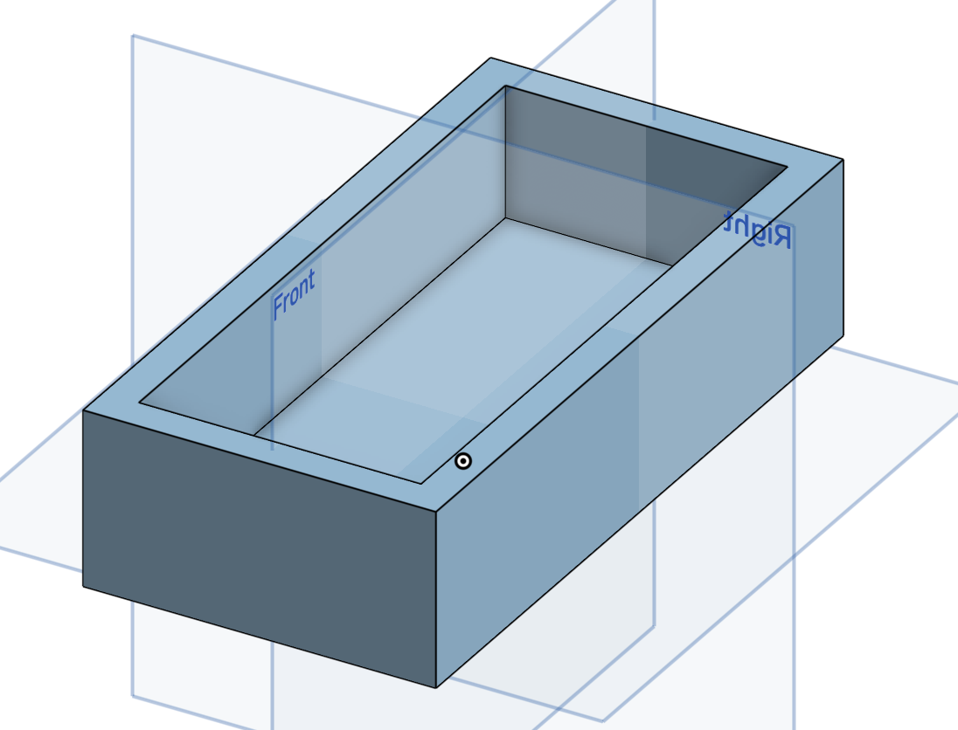
- Click the green check mark to complete the extrusion. Again rotate the figure to see how it looks. It should look like the picture at right.
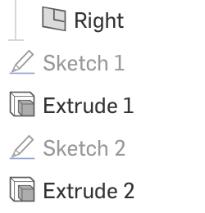
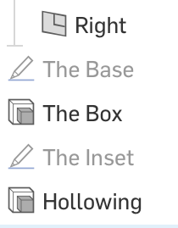
- If you want, you can make it clearer which sketches and extrusions correspond with which steps by renaming them. You can two-finger click on a sketch or extrude name in the Features window on the left and choose Rename and give it a more meaningful label. Doing this makes it easier to keep track of more complicated designs.
Making the Bumps
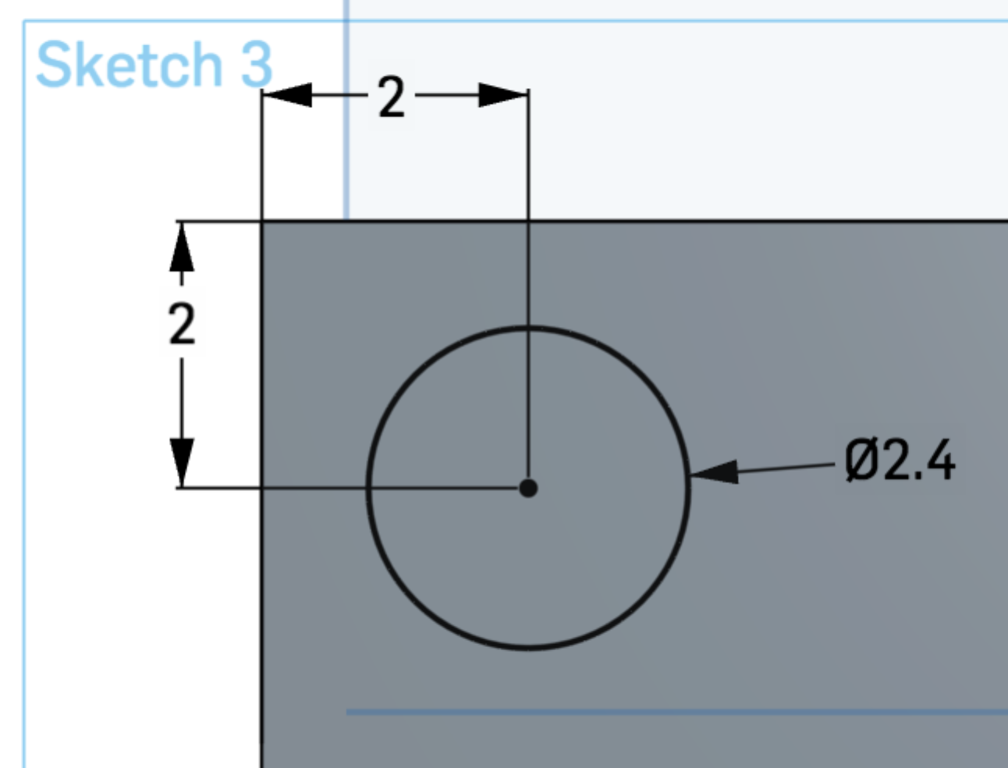
- Go back to the Top view and start a new sketch on the top surface of the brick (not the Top plane itself).

- Sketch a circle on the top of the brick and dimension its diameter to be 2.4 cm and then dimension ( ) the center of the circle to be 2 cm from the top and left edges of the brick.
- Make copies of the circle using the Linear repeat tool: . Click on the tool and then on the circle. Your screen should look like this:
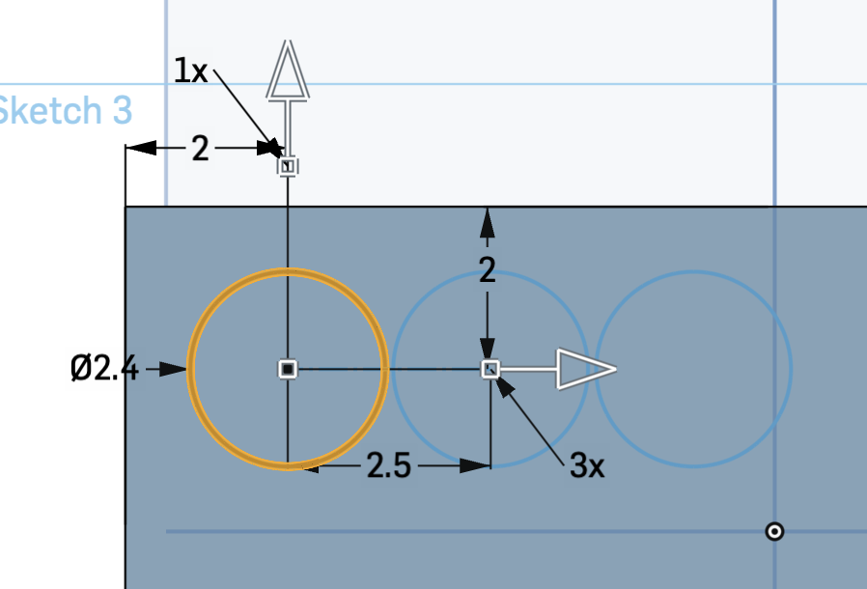
- Double click on the horizontal spacing value to make it 4 cm and hit return.
- Double click on the number of horizontal copies (“3x”) and type in 4 (without the “x”). An extra circle will appear at right.
- Double click on the vertical copies (“1x”) and make it 2. There should now be another row of circles.
- Double click on the vertical spacing (the 2.5 that appeared with the new row) and set it to 4 cm.
- The circles are now stacked above and off the brick. Click on the head of the vertical arrow to reverse its direction. You should now have 8 circles symmetrically arranged on the brick.
- Extrude this sketch make 8 cylinders. The settings for your extrusion should be:
  - Add (not New) is selected. If you forget this step, each bump will appear with a separate color when the extrusion is complete and count as a separate part.
  - Set the depth to 1 cm.

- Once the extrusion is complete, rotate it to make sure the bumps are bumping out.
- Now use the fillet tool to round the edges of the tops of all 8 bumps with a radius of 0.1 cm. You are in the 3-D mode (not a sketch). Click on the tool and then click on the top circular faces of all 8 bumps, enter 0.1 for the Radius, and check the green check mark. Now the bumps have smoother edges.
- Fillet the top surface of the brick with a radius of 0.1 cm. Which additional edges round off?
- Two-finger or right click on the brick and choose Edit Appearance (all the way at the bottom of the menu). Pick a fun color for your brick.

Assemblies and Interference
Your teacher will demonstrate how to put copies of your brick together in an assembly and to make sure they are not overlapping (there is no interference).

Other ways to make a hollow brick:
- Make a 1 cm thick extrusion of the original rectangle. Then, on the bottom do a sketch and redraw the rectangle and make an inset copy 0.8 cm in. Then extrude that sketch 3 cm in Add mode.
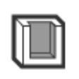
- Or, not quite what we want, make a 16x8x4 box and then click on the shell command and set the thickness to 0.8 cm. This makes the walls the desired thickness, but the top of the brick is also 0.8 when we wanted it to be 1.0 cm.

Possible Extensions – Use a caliper/giraffe for all measurements. Plan your work on paper first. Use divisions to plan any circle centers.
- Adjust the measurements in your design to match an actual 2x4 brick’s measurement (which are much smaller than 16 cm).
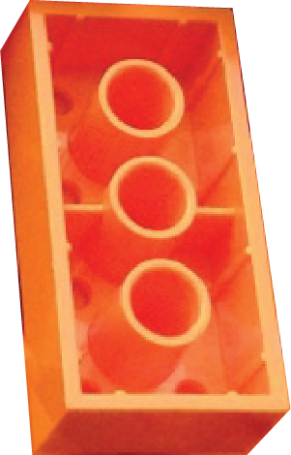
- Add an embossed letter (perhaps your first initial or an “L” in honor of the original Lego pieces) on each bump.
- Make the inside columns of a standard 2x4 into which the bumps snap. Make sure they would fit snuggly with bumps in place but not overlap.
- Make a Lego girder or other piece with some other different features.
- Propose a different design that involves repetitive elements.
Once completed, test your component to make sure it assembles well.

