Isometric Drawings Name _____________
An isometric drawing is a way to represent three-dimensional objects with a two-dimensional (flat) picture. Isometric paper helps us follow the three directions in space. Segments in the direction of the blue one in the diagram below show us the width of an object. Segments in the direction of the red segment represent the depth of the shape. The blue and red segments looked diagonal but represent horizontal lines. Vertical segments, such as the green one, show the height. Iso-metric means “same measure” and you can see that the distance between adjacent dots in each of the three directions is the same.
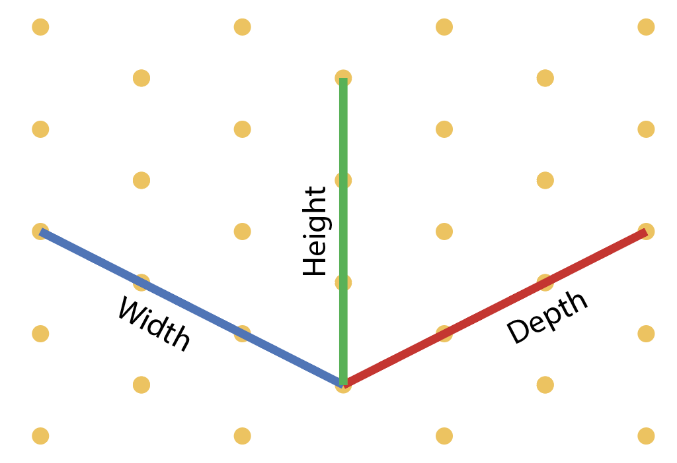
In the leftmost isometric drawing below is the simplest possible isometric drawing: a cube. The view is as if we are above the shape looking diagonally at a corner. If you look at a centimeter cube or a box, you can get the same perspective with three faces showing and three hidden. The next two drawings show two adjacent cubes and a rectangular solid of the same size as the two cubes.
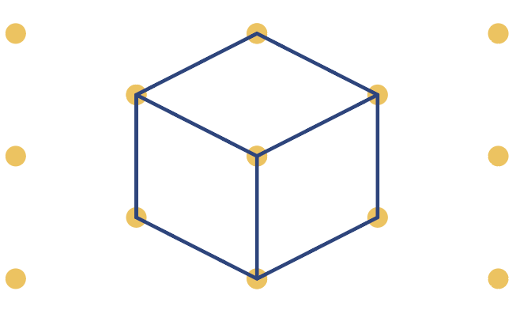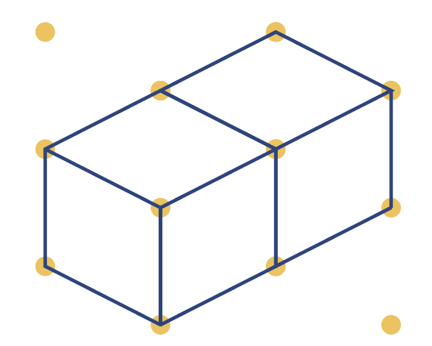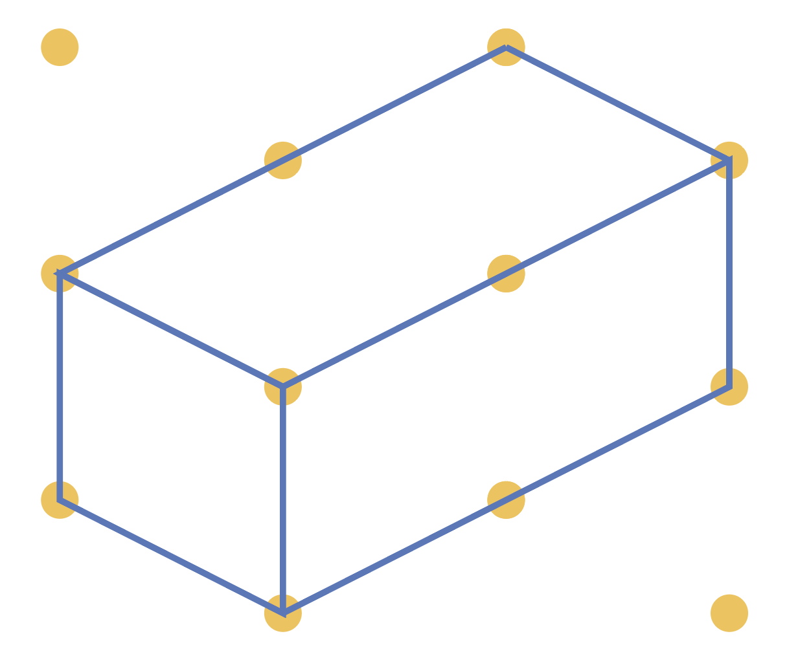
When drawing multiple cubes, it is easiest to start with the one closest to the viewer (you) and then add ones that are partly obscured by that first cube. It is easier to picture which edges of the cube should be omitted that way.
Using the isometric paper below, draw each of the two shapes pictured here. Start with a square that is not blocked by any other square (for example, the red or green ones in the image at right).

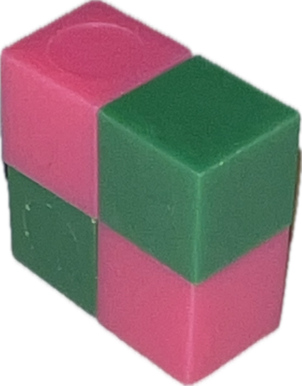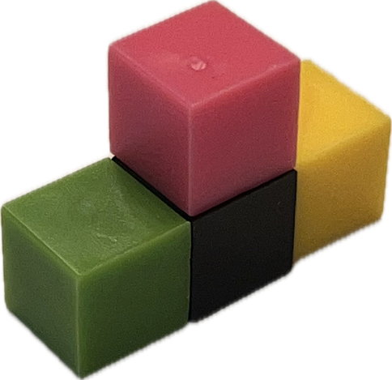



Using a few centimeter cubes (or blocks), make a structure and then create the isometric drawing for it.
Try to make an isometric drawing of a staircase, simple building, bridge, or other boxy structure just using the dot paper.
Pick a letter (such as one of your initials) and make a three-dimensional version of it.
1) Make a letter outline 2) Add depth 3) Shade faces in the same direction
