

Teacher Guide

The Mathematics of Stamp It! 1
A First Investigation 1
Branching Out 2
Using b to Compare Positions 4
Two Colors, Subtraction, and Designing Shapes to Solve Challenges 4
For the Numerically Inclined 5
Some More Challenges 7
Generalizing Further: Making Width a Variable 9
Generalizing the Count by Step 9
Everything All At Once – Varying Width and Count 10
Use Numerical Examples to Test Expressions 10
Work Backwards from an Expression 10
Feedback 12
Templates for Assignments 12
Solutions to Some of the Sum Challenges 13

The Mathematics of Stamp It!
Algebra gives us the power to describe relationships for a large, and frequently infinite, number of problems. We often develop algebraic expressions for a setting by generalizing patterns that we see in specific examples. In Stamp It!, students explore relationships between numbers in a grid that have the same spatial relationship for each case. They connect those examples to patterns in a table and then to algebraic expressions that they build. As they do so, they see how useful a variable can be in expressing numerical and geometric patterns. As students work through different challenges, they see new ways in which variables can be used to generalize the patterns in the grids. Students grow in their ability to explain how the numbers, variables, and operations in their expressions make sense and connect to the specifics of each setting. Lastly, students work backward: given an expression, they find Stamp It! problems for which the expression is the solution. See the “Teacher Notes: Expressions before equations!” PDF on the Making Math Algebra - Expressions and Equations page for a discussion of the value of emphasizing expressions early and often as students are introduced to algebraic thinking. Stamp It! is best positioned after some of the paper and pencil (and toothpick, etc.) activities shared on the algebra page.

A First Investigation
Begin with the program’s default starting arrangement: a grid 6 cells wide, counting by 1 from 1, and one of the simplest stamp shapes, Vertical 2.
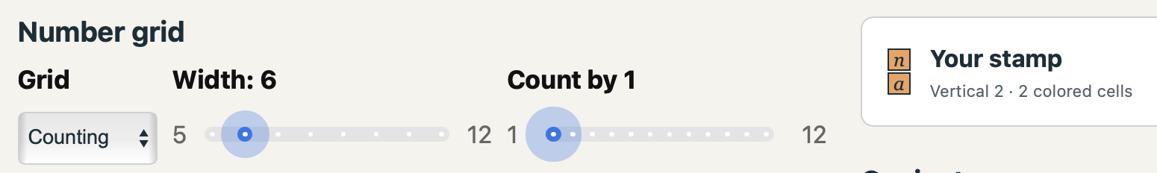
Point out to students the Grid, Width, and Count by controls and the grid that they produce. Emphasize that the shape they are stamping is always displayed to the right by the “Your stamp” heading (see the purple oval above). That diagram shows not just the configuration of the cells that will be stamped each time; it also shows where the anchor cell, represented by n, and the target cell, a, are within the stamp. For a larger stamp, some cells will not have a specific label.
Have students stamp a few cases in their grid (or demonstrate it on a display) and point out that each time the stamp is clicked, that example is marked on the grid and the data associated with it – the value in the cell where n is and the value of the cell where a is – is entered as a new line in the table. Additionally, the n cell value is displayed in bold in the grid.
Ask each student to write a description of the relationship between the first column in the table of n values and the second column of a values. Many should be able to note that a is always 6 more than n. Ask how that can be written with an operation using n. Once you have “n + 6” as an answer, you can discuss that this is an expression that seems to always describe the relationship between the two variables (a and n + 6 always generate the same answer). Show how to enter formulas in the expression window. If a student has an alternative idea, encourage them to enter it for their answer and report out on what the program shows. Ask students if the expression is going to keep working as they stamp more examples (which they should do). Can someone explain why the expression works? Why, even as the locations change, does the relationship between the two cells stay the same?
If a student says, “add the width,” invite them to explain why moving one row down has that effect. A verbal rule is a useful beginning worth highlighting; discuss how to re-express English statements symbolically by paying attention to the explicit or implied operations (and their order).
Working with this program encourages moving between examples in picture and numerical form and between English descriptions and expressions that use variables. If students have not previously worked with variables (and even if they have), it should be celebrated how using a symbol allows us to discuss an infinite number of situations with one statement – the variable is a place holder for any and all possible values of n that could be stamped in the grid. Algebra gives us the power to describe an infinite number of problems all at once!
Next, add a column in the Conjecture table and choose Sum for its value. Again, give students time to study the values and come up with a way to generate them. Adding the column values for n and a will likely be suggested. However, the program (intentionally) does not allow a in the expressions. Only n (and, later, w and c) are permitted. So, if they want to add n and a, how can they do this using only n? Since they have already found a rule for a, “n + n + 6” should be suggested and can be entered in the expression window. When it is, the values should all check out. If someone suggests 2n + 6, add a third column also for the sum and try that out. Discuss the nature of simplifying expressions and of equivalent expressions (which always yield the same results for the same starting values). Neither expression is inherently better, as unsimplified expressions are often in a more informative arrangement than simplified ones. For example, we are told to distribute components of an expression to simplify it, but in many ways (x + 3)⁴ is simpler than x⁴ + 12x³ + 54x² + 108x + 81. We can learn something different from each form.

Branching Out
You can set the students loose experimenting as discussed below or do one more demonstration setting up this problem with a Width of 7, Count by of 2, Cycle shades checked, and with a modified shape. For the shape, enter Choose Shape, scroll down to “Horizontal Separated Pair Wider” and use Set n to move n from the middle to the left cell. You can stamp out some examples and ask partners to discuss an expression for the sum. Students may offer n + (n + 8), 2n + 8, or 2(n + 4). This latter approach is based on finding the average of the two cells, which is likely to come up for some of the later challenges (e.g., having a two-color shape whose sum does not change).
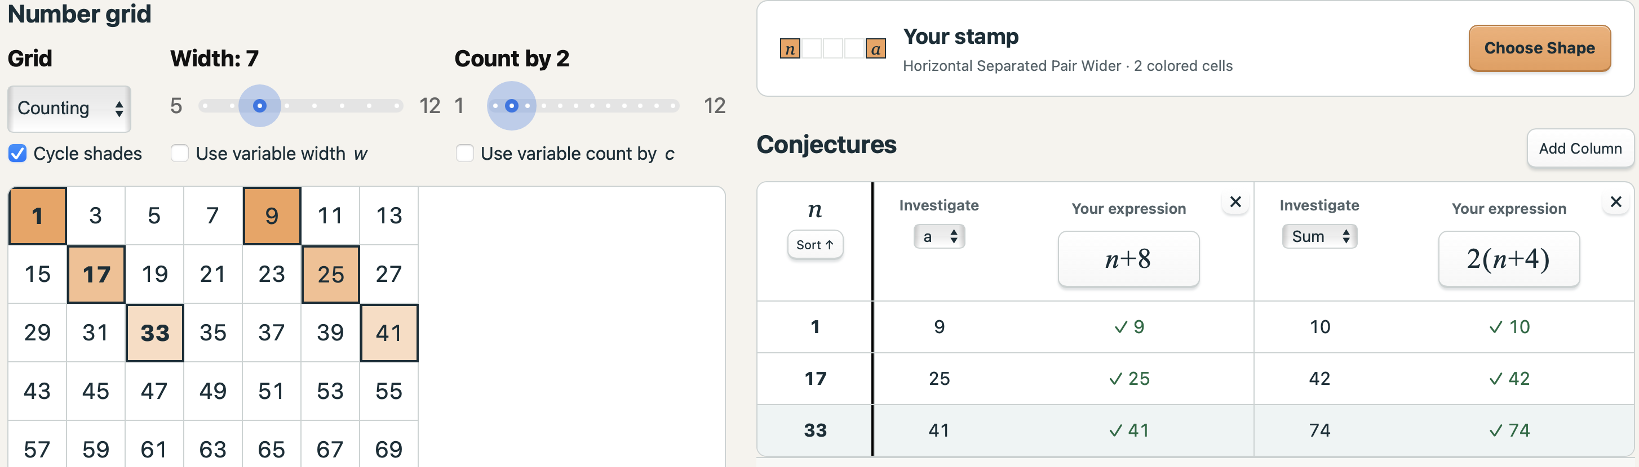
Once students have an initial familiarity with the program, encourage them to vary the Width for the first problem and look at the value a for the cell that it represents and the sum and/or product. As they get more comfortable, ask if students can predict the formulas before they even stamp a shape (or by choosing No Values mode). Anticipating possible answers is a good mathematical habit to cultivate in all settings.
Once students have changed the width, have them vary the Count by slider for different shapes. They can also see if a grid of whole numbers or integers changes their expressions (the domain should not matter, but seeing how the integers affect results is helpful for later challenges).
In all situations, the more students determine a formula for every cell in the shape, the more that will become the main task and finding the sum and product will just put those individual results to work. However, that does not make the Sum and Product challenges uninteresting. The Sum expressions are a great opportunity to explore like terms and simplifying linear expressions. The Product expressions lend themselves to many questions regarding possible types of numerical results. The products also are opportunities to practice distribution (when there are not too many terms to work with). The distributed product expressions may not always offer additional insights, but for shapes with two or three cells, they can confirm observations. For example, the products for the Horizontal Separated Pair are always 1 less than a perfect square since (n – 1)(n + 1) = n² – 1.
When students are using software, they tend (appropriately) to experiment and try things out. Let them! Have them report out their findings. If someone starts trying out new shapes, have them show the class what they learned. The options I would have students hold off on at first are those that generalize to all widths w or all skip counts of c. That said, the No Values option hides the data and encourages students to reason straight from the shape to the formula and that is a good next step once they have done some concrete investigations with different shapes.
Issues to watch for:
- If a student treats n as the name of a cell rather than its value.
- Students counting the number of steps between cells incorrectly. They might overcount by starting at the first cell and just counting the total number of cells. Alternatively, they may just count the number of cells in between and come up one short of the number of steps between two values.

Using b to Compare Positions
Many shapes have many cells. For some students, building up to those more complicated options may be aided by working with some of the 3-cell shapes. Show students how to position n, a, and b so they can explicitly develop formulas for all three cells before working on the sum or product rules. Have them make a shape such as the one shown below and develop formulas for both a and b. They can then add or multiply those expressions for a third column result. Encourage them to work with their expressions on paper. They can write a = n – 12 and b = n + 12 and then write their sum equal to n + n – 12 + n + 12, test it in the program, and then simplify that to 3n and test that version.
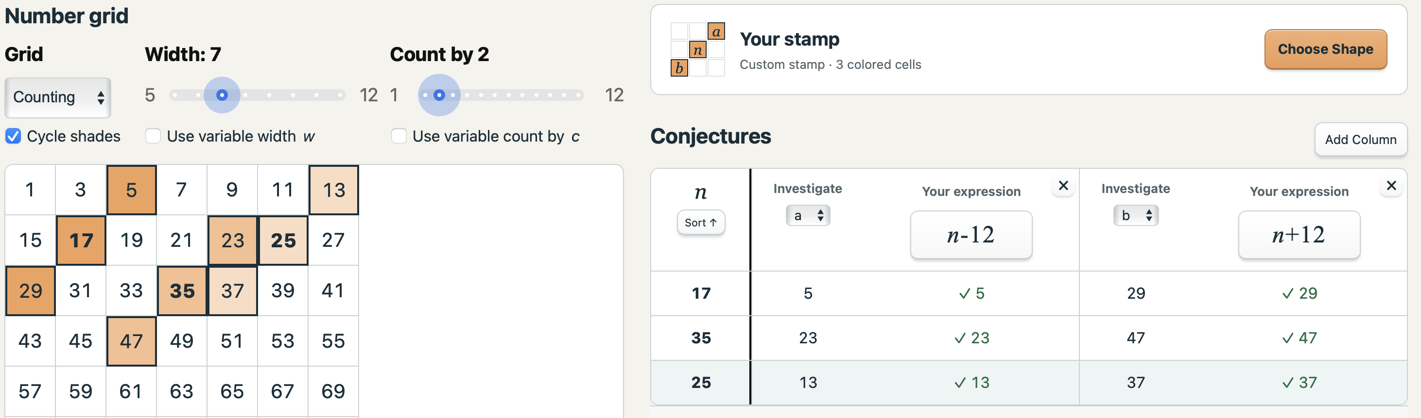
Students can be asked to explore what happens to their formulas if:
- n’s position is changed?
- a’s position is changed?
They should discover that the first does change the sum and product expressions, but not the sums or products themselves, while the second does not. Can they explain ways in which n changes the formulas? Is there a “best” location for n?

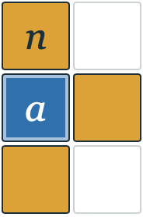
Two Colors, Subtraction, and Designing Shapes to Solve Challenges
Two-color stamps introduce subtraction of cells into the calculations. In Choose shape, enable Two-color sum. Orange cells contribute their values; blue cells contribute the opposite of their values. In Integer mode, blue may make a cell positive, so this is a great time to remind students that the sign in front of a variable does not mean you have a negative value (–n might be positive). For the shape at right, if the grid is 8 wide and counts by 3, we have cells with values n, n + 24 (for the blue one), n + 27 for the cell on the right, and n + 48 for the bottom cell. Calculating the sum, students will get n – (n + 24) + (n + 27) + (n + 48). This is a nice opportunity to discuss distribution when simplifying (or students may subtract n but not 24). They don’t have to be told. They should enter the original expression and their simplified version and see if they match. If they don’t, they will debug their thinking and discover they are off by 48 (+24 instead of -24) and that is a great moment to review distribution. You can ask what happens if all four cells have their color reversed. Can they predict the new sum expression? Note: let students know that the expressions for a or b are not affected by the color; only the sum and product options attend to color.
Solutions to some of the following challenges are at the end of this guide.
Challenge 0: Find more than one 3-cell shape with a sum of 3n.
Challenge 1: Find more than one 3-cell shape with a sum of n.
Challenge 2: Find a 4-cell shape with a sum of 4n.
Challenge 3: Find a shape with a sum that is always 0. Explain why n does not affect the sum.
Challenge 4: Find shapes with different numbers of cells with a sum of 0. Can you make one with 2 cells? 3 cells? 4 cells? Etc.?
Challenge 5: Find a shape with a constant sum that is your age.
Challenge 6: One of the teachers is 48. Find a shape with a constant sum of 48.
Challenge 7: I am, as of this writing, 65 years old. At first, I thought that might not be a possible constant sum, since one factor of 65 is 13, which is prime, and the shapes, the grid width, and the skip counting are all less than 13. However, it is possible. How?

For the Numerically Inclined
Above, it was suggested that students could use the No Values mode so that they could develop their expressions strictly based on the arrangement of the cells and the grid’s specifics. That is, they were to ignore any information the table might provide and go from the geometry directly to the algebra without benefit of numerical examples.
Alternatively, students can ignore the grid and focus their attention on the values in the table to look for patterns. Finding patterns in the table is easier if students stamp their shape systematically (moving the same amount sideways or vertically each time), which is not always easy if a shape does not fit snugly with itself. Scrolling downward in the grid and stamping the same number of rows below each time is an option. The goal is to record evenly-spaced (linear) values of n. In the screenshot that follows, the shape is four diagonally arranged cells. At the top of the grid, they have been stamped five times with n in cells 0 through 4. Below that, the shape has been stamped four times moving down a row each time with n increasing by 9, which is the grid’s width. In the table, the purple line separates these two distinct patterns.
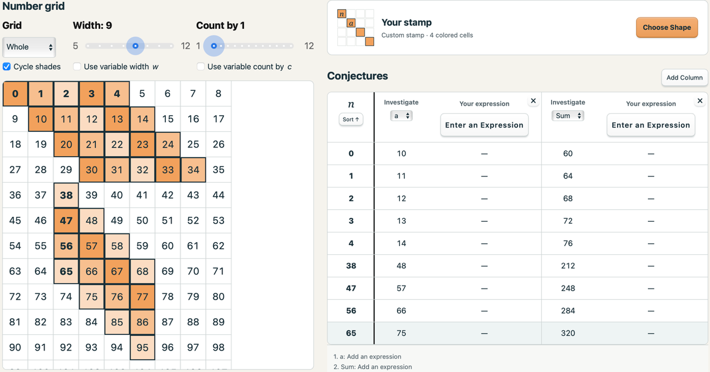
When working with tables of numbers, there are two common ways to look for patterns. For the value of a, given their introductory explorations, students are likely to seek an explicit rule, one that starts with n and directly produces a value for a (such as a = n + 10). The constant difference between paired values of n and a makes that a readily discoverable option. But when they look at the relationship between n and the sum, they are more likely to think recursively (even if they have never been taught that word or concept formally).
For recursive descriptions of a pattern, each value is determined based on the value (or values) before it. The Fibonacci sequence, which generates each new term by adding the previous two terms, is an example of a recursive rule. Looking at the first values for the sum, they will note that each value of Sum is 4 more than the previous one. Since n is going up by 1 each line, that constant increase tells us that the pattern is a linear one. A full recursive definition includes both a rule for the relationship between consecutive values and also a starting point (without which we can’t generate any terms). The notation for the recursive definition of the Sum column is: $\left\{\begin{aligned}S_{0}=60 \\ S_{i}=S_{i-1}+4\end{aligned}\right.$ which translates to “start at 60 and generate each term by adding 4 to the prior term.” Stamp It! does not allow recursive descriptions, but they can still be helpful. A constant difference each time n goes up by 1 tells us that this difference is the slope (for students who know about linear graphs and equations) or that we have n times the difference (multiplication is accumulated repeated addition). So, we know the expression for the sum is along the lines of 4n +/- something. We can then pick the value that works for a given n (0, in this case, being the easiest) and get 4n + 60, test it out, and confirm, for example, that when n = 3, we get 4$∙$3 + 60 = 72.
If the shape is such that we can’t position our stamps to get consecutive values of n, we can still find constant differences. In the entries below the purple line, n increases steadily by 9 and the sum increases by 36. We can divide to see that our rate of change is still 4. This calculation is the same as the slope formula: $\frac{{Sum}_{2}-{Sum}_{1}}{n_{2}-n_{1}}=\frac{248-212}{47-38}=4$.

Some More Challenges
Challenge 0: Find a shape whose sum is always odd. Find one that is always even.
Challenge 1: Can you find shapes that meet the Challenge 0 goals above with a shape with 2 cells? 3 cells? 4 cells? Etc.?


Challenge 2: Can you find a shape whose product is always even? Always odd? Why or why not?
Challenge 3: For either of the two shapes shown at right, along with an Integer grid, how many different placements will yield a product of 0? How can that answer be explained in terms of the shape and also in terms of the expression for the product?
{Note: the two product expressions, n(n + 7)(n + 14)(n + 21)(n + 28) and
n(n – 7)(n – 14)(n – 21)(n – 28), can be used to show how five different values
for n can make each of the factors, and therefore the product, 0. This zero
product property is an important algebraic tool for solving equations.}
Challenge 4: Can you find shapes whose products are always multiples of 6? Explain why 6 has to be a factor.
Challenge 5: Can you design a shape whose product is always negative using the counting grid? With the integer grid?
Challenge 6: Can you design a shape whose product is always nonnegative with the integer grid?
Challenge 7: Can two different shapes have the same sum but different products? Can two have the same product but different sums?
Challenge 8: Design a shape that meets two conditions picked from earlier challenges. For each explore how many cells such a shape might have. Prove your stamps do what you claim and also why a certain type of stamp is not possible. Explain if a particular grid size or skip count is needed. Here are some possibilities (but come up with your own!)
- The sum is always odd and the product is even
- The product is always odd and the sum is even.
- The sum is always 0 and the product is always even.
- The sum is always 0 and the product is odd half of the time and even half of the time.
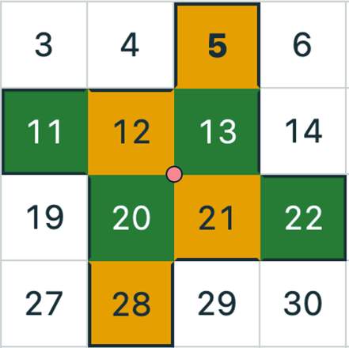
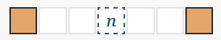
Challenge 9: For the three final built-in stamps (the “Horizontal Separated Pair” stamps), there is a pattern to the formulas for the products. Stamp It! doesn’t allow stamps wider than these, but discover and prove a formula for all horizontal pairs with n in the middle and the two orange cells s spaces away from that central cell. What would the formula be for this stamp: ?
1 2 3 4
4
3
2
1

0
Challenge 10: When do rotations have the same sum? In the grid at right, there is a four-cell orange shape stamped. A 90° version of that shape shown in green is also stamped with the same shared center point (marked with a pink circle). The sum for these two shapes is the same. For which shapes are 90° rotations around the center guaranteed to have the same sum? First, let’s clarify what the center of a shape is. We can find the center by averaging the x-coordinates and the y-coordinates of the centers of each cell relative to a 2-D coordinate system. We add purple axes, ignore the cell values, and just focus on the number lines that constitute the axes. For the orange cells, with centers marked with blue points, we have these coordinates:
Cell 5: (2.5, 3.5) Cell 12: (1.5, 2.5) Cell 21: (2.5, 1.5) Cell 28: (1.5, 0.5)
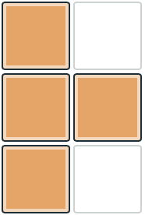
Averaging the x-coordinates yields x_{center} = 2. Averaging the y-coordinates yields y_{center} = 2. So the center, highlighted with the pink dot is at (2, 2). If we had started with different axis locations, the center would still have landed at the same center point. Rotating the orange shape around that point 90° (in either direction) produces the green shape.
1 2
3
2
1

0
At right is an example that raises a red flag for this shape as a candidate. The coordinates of the blue cell centers are (0.5, 0.5), (0.5, 1.5), (0.5, 2.5), and (1.5, 1.5). Averaging yields a center point of (0.75, 1.5). The problem with this shape is that the x-coordinate makes it impossible for the shape to land back on the grid (it will be offset by 0.25 vertically if rotated by 90° or 0.5 horizontally if rotated by 180°). Picking a different definition of “center,” we can certainly rotate the figure so it does fit the grid, but the sum is not going to match. This second shape does have symmetry (reflection over a horizontal line), so there is a lot that students can explore about which shapes rotate and about which points and when that rotation leaves the sum unchanged. In math, a quantity or property that remains unchanged when we carry out an operation is called invariant. So, students are exploring which shapes have a sum that is invariant under rotation. Note: if a shape does have this property and, as in the first example, doesn’t land on itself, then it gives us a way to make a single shape with a sum of 0 using two colors. If the shape does land on itself under rotation, there may still be a way to figure out an orange/blue coloring that builds on it to make a zero-sum, two-color shape.

Generalizing Further: Making Width a Variable
When we choose No Values with, for example a Width of 6 and Count by of 1, students can still describe the cell below n with n + 6. Hiding the entries removes the reliance on specific cases, but it does not make the known width unknown (there are still six columns).
Once we enable Use variable width w, the situation changes. Now we really don’t know how wide the grid is and we need to come up with a formula that, when necessary, incorporates w for the width. The arrow labeled w, the ellipses, and the final column indicate that the displayed diagram is only a sketch of a grid with unspecified width. Students should not count its visible columns and substitute that count for w. Stamps are placed in the continuous cells before the dots.
With Count by 1, moving right still adds 1; moving down now adds w. Ask students to explain each of the following:
- n + 3 {over 3 to the right}
- n + w – 1 {down one row, 1 to the left}
- n – w + 2 {up one row, 2 to the right}
- n + 3w {down 3 rows}
A horizontal three-cell stamp centered at n still sums to 3n when the width changes. A vertical three-cell stamp centered at n also sums to 3n, even though the individual values depend on w. Ask students to distinguish “the cells do not change” from “their changes cancel in the sum.”
Count by values still impact the formulas for each cell as before. If we are counting by 5, then moving a row down will add 5w. But we can go one step farther in generalizing our grids…

Generalizing the Count by Step
Turn off Use variable width w and enable Use variable count by c. Once again, the grid switches to No Values and the Count by slider is disabled. Moving one cell to the right now adds c. If the width is 7, the cell below n is n + 7c (we are taking 7 steps of c).
Ask students to explain each of the following for a grid with width 7:
- n – c {one step to the left}
- n + 3c {3 steps to the right}
- n – 7c {up 1 row – someone may offer 7 steps to the left, which is true, but
with a width of 7, those steps will wrap back up a row}
- n + 9c {down 1 row and over 2 more spots right, n + 7c + 2c}

Everything All At Once – Varying Width and Count
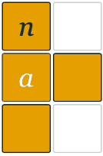
When both the width and count variable options are on, students get to develop solutions for a, Sum, and Product in terms of n, w, and c. They can discover that each row now adds wc. One row down and one column right adds wc + c, or c(w + 1). Both expressions count the same journey in different ways. As with prior settings, Sum is still the total of the expression for each individual cell in a shape and Product has each expression as a factor. For the shape at right, we have cells of n, n + cw (for a),
n + cw + c, and n + 2cw, so our sum is n + n + cw + n + cw + c + n + 2cw = 4n + 4cw + c and our product is n(n + cw)( n + cw + c)(n + 2cw), which “simplifies” to:
n⁴ + cn³ + 4cwn³ + 5c²w²n² + 3c²wn² + 2c³w³n + 2c³w²n Yeech.

Use Numerical Examples to Test Expressions
The Test values… button is available when w, c, or both are enabled. It allows us to put our complicated expressions to the test for specific values of our choosing. Picking values for n, w, and c, we get to see the result and the predictions from our expressions.
Tests leave the symbolic grid unchanged. If only one variable option is enabled, the other setting comes from its slider and cannot be edited in the panel. Highlight which quantities are variables and which are held fixed.
Some of the above challenges may have yielded solutions dependent upon specific w or c values. Ask students to generate the most general expression in terms of all three variables and still see if, for example, they can justify their earlier solutions (e.g., will the sum still always be their age? Will the product still be divisible by 6?).

Work Backwards from an Expression
One of Making Math’s favorite ways to generate new mathematical problems to explore is to simply reverse a problem. Stamp It! is a good setting for reversing a process. Students can start with expressions and seek shapes and grids for which the expressions are a solution. The table of expressions on the next page lists possibilities for which students can choose a pre-existing shape or design a new shape and pick grid settings and a column goal for which the expression is a solution. Providing orange and blue pencils or markers helps students sketch out candidate shapes.

Expression | Column Goal  (a, Sum, Product) | Shape | Grid Width | Count by
n – 11
n + 20
3n
3n + 8
2n
4n
5n
6n + 3
25n
10
− 7
n
n(n + 1)(n + 2)(n – 12)
n² – n
n² + n
n³ – n

As an activity, you might give a substantial list of expressions and ask students to solve some small subset making sure that at least one of their solutions is for each type of column (a, sum, and product) and that they come up with more than one solution (different shape and/or grid characteristics) for at least two expressions. Possible prompts for further investigations:
- Can they use the same expression for an a column and a sum?
- Are there expressions that have unique solutions? If none are on the list, can they propose one?
- Are there expressions which have no solution? How can they justify their claim?
As a warm-up, give students 3n + 13 and ask them to work with a partner to come up with at least two possible solutions. One solution is an L in a grid 6 cells wide with n at the upper left and colored cells directly below and below-right. The cell values would be n, n + 6, and n + 7. Have students draw their proposed stamp shapes on paper before testing them.
Students can also warm up with problems that they come up with themselves (based on actual shapes and grids so they know they work) and swap with a classmate to solve. If stuck, the originator of the problem can give hints, such as the width, counting step, number of colored cells, or whether two colors are used.

Feedback
In general, if a student is stuck, ask them what they have tried, what they notice, or what part of the problem feels tricky for them. Share diagnostic questions with them:
- Can they connect expressions for each individual cell in their shape to their expression?
- Are the numbers generated by their expression consistently higher than the target values? If so, do they differ from the target by a constant amount or a growing amount? If the latter, then they will need an adjustment that includes n. Look at the differences, perhaps in a spreadsheet. Do they grow linearly or faster than that?
- What if the expression is consistently too low?
- What if the expression starts lower than needed and ends up higher (then it may be of a higher power than it should be)? What if it starts too high and ends up too low (then it may be of a lower power than needed)?
- If a student is getting stuck working with w and/or c, encourage them to return to specific related examples (with known width or count), to collect a few solutions and to list them on paper in a table, and to then generalize from the patterns they see. Remind them that the operations with w and/or c are the same as with specific cases.

Templates for Assignments
You can set up a problem with a specific shape (built-in or created), various grid settings, and desired target columns and then save it as a .stamps file that you can distribute to students to work on (by opening it from within Stamp It!).
Similarly, you can invite students to create a Stamp It! challenge and to swap with a classmate. If the task is more complicated than finding an expression or expressions, they should include written instructions for the challenge and state any limits (e.g., not allowed to change width). An example of a challenge that would require instructions is, “Design a two-color stamp whose Sum does not depend on n but does depend on the width.” Students should write explanations of their process and answer and not just provide a finished expression.

Solutions to Some of the Sum Challenges
Here are five solutions, but which ones go with which problems can be figured out for practice (but, if you don’t want to, answers are on the next page).
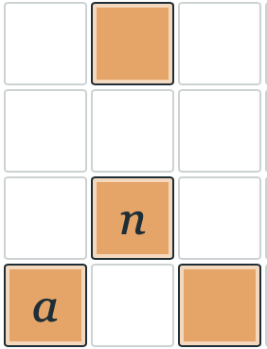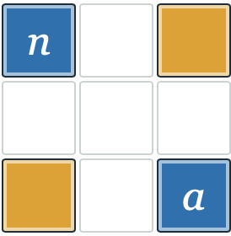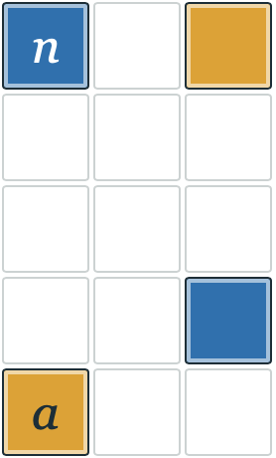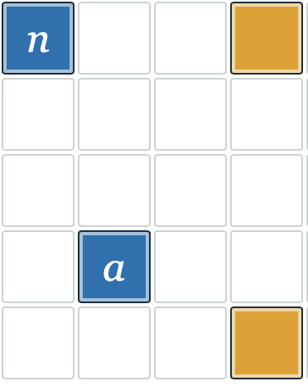
Width: 8 Count: 5
Width: 6 Count: 8

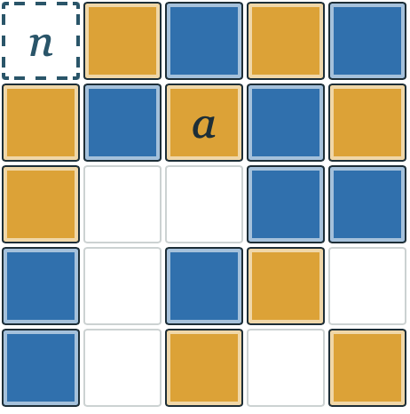
Why does this work without any evident symmetry?

This work © 2026 by Joshua Abrams/Making Math is licensed under CC BY-NC-SA 4.0

Challenge 2 Challenge 3 Challenge 6 Challenge 7
Width: 8 Count: 5
Width: 6 Count: 8
Challenge 4

Why does this work without any evident symmetry?

This is the plural of “ellipsis,” which is the name of three consecutive periods, “…”. It is pronounced el-ip-sees, not el-lip-siz (the plural of ellipse).

