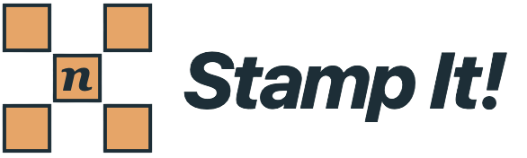
What is the purpose of this program?
Stamp It! gives students opportunities to describe number patterns with algebraic expressions. They “stamp” a number grid, which selects a few cells in a particular arrangement. They then look for relationships between the value of the cell labeled n and the values of other cells in the stamp. Students write expressions, test them against their data, and explain why their formula works. These steps help them to deepen their understanding of algebra: how a variable can represent an infinite number of situations, how to simplify an expression, and what it means for two expressions to be equivalent.

User Guide
Contents at a glance
- The Stamp It! Interface (page 2)
- Writing Expressions (page 4)
- Column and Grid Settings (page 4)
- Choosing and Modifying Stamps (page 5)
- Grids Without Numbers (page 6)
- Saving, Opening, and Printing Your Work (page 9)
- Questions for Investigations (page 9)

The Stamp It! Interface
The main features of the program interface are the number grid and its controls on the left (highlighted in brown), the data and conjecture table on the right (blue), and the stamp display and Choose Shape button in the upper right (purple).
- The grid is where patterns are stamped to generate data and where the relationships between the values in the cells can be studied.
- The Conjectures table is where you look for numerical patterns and build expressions to represent those patterns. A conjecture is a relationship you believe will work; an expression gives you a way to describe and test it. Once your expression matches the data and you can explain why it works for every case, you have justified your conjecture. At that point, it is not a conjecture any longer – it is a true formula!
- The stamp display shows you the arrangement of cells in your stamp, which cell is the anchor cell represented by the variable n, and which cells are also represented by variables (a and, if used, b). The Choose Shape button opens a window that provides many different stamp designs; the ability to move which cell is associated with n, a, and b; and the option to design your own stamp (including introducing negative cells).
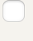
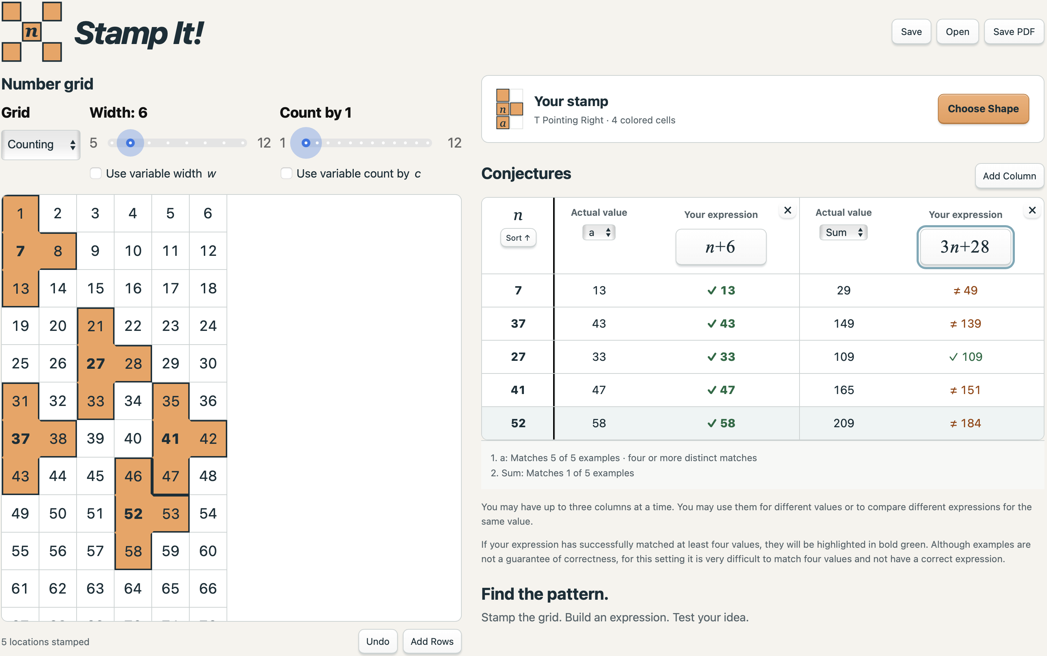
Cycle shades

The Grid
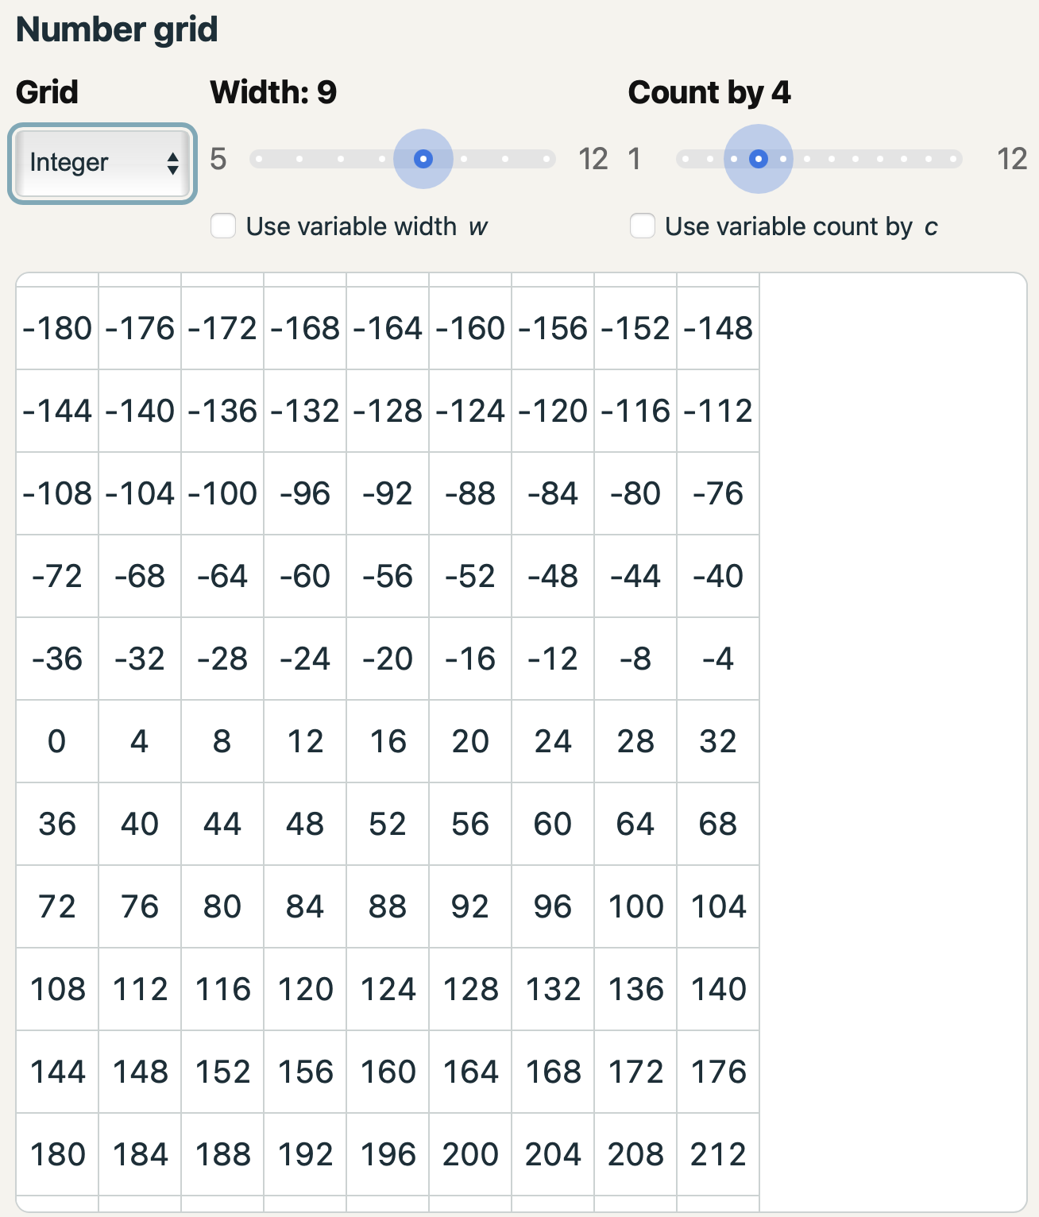
In the screenshot above, the number grid is 6 cells wide, the numbers start at 1, and they count by 1. This grid arrangement is controlled by the dropdown menu and two sliders above the grid. The Grid menu includes options to start at 1 (Counting), at 0 (Whole), or to show values in both the positive and negative direction (Integers). It also has an option, No Values, which shows a blank grid, which means the user has to consider the tasks more abstractly. The grid example that follows shows a grid 9 cells wide with integers counting by 4. The grid scrolls vertically and, for Counting and Whole grids, additional rows can be added (up to a value of 9999) with the Add Rows button. The Cycle shades checkbox makes adjacent stamps distinguishable.
Cycle shades
When the mouse cursor is over the grid, a preview of the stamp shape appears with the n cell at the cursor’s location. When stamping a new copy of the shape, all cells must fit within the current grid (without wrapping around) and must not overlap a pre-existing instance of the shape. If you want to remove a stamp, in order to place a different one that would be blocked by it, click the Undo button below the grid.

The Conjectures Table
When using the Counting, Whole, or Integer options, each time a new stamp is added to the grid, a new row will appear in the Conjectures table. The table will list the value for the cell associated with n and calculations for the values of a, b, Sum, or Product as chosen from the dropdown menu. New columns start with a as the option. Sum adds the values of all orange cells and, if in two-color mode, the opposite of all blue cells. Product multiplies all cell values counting blue cells as the opposite of the value in the cell. An uncolored cell never contributes to either calculation, even if it is marked n.
Use the Sort ↑ option in the header for the column of n values to show the examples sorted by increasing size of n. Unsort restores the order in which the examples were stamped. An ordered list might help you more readily discover a pattern.
Your goal is to develop an algebraic expression that will generate the values in a column using only the variable n (since a and b need to be understood in terms of n). Once you have an expression to try out, you should click Enter an Expression, type your formula using the tools explained below, and click Submit Expression (or press Return). The program applies that expression for every value of n in the column. If the value produced by the expression matches the actual value in that column, it will be highlighted in green. Otherwise, it will be orange. When all of the collected examples in a column are successful matches and there are at least four, the matches appear in bold green. A later mismatch would remove the bold emphasis. Multiple matches with no counterexamples are useful evidence that an expression is correct; however, examples are not a proof, so the next mathematical step would be a clear explanation of how the pattern in the shape connects to the expression.
Additional columns can be added with the Add Column button. Up to three different columns may be explored at the same time. If the table is wider than the screen, it will be horizontally scrollable. The × beside an expression heading removes that column.
You may want more than one column showing the same quantity, so you can try more than one expression at a time for comparison. For example, for the shape Vertical 2 with a grid width of 6 and Count by of 1, a Sum column with 2n + 6 and another with n + (n + 6) would show their equivalence. You might study a column with a and another with Sum or Product so you can build up the Sum or Product expression based on the values of n, a, and, if used, b.

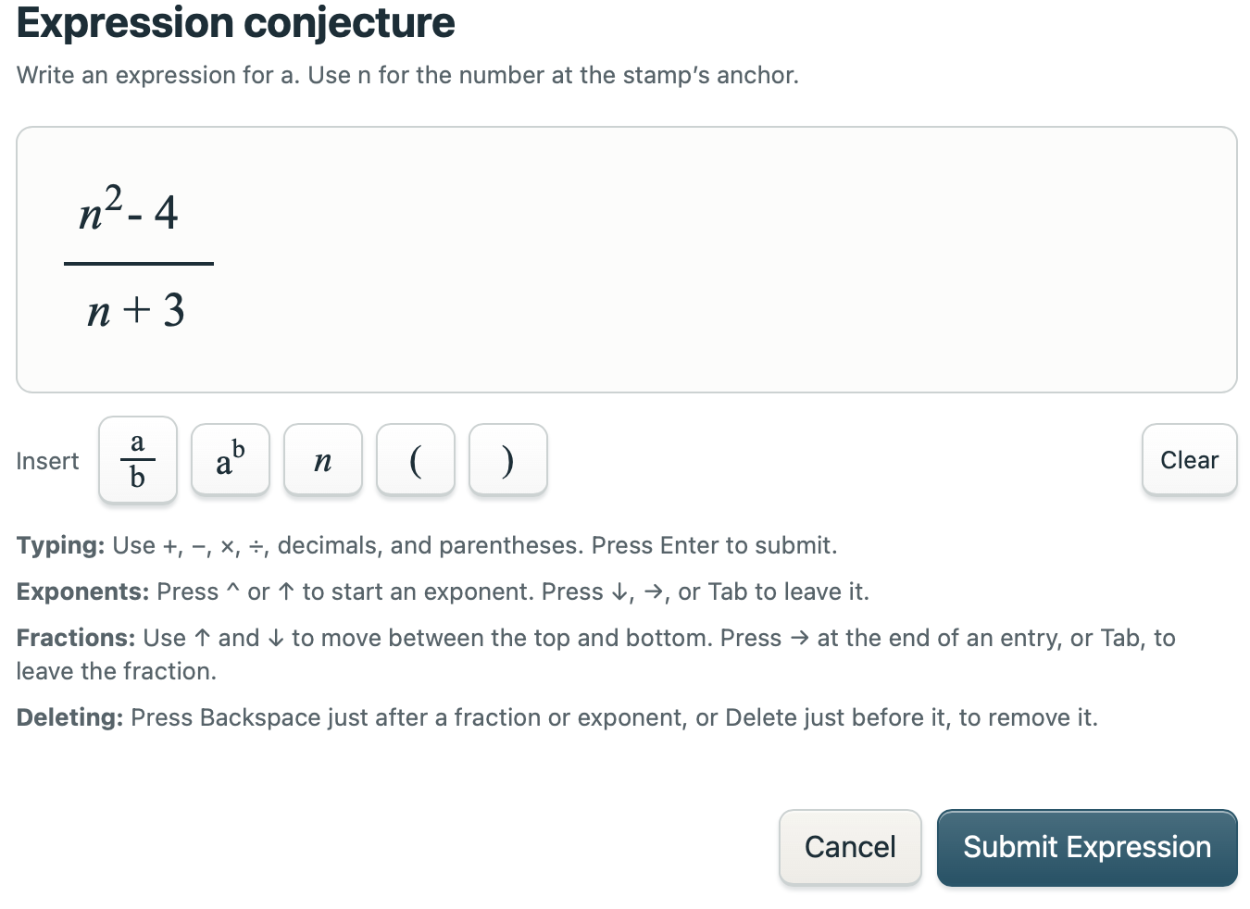
Writing Expressions
Once Enter an expression has been clicked, a window appears for entering and editing expressions. Both explicit (3*n) and implied (3n) multiplication are supported. Fractions and exponents can be inserted with the 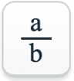 and 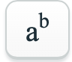 buttons.
Type “n” or use the button to represent the value in the cell marked “n”. The variables a and b identify cells you can place in your shape, but they are not values you can type into an expression. Expressions are only in terms of n, until, after some experience, you try grids without numbers. In No Values mode, you can also generalize for the width of the grid, w, the counting-by amount, c, or both as additional variables that you can incorporate in your expressions.

Fractions and Exponents
Fractions: The $\frac{a}{b}$ button inserts a fraction. Enter the numerator above the solid fraction bar and the denominator below it. Shading and a dashed underline show the active typing area. You can click to different locations in the expression or navigate left, right, up, and down (for fractions and exponents) with the arrows. At the end of an entry, the Right Arrow or Tab leaves a fraction.
Exponents: The $a^{b}$ button inserts a raised entry after a base; to square a value, enter the base first, click the button, then type “2” in the raised entry box. Exponents must be integers. In addition to the exponent button, the caret symbol, “^”, and the Up Arrow start an exponent. Down, Right, or Tab leaves it.
Clear clears the draft in the editor. Submit Expression puts your edited expression in the table; Cancel or Escape leaves the earlier expression in place. If an entry is incomplete (for example, “n +”), the editor stays open and asks you to fix it.

Column and Grid Settings

Changing the Number Grid
The Counting option in the Grid drop-down menu starts the grid at 1. Whole starts it at 0. Integer includes negative numbers, zero, and positive numbers. The No Values setting hides the numbers, so you can reason about a general location; this option is discussed further in Grids Without Numbers on page 6.
The Width slider chooses 5 through 12 cells per row. Count by chooses a step between cells from 1 through 12. Count by 3 with the Counting option, for example, starts the first row 1, 4, 7, … .
Changing the grid, width, or counting step clears stamped examples but keeps expressions that are still allowed. Does your old rule still provide clues to the new arrangement? Undo restores the previous grid setting and work. Add Rows extends a numbered grid by up to 20 rows at a time; the program stops before a complete row would contain a value above 9,999. Integer and No Values grids do not have this button.

Choosing and Modifying Stamps
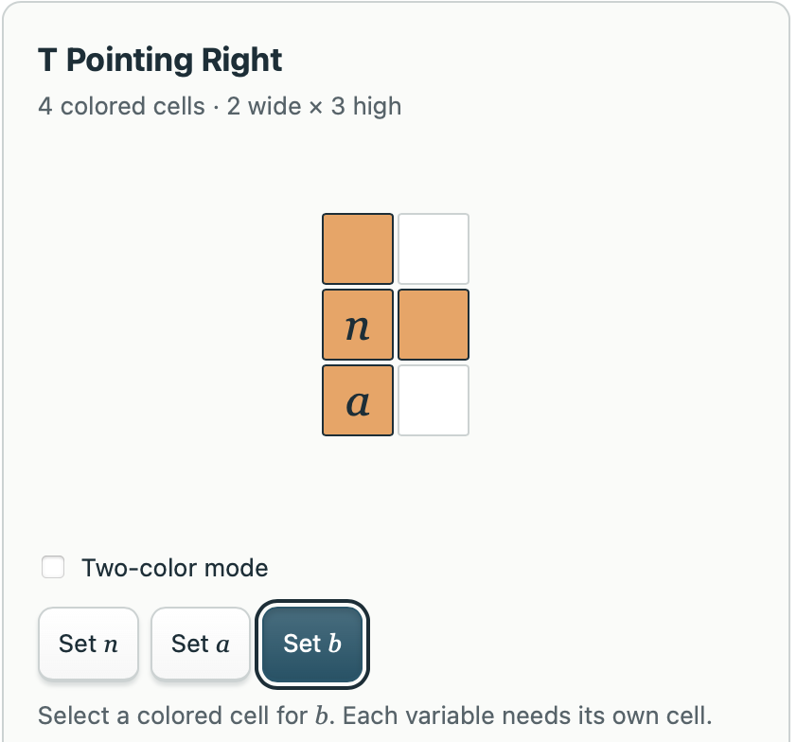
To try one of the many possible shapes, click the orange Choose Shape button. Scroll through the Built-in stamps and select a pattern. The preview lets you choose where n, a, and, if desired, b go before you commit to the new stamp.
Choose Set n, then click the cell that should be n. This is the cell you position when you stamp the grid. Choose Set a or Set b, then click a colored cell. Each variable needs its own cell. The n cell may be uncolored, which is useful for stamps with gaps; a and b must be on colored cells.
The program chooses an initial location for n and a. Check them in the preview and move either, if you wish. The variable b is optional. Remove b takes away the variable without removing its cell. If b is not used, its table menu entry is grayed out.
Click Choose Stamp to confirm your choices. Changing the shape, colors, or variable locations clears the earlier examples and expressions, so save work you want to keep first. Cancel or Escape leaves the current investigation alone. If you choose the shape Horizontal Separated Pair Widest, which is 7 cells wide, and the grid width is less than 7, the choose button will also offer to widen the grid.

Two-Color Sums and Products
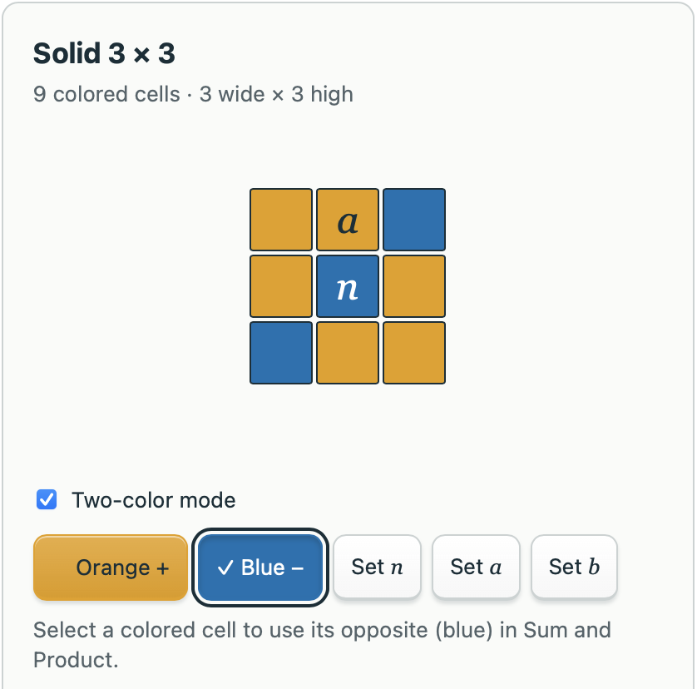
Two-color mode operates on orange cell values as they are displayed and uses the opposite of blue cell values (their sign is reversed) when calculating Sum and Product columns. In Choose Shape, check Two-color mode. Choose Orange + or Blue −, then click a cell to count the cell value, when orange, or its opposite, when blue, for both the Sum and Product patterns. The selected color tool has a checkmark and outline.
For Sum, the program will add orange-cell values and subtract blue-cell values. For Product, the program will multiply orange-cell values with the opposite of the blue-cell values. Blue does not change the number displayed in a cell or the formula for a.

Creating Your Own Stamp
In Choose Shape, select the Create Your Own tab to design your own shape. The 5 × 5 board is a design area for your stamp.
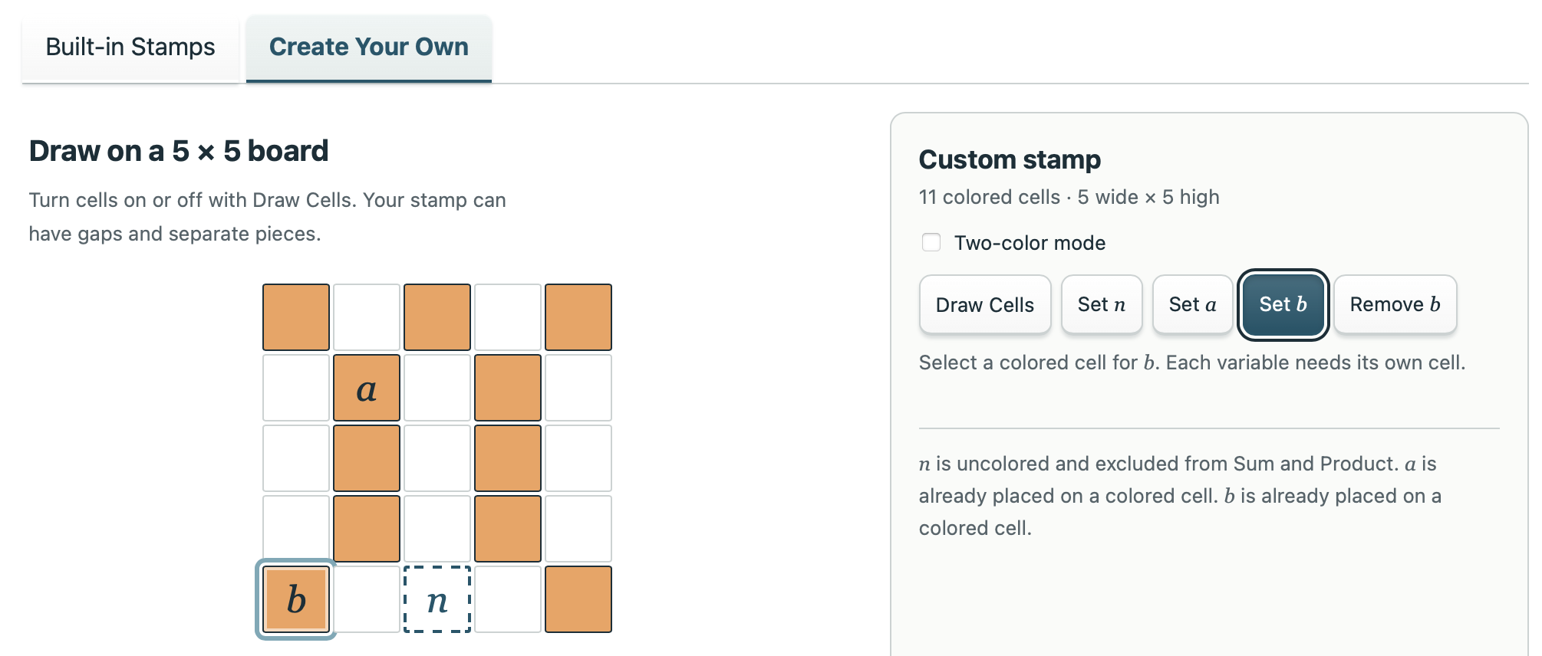
1. Choose Draw Cells. Click a cell to color it; click again to clear it. Your stamp may have gaps or separate pieces. At least one cell must be colored.
2. Use Set n, Set a, and, if wanted, Set b to arrange the variables. n may be on an uncolored cell; a and b need separate colored cells. Removing a cell can change which variable locations are available, so check the preview before finishing.
3. For a signed design, check Two-color mode and use Orange + and Blue − to color cells. These tools can also add colored cells to a custom design.
4. Click Choose Stamp.
Your custom shape is kept in a saved investigation. It is not added as a permanent new tile in the built-in gallery. Save different designs as separate files, if you want to use them again.

Grids Without Numbers

Hiding the Numbers
Choose No Values in the Grid menu to hide all cell values. The width of the grid will still be visible as shown in the screenshot below. This mode removes the numerical data and focuses your attention on the geometric relationship between the cells in the shape. You will need to generalize for all stamp locations. Since stamping in one place is no different than another, only one location is shown. Likewise, the Conjectures table will only show one line, and it won’t show any data – it just provides the opportunity to enter an expression and then gives feedback on whether or not that expression works. As before, all expressions are in terms of n and will be the same as they would be if values were shown. For example, the screenshot that follows shows the Vertical 2 stamp with a Width of 9 and Count by of 1. For this situation, n + 9 is the correct expression regardless of whether the values are showing or not.
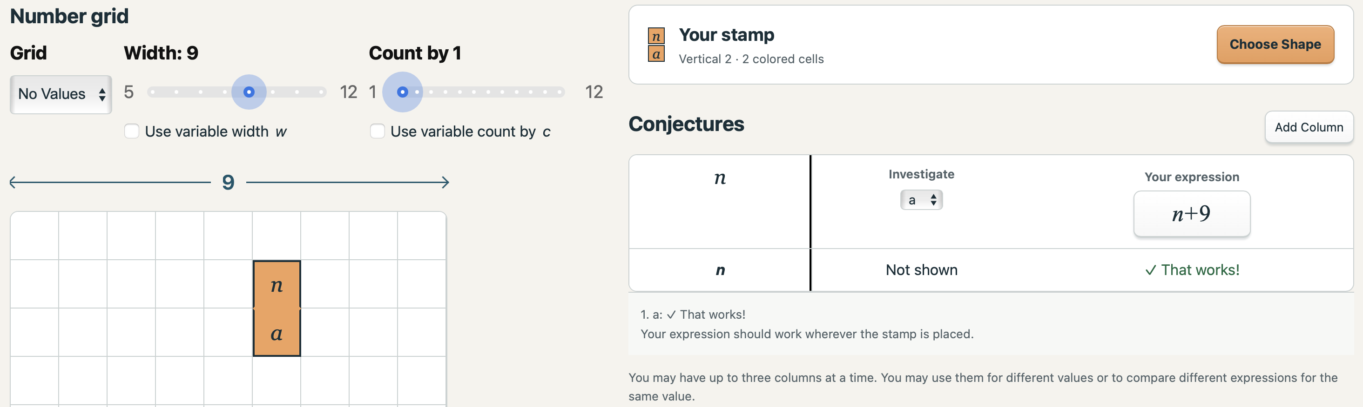
Cycle shades

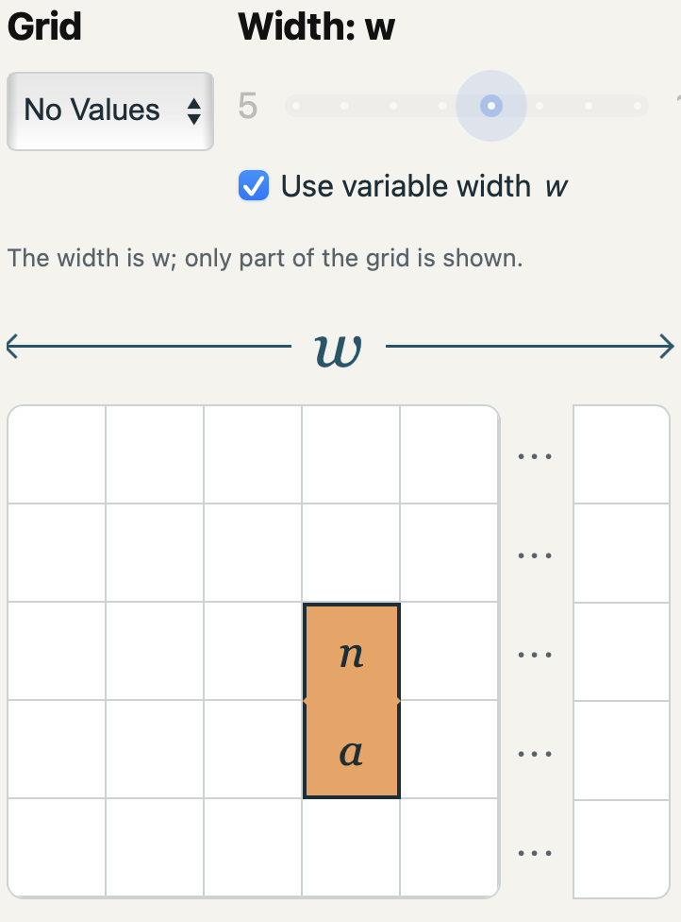
Solving for All Widths at Once
Check Use variable width w below the Width slider to generalize all problems to all possible widths, w. When this checkbox is checked, the Grid menu will switch to No Values and the width slider is disabled. The width is now w, representing any and all possibilities, and expressions need to incorporate w, if it affects the values (which it most likely will, if cells are on more than one row). w is available in the expression editor.
The grid now appears as shown here at right. The ellipsis notation (“…”) indicates an unspecified number of intervening columns. As with the regular No Values mode, the shape can be stamped only once, the location doesn’t matter, and there will be only one row in the Conjectures table.
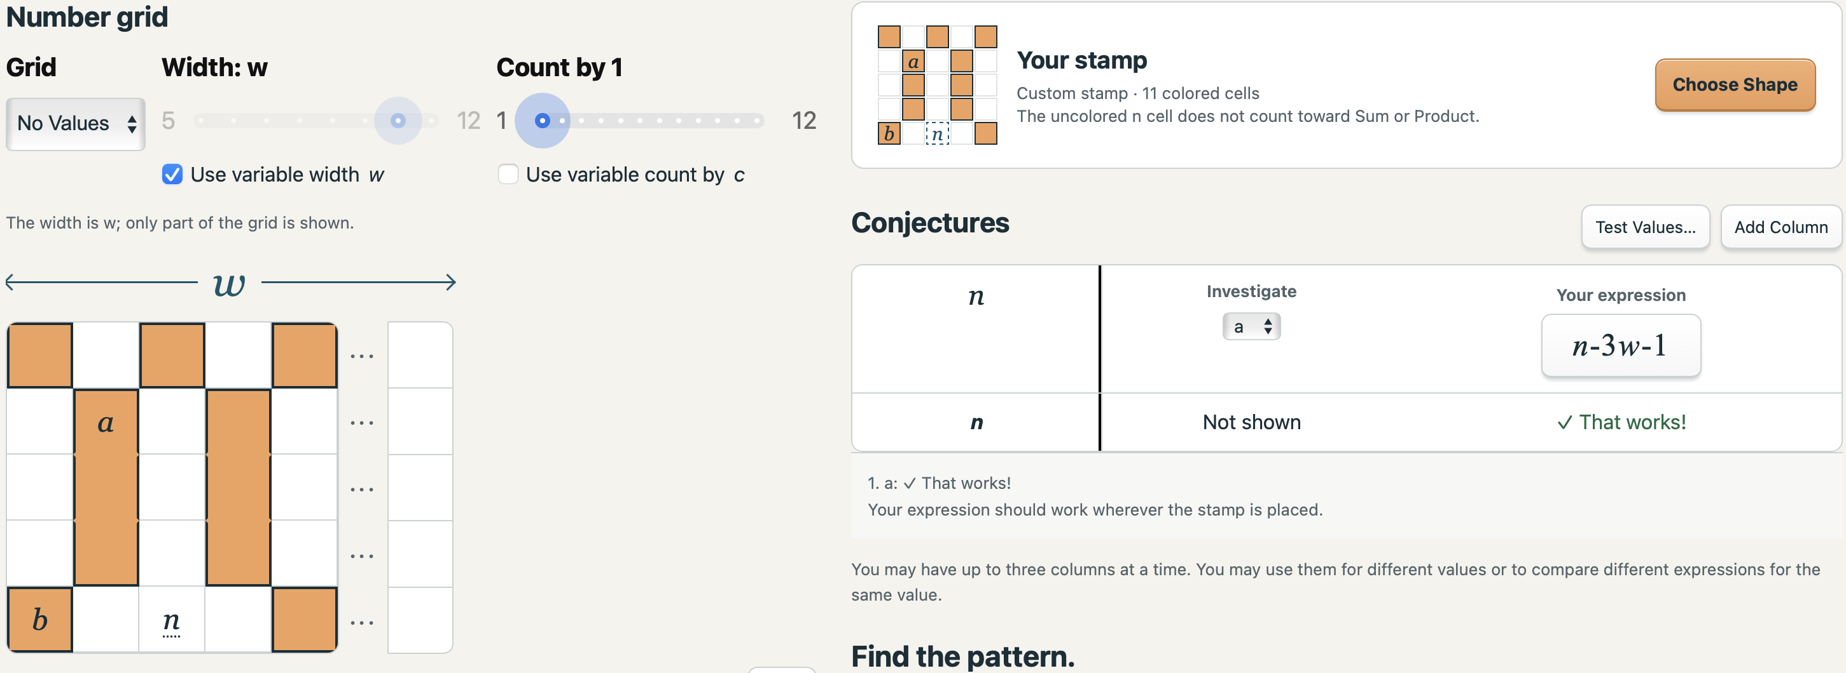
This mode provides the opportunity for the next level in abstract thinking as you consider how the values in a shape’s cells will change for all possible widths at once. At right is a sample solution: a is three rows of w cells above, and one column to the left of, n as expressed in the formula n – 3w – 1.
Cycle shades

Generalizing for Different Count by Values
Check Use variable Count by c below the Count by slider to generalize all problems for all skip counting values. Once checked, the program switches to No Values, disables the Count by slider, and lets you use c in expressions. The value c is the amount added at each step across the grid. n is still the value at the stamp’s n cell, so the cell to its right is c greater and has the value n + c. If the row width is 8, then each row has 8 changes of c, so the cell below n has value n + 8c.

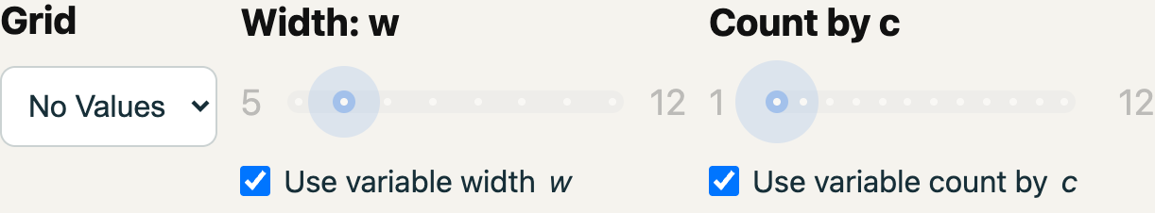
Using w and c Together
Both the Width and the Count by amount can be variables.

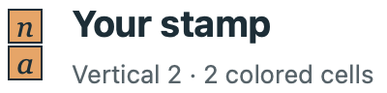
If both variable options are checked, moving right adds c. Moving down adds wc. Moving diagonally down and right adds wc + c. For the simple Vertical 2 shape shown at right, the three column options become: a = n + wc Sum = 2n + wc Product = n(n + wc)
Unchecking c returns the Grid menu to Counting, if w is also unchecked. If w remains enabled, the grid stays in No Values mode and the ordinary Count by slider becomes available again. Unchecking either variable clears expressions that use that now-unavailable variable. Undo restores the previous setting and expressions.

Testing Values and Reading Feedback
Whenever w or c is enabled, the Test values… button appears beside the Add Column button above the Conjectures table. This tool allows you to try concrete values for n, w, and c, connecting your general expression to particular numerical examples. This option is helpful for debugging expressions – it gives feedback comparing correct values to the ones your expressions are generating.
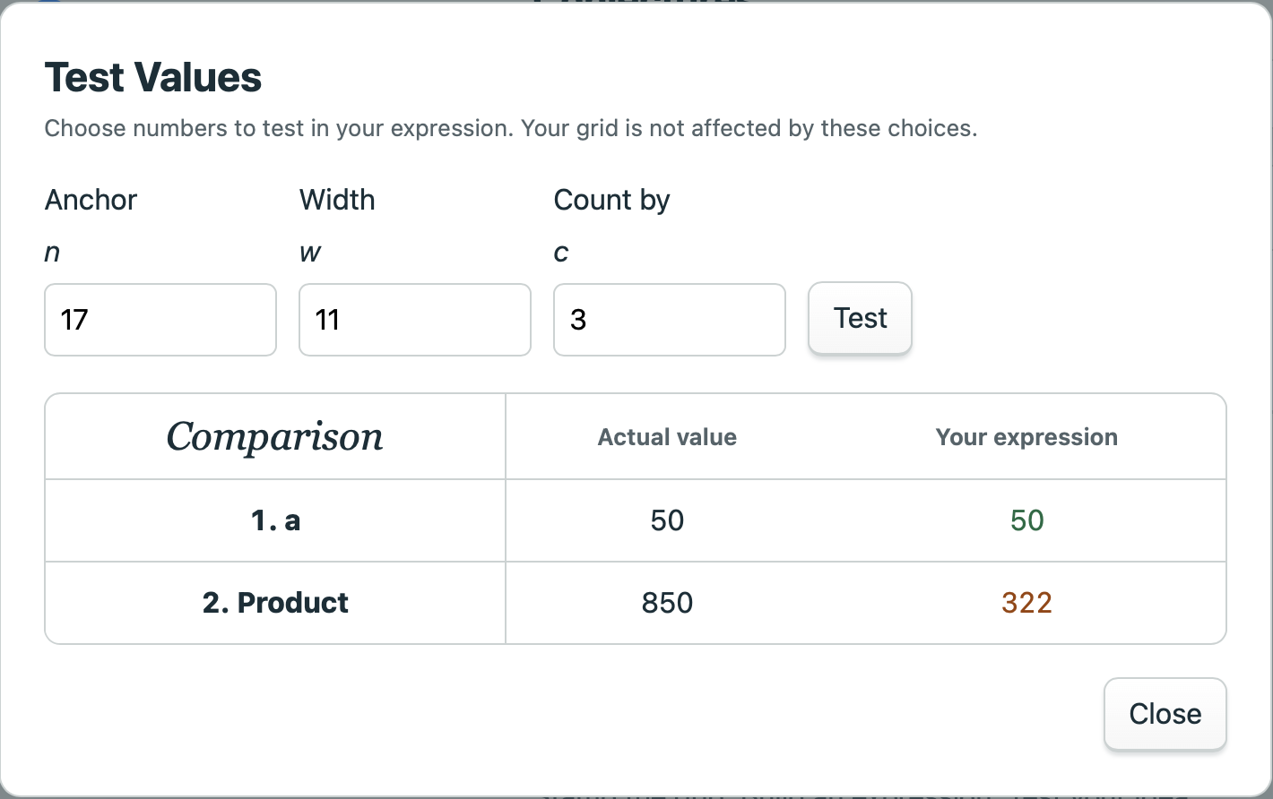
1. Open Test values… and enter a value for n. Set w, c, or both depending on which options are enabled. A setting that is fixed by a slider is shown but cannot be edited here.
2. Click Test. For every table column, compare the actual value with the result of your expression. In the example above, n + wc becomes 17 + 11 × 3 = 50.
3. Try another set of numbers. Change just one value at a time if you want to see which part of the expression responds. Close the panel when you are ready to continue; the grid itself is not affected by these choices.
Use integers for these tests. n can be negative, zero, or positive. The Count by amount is positive, and the width must be at least 5 and wide enough for the stamp. The panel reminds you of the allowed ranges, if an entry is outside them.

What the Feedback Means
In No Values mode, “That works!” means the program’s numerical checks agree with your expression. “That expression doesn’t match” means it found a disagreement. When an expression is not correct, the Show a Counterexample button will pick random values that show a mismatch between the correct value and the one generated by your expression.
A counterexample can help you locate a missing step, sign, or order of operations mistake. If the program cannot check an expression, it gives a message such as a reminder to look for division by zero. Seek clarity on how the positions and colors of the cells explain each part of your expression.
Saving, Opening, and Printing Your work

Save and Open
The Save button, in the upper right corner, downloads a .stamps file containing all of your current investigation: the current settings, shape stamps, and Conjectures table entries. The file will download with the current date in its file name. You can rename it with a descriptive name of your shape. Be sure to leave the “.stamps” file suffix in place, so it can be reopened. Because Stamp It! is a browser-based program, files can only be reopened from within the program (and not by clicking on the files).
Use Open to choose a saved .stamps file. The program asks if you want to save your current work before replacing it. Choose Save current & open if you want to keep that work first, Open to replace it, or Cancel to leave it alone.

Save PDF and Print
Save PDF creates a landscape report with your grid, stamp, settings, and conjectures. For the grid, choose Visible rows for the portion you are viewing, or All stamped regions to include the areas where you stamped. The numbered-grid report includes all table examples, even if some are off screen, and follows the current n sorting order.
In No Values mode, the report shows the symbolic investigation and its expressions. The selected variable settings appear in the report. Click Download PDF, then open the downloaded file to print or share it. A PDF is for reading; use the .stamps file if you want someone to edit the investigation. PDF files are formatted for neat printing with helpful page breaks (rather than trying to print directly from a browser).

Undo
Undo reverses recent grid actions, such as stamping, adding rows, and changing grid settings. It is not a complete edit history for every tool. Use Cancel while editing an expression or choosing a stamp if you want to discard that draft. Changing the stamp starts a new investigation and clears its previous examples, expressions, and Undo history; opening a file also starts a fresh Undo history.

Questions for Investigations
- Can you explain why your rule works for every allowed stamp location without relying on numerical examples?
- Can you write two equivalent expressions for the same quantity and explain how each reflects the stamp’s arrangement?
- Can a stamp cover more than one row but have a sum that does not depend on the grid width?
- How does the sum change when the stamp moves one cell to the right or one row down?
- How does choosing a different cell as the anchor n change your expression for the same stamp?
- What relationship(s) are there between the number of cells in a shape and the expression for its sum? For its product?
- Which changes to the stamp leave its sum unchanged?
- Can you design a two-color stamp whose sum stays constant wherever it is placed?
- Can two different stamps have the same sum expression for every allowed grid width and counting step?

This work and its associated software © 2026 by Joshua Abrams/Making Math is licensed under the Creative Commons license CC BY-NC-SA 4.0.

