Area Questions
For all problems, when measurements are needed, but not provided, please use a metric ruler, record all measurements in their place on the figure using units, show all calculation steps, and give units for all measurements and answers. Show steps in a logical order. Don’t do calculations off to the side. Write any formulas that you are using before you use them. You may round but not by too much (don’t keep more decimal places from your calculations than your measurements entailed).
Find the area of all three figures. For C) show how to find the area two times, using a different base each time and compare your answers.
- B)

C)
Find the area and perimeter of these figures. Show all measurements.

- Using the cm grid, carefully draw a rectangle that is 2¼ cm wide by 3½ cm high.
1 cm 2

- Put a “1” in each full grid box in your rectangle. Put a fraction (such as ½) that accurately reflects what part of a whole box each partial box within your rectangle is (see example).

- Add up the numbers to find your total area.

- Multiply the lengths to check your answer∗. If they do not agree, check your diagram.

Complex Figures (more than one shape)
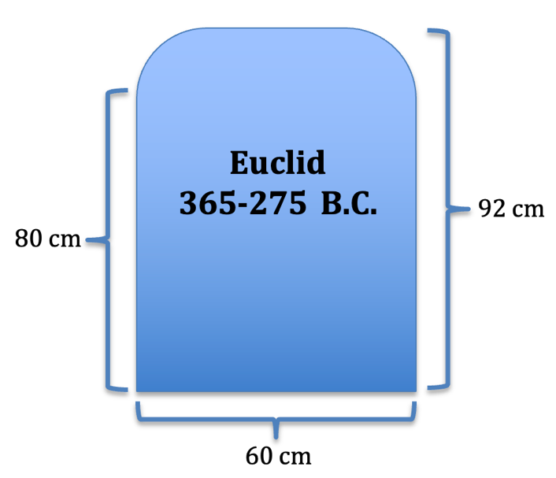

What are the perimeter and area of this tombstone?

If the tombstone is 10 cm deep, what is its volume?

- Yin and Yang. The diameter of the largest circle below is 16 cm. The nine labeled points are equally spaced.
- What is the total length of the arcs in the figure? Show all steps carefully labeled.
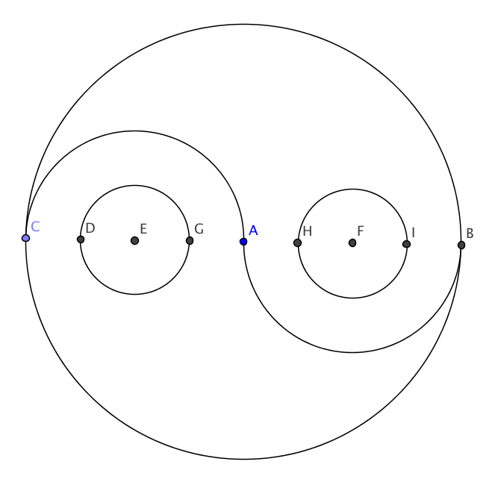
- What is the area of each of the four regions? Show all steps carefully labeled.


The Google Chrome logo at right has a diameter of 3 cm and the blue and white center has a diameter of 1 cm. What is the area of the yellow region?
red
yellow
green
blue

What are the area and perimeters of these shapes (make your own measurements)?

Use a metric ruler to find the lengths needed to find the area for each of the figures below. USE UNITS. Before you begin, estimate the area and, afterward, compare the answer you find with your estimate. Write any measurements neatly in place (mark the lengths that you measure). USE UNITS for measurements (linear) and answers (area)! Show all steps, but feel free to use a calculator.
Estimate: ________
Estimate: ________
Estimate: ________
This is the same triangle. Use a different base this time.
Estimate: ________
Estimate: ________
Estimate: ________
Estimate: ________
Estimate: ________

You have a parallelogram. Its sides are 8 cm and 13 cm.
  - Why is it not possible to determine its area?

  - What is the biggest its area could be and why?

- How many milliliters are in a liter?

- How many decigrams are in a kilogram?

- How many inches are in a foot?

- How many square inches (in²) are in a square foot (ft²)?

- How many square centimeters (cm²) are in a square meter (m²)?

Draw a trapezoid and write down lengths so that the trapezoid has an area of 100 cm².

Muizza’s Hula Hoop Emporium sells Hula Hoops. If she has a six foot long piece of tubing that she connects into a hoop, how wide will the hula hoop be?

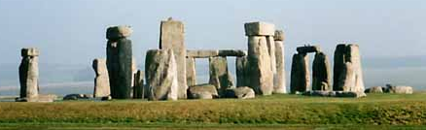
Stonehenge is a circle of massive stones in Southern England. The circumference of the outer ring of stones is 348 feet. What is the diameter of the circle? What is its radius?

The region at right is made up of a rectangle and a semicircle.
What is the perimeter of the shape?
30 mm
37 mm

What is the area of the shape?

I want to measure a tree’s diameter, but it is difficult to do so accurately so I wrap a string or tape measure around the trunk. The trip around the trunk measures 7.3 meters. How wide is the tree?

Find the area and perimeter of this figure: 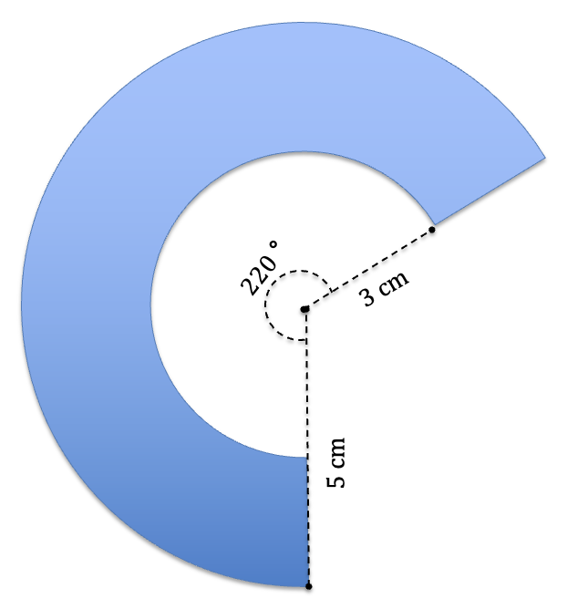

What is the length of the side of a square whose perimeter and area are the same (ignoring the fact that their units mean different things)?

What is the radius of a circle whose circumference and area are the same?

Jen claimed that a triangle was really just a special kind of trapezoid with one side and the opposite vertex “parallel” and that she could use the trapezoid area formula to find the area of a triangle. Rowena was skeptical and asked Jen to find the area of a triangle with a base of 4’ and a height of 6’ using the trapezoid formula. Show how Jen would do this.

What is the perimeter of this figure?
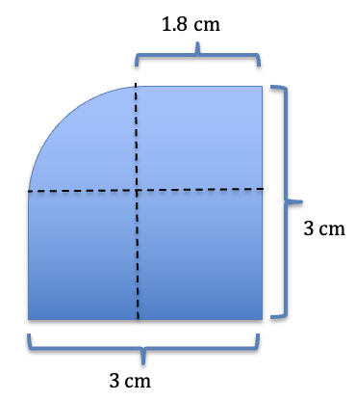
This shape is symmetrical. What are its area and perimeter?

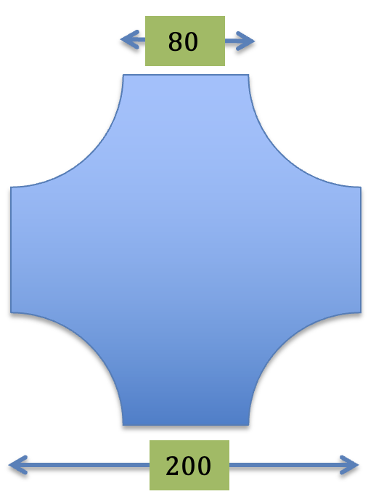

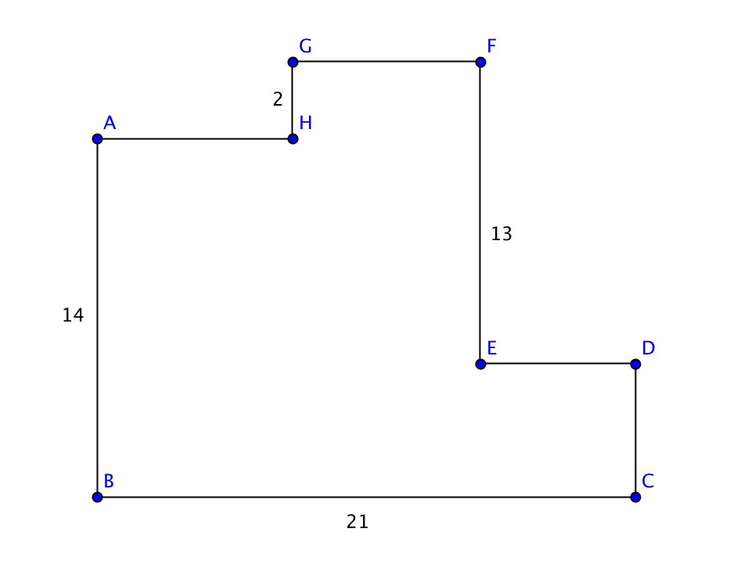
What is the perimeter of this figure? All angles are right angles. There is enough information!

What is its area?

What are the perimeter and area of this figure?

The area of a parallelogram is 420 mm². It’s sides are 20 mm and 60 mm. What are the lengths of the two different heights? Sketch an approximately scale version of it.

A photograph is similar to its original subject. If the distance on Mount Rushmore between Jefferson’s pupils (pictured here between George Washington and Teddy Roosevelt) is actually 54 feet, how high is Lincoln’s head (far right) from the base of his beard to the top of his hair? Take measurements from this photograph and show all steps in your work.

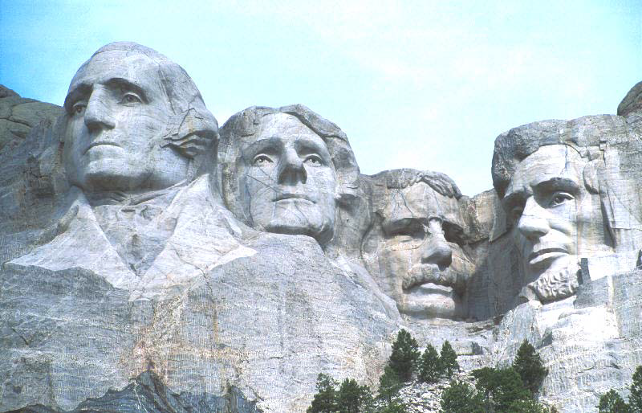
54’

The perimeter of this rectangle is 46 m. What is its area? Your answer should be a number (and not include X).
X
X + 3

The perimeter of this figure is 74 cm. What is the area (you do not need x in your final answer)?

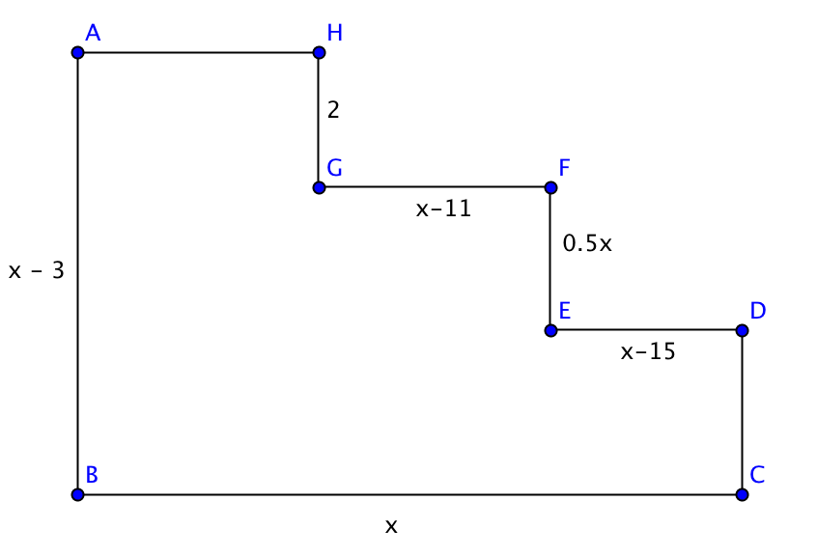

14 mm
What is the total length of wire needed to make this peace sign?
The dot is at the center of the circle.

Circumference | Radius | Area | Diameter
 |  | 88 cm²
 |  |  | 14 m
 | 0.2 in
20π
 |  | B
 |  |  | 2W
 | Z
Y

Grandiose Gabe of the Large-scale-Object-Using Department (LOUD) wrapped a metal band around the equator of the Earth (see diagram below). Wanting to improve on the aesthetic qualities of the work, he added a segment to the band such that it was now 1 meter above the earth’s surface for the entire trip around the globe. What is the length of the segment which he added?
Hint: Amazingly, you have all the information you need to know.
Do pretend that our planet is a perfect sphere (no hills or valleys, etc. to consider).
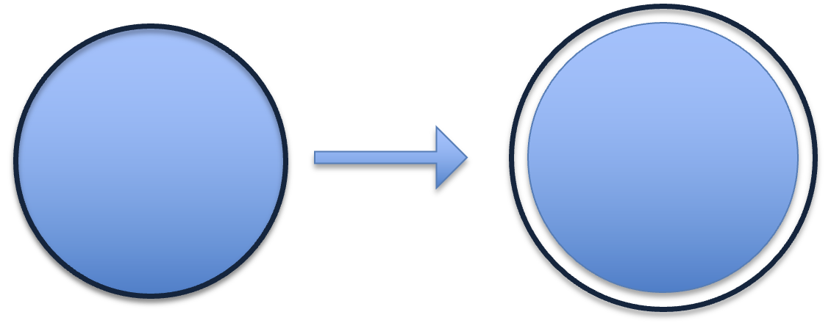
Find the area of the shaded region. Show all calculations and units in an organized fashion.
20 cm m

20 cm m
Find the area of the following shaded region. The inscribed figure is a square.

