Quadratic Formula Proof – graphically motivated without completing the square

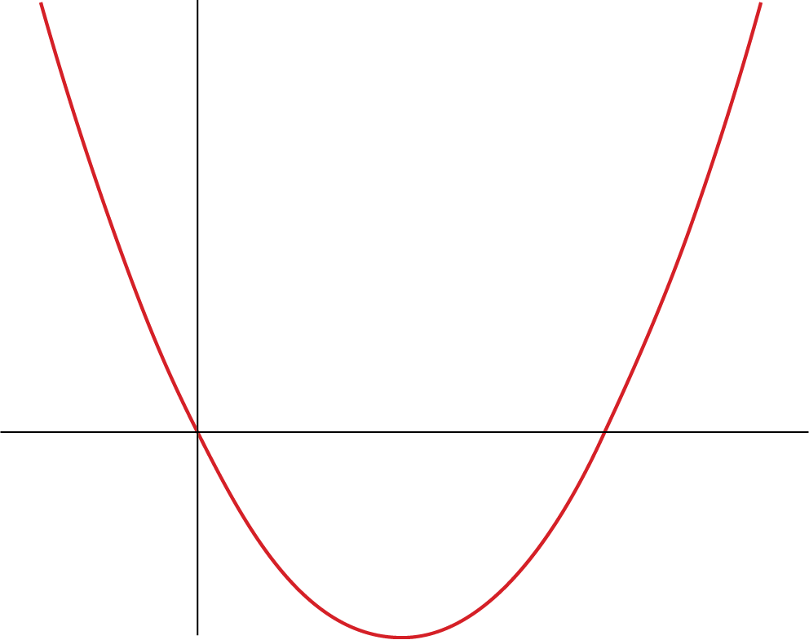
Theorem: $ax^{2}+bx+c=0 has solutions x=\frac{-b±\sqrt{b^{2}-4ac}}{2a}$
y = ax² + b
a>0, b<0
Graphically, the quadratic formula finds the x-intercepts of
$y=ax^{2}+bx+c$. This proof will mix algebraic and graphical thinking. Let’s begin with the simpler equation $y=ax^{2}+bx.$
Setting $y=0$ and factoring yields $0=x\left(ax+b\right).$
The roots of these factors are $x=0, -\frac{b}{a}.$
The Vertex
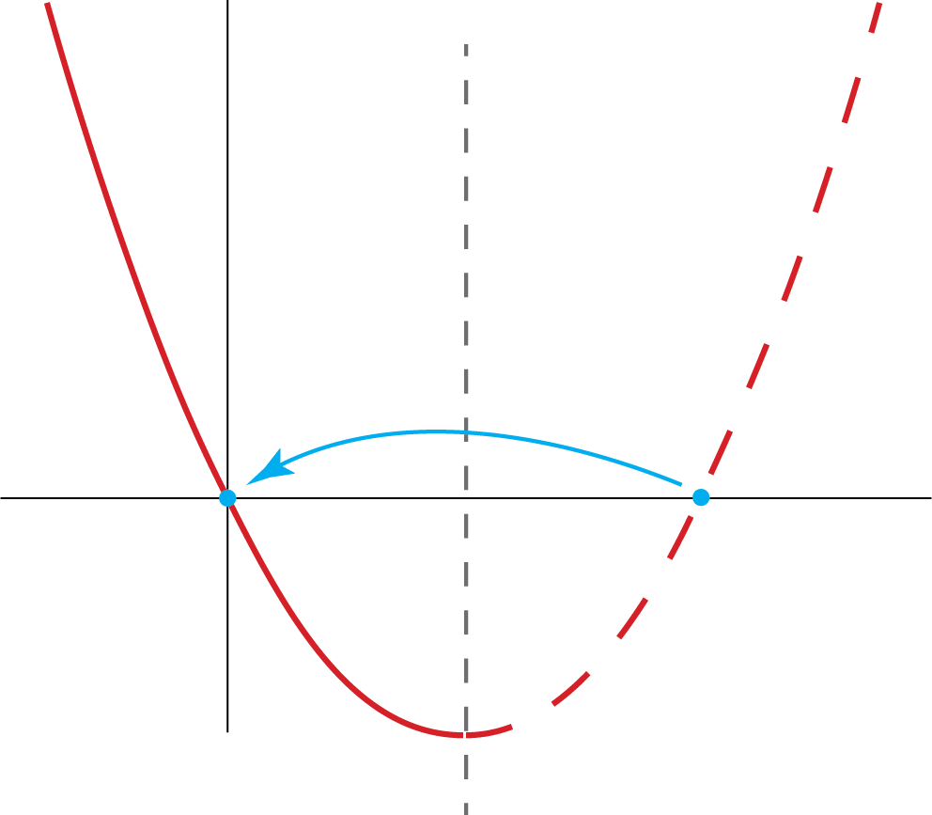
The graph of $ax^{2}+bx+c=0$appears to be symmetrical with a minimum (a > 0) or maximum (a < 0), which is called the vertex. Let’s prove these observations about parabolas.
Lemma The graph of $y=ax^{2}+bx$ has a vertex, or extreme value (minimum or maximum), at $x=-\frac{b}{2a}$.
If the parabola is symmetric, then the x-coordinate for the vertex would be at the midpoint of the roots (since they are matching points if we fold the parabola over its axis of symmetry.
The midpoint (just an averaging of the coordinates of the roots) is at $x=\frac{0 + -\frac{b}{a}}{2}=-\frac{b}{2a}$.
If that is, in fact, the vertex, it has to be a minimum or maximum.
What is the y value for our presumptive vertex? Let’s plug the above x-coordinate into $y=ax^{2}+bx$:
$y=a{\left(-\frac{b}{2a}\right)}^{2}+b\left(-\frac{b}{2a}\right)=\frac{b^{2}}{4a}-\frac{b^{2}}{2a}$, which is $\frac{1}{4}\frac{b^{2}}{a}-\frac{1}{2}\frac{b^{2}}{a}= -\frac{1}{4}\frac{b^{2}}{a} or \frac{-b^{2}}{4a}$.
These calculations give us a candidate point for the vertex at $\left(-\frac{b}{2a},\frac{-b^{2}}{4a} \right)$, so let’s look at the y-coordinates for all other points $x=\frac{-b}{2a}+k, k≠0:$
$y=a{\left(-\frac{b}{2a}+k\right)}^{2}+b\left(-\frac{b}{2a}+k\right), which simplifies to y=\frac{-b^{2}}{4a}+ak^{2}$.
The first term of this sum is just our vertex’s y-coordinate, so all other points differ from it by $ak^{2}.$ That is cool for two reasons. One, the second term is just the equation for a parabola all over again, but in terms of $k$, our distance from the vertex horizontally. We also see, since $k^{2}$ is always positive, that if a is positive, all other points will have a y-coordinate that is greater than the vertex’s. The vertex is indeed the minimum. If a is negative, all other points will have a y-coordinate that is less than (below) the vertex’s. The vertex is the maximum.
Note that $y=ax^{2}+bx+c$ is a vertical translation of $y=ax^{2}+bx$ and so it has the same x-coordinate for its vertex (and the y-coordinate is just c higher).
Corollary to the Lemma The graphs of $y=ax^{2}+bx$ and $y=ax^{2}+bx+c$ have horizontal symmetry.
We saw in the lemma that the coordinates for points, in terms of their horizontal distance k from the vertex, are $\left(\frac{-b}{2a}+k,\frac{-b^{2}}{4a}+ak^{2}\right).$ If we pick corresponding positive and negative values for k, we get the same y-coordinate, because the negative value is cancelled out by the square of k. For example, k = 3 and -3 produce $\left(\frac{-b}{2a}+3,\frac{-b^{2}}{4a}+9a\right)$ and $\left(\frac{-b}{2a}- 3,\frac{-b^{2}}{4a}+9a\right).$ So all points on the parabola have a symmetrical point over the vertical line $x=\frac{-b}{2a}.$
Note again that the vertical translation by c does not impact the symmetry of the graph.
The Main Proof
Since the two roots of $y=ax^{2}+bx+c$ have the same y value, they are symmetrical with regard to the axis of symmetry and can be expressed as x = $\frac{-b}{2a}±k.$ Given those roots, we can write the original equation in this factored form: $y=a\left(x+\frac{b}{2a}+k\right)\left(x+\frac{b}{2a}-k\right)$. Expanding and simplifying, we get: $y=ax^{2}+bx+\frac{b^{2}}{4a}-{ak}^{2}$.
Comparing this result with $y=ax^{2}+bx+c$, we see that $c=\frac{b^{2}}{4a}-ak^{2}$. Solving this equation for k, we get $k^{2}=\frac{b^{2}}{4a^{2}}-\frac{c}{a}=\frac{b^{2}-4ac}{4a^{2}}$ and $k=\frac{±\sqrt{b^{2}-4ac}}{\sqrt{4a^{2}}}=\frac{±\sqrt{b^{2}-4ac}}{2a}$. Lastly, we substitute this value for k (which, remember, is how far each root is from the symmetry line) into x = $\frac{-b}{2a}±k$ to yield x = $\frac{-b}{2a}±\frac{\sqrt{b^{2}-4ac}}{2a} or x=\frac{-b±\sqrt{b^{2}-4ac}}{2a}$. Q.E.D.

This work © 2025 by Joshua Abrams/Making Math is licensed under CC BY-NC-SA 4.0

