The Initials CUBE My initials ____________
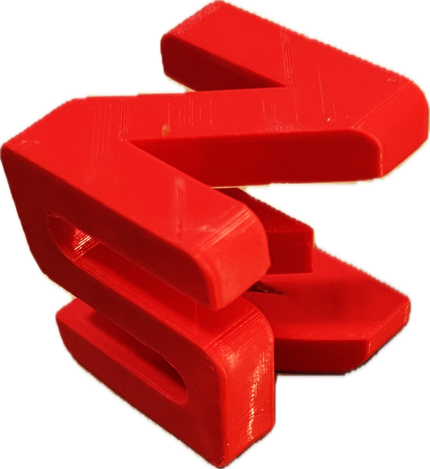
You are going to make a cube whose three orthographic projections or shadows are your initials. At right is an example of an initials cube with the initials S.N.E. (in this image, the “E” is not so visible from the right).

To make an initials cube, you will make a sketch in OnShape for each initial in your name and make them outlines of the needed letters.

For example, an A could look like one of these:
A A 
Tips:
- Sometimes, even though your two-dimensional outlines may look fine, when the three-dimensional structure is completed, there are important portions that are not connected (and so there is not a single object you can 3-D print). You can often avoid this difficulty by designing outlines that fill up as much of their square (see below) as possible. So aim for a boxy version of your letters, such as:
- Sometimes, the individual letter designs are fine, but their orientation in the cube matters and rotating one of them 90° in their square will fix a problem of unattached bits.

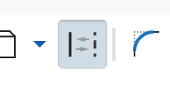
To set up for each of your three sketches:
Construction tool
- Select the construction tool so that the shapes you are about to draw are just guides. They will appear dashed and will not be an actual part of your design.
- Use the Center Point Rectangle tool and draw a square that has its center at the origin (the point where the axes intersect).
- Dimension the square to be 10 cm x 10 cm.
- The square should now be a dashed boundary that looks like this

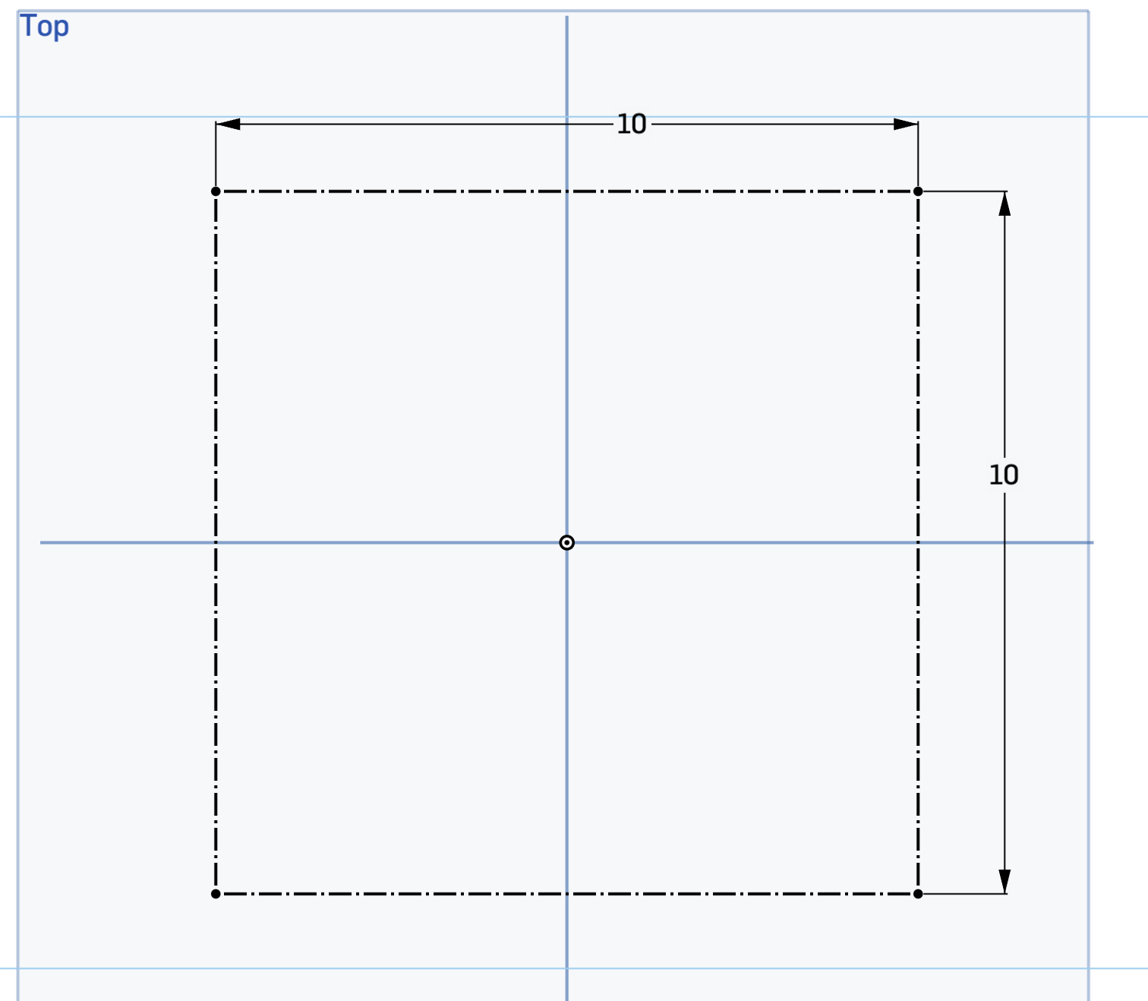
If you have more than three initials or only two, pick three representative letters that you like. Sketch each of your initials in a different plane:
- Your first initial in the Top plane,
- Your middle initial in the Front plane, and
- Your last initial in the Right plane.
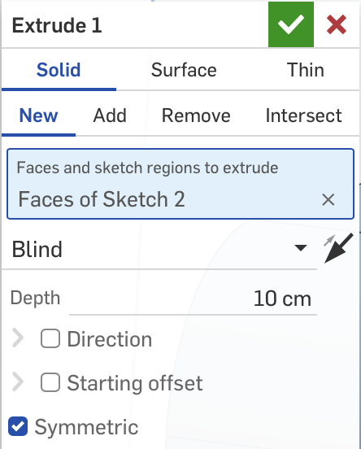
Extrude your first initial as a New one with the Symmetric option checked and a Depth of 10 cm.
Then extrude the second and third initials in Intersect mode and the same Symmetric and Depth settings.

Extruding symmetrically for 10 cm will extend your surface in 5 cm each above and below your sketch plane.

