Sketching Tools and Constraints Name ______________
For each of the options below, test the soundness of the design as you add elements by clicking off any tool and using the arrow cursor to click on points and drag them. If the whole design retains its proportions and relationships, it is well-constrained and dimensioned.
Constraint tools that might be particularly helpful for these designs are the parallel, equal, perpendicular, and tangent tools. Tangent makes sure an arc meets a segment at the same angle as the segment. You can also dimension lengths and angles. To dimension an angle, click on two segments that are not parallel and then click and edit the angle measure.

If you use construction lines (dashed lines that can guide your design without being a part of it), adding midpoints with the point tool might be useful. You can also make half of a figure and then use the mirror tool to reflect it over a construction line to make a symmetrical shape:

- Sketch a simple house (square with triangular roof). Use constraints to make it perfectly symmetric and ensure the roof triangle is centered on the square base. Once you have your house’s basic outline, add a couple of windows and a door. The windows should be the same size and placed in line with each other. How about a chimney or other features?
- Do any of the outlined letters, numbers, or symbols here (all of them, except for the final simplified dartboard design should be extrudable and still look correct):
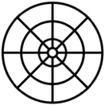


A B C D E F G H I J K L M N O P Q R S T U V W X Y Z 1 2 3 4 5 6 7 8 9 0
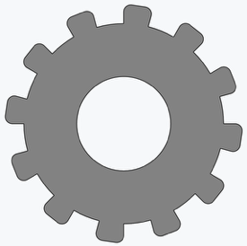
- Create a sketch of a traffic light with three circles stacked vertically with equal spacing. Constrain them to have equal diameters and align their centers vertically.
Challenge (once you have done one or more of the above): Create a gear with several teeth. You will want to learn about circular patterns first: https://cad.onshape.com/help/Content/sketch-tools-circularsketch-pattern.htm?Highlight=circular%20patterns

