GeoProof Studio Teacher’s Guide

Contents
The Nature of Proof and How GeoProof Studio Supports Effective Thinking
Some of the Ways Proofs Are Not Linear
Lemmas
Templates For Customizing GPS For Your Classes
Templates for Activities
Proof Practice and Projects
Teaching the Program

The Nature of Proof and How GeoProof Studio Supports Effective Thinking
Proofs in mathematics are typically presented in prose form with symbolic and graphic representations interspersed. This format is inherently linear, which means the often-complex pathways within a proof are wedged into a single narrative. However, most proofs of any complexity have parallel strands of reasoning and may require multiple conclusions. While experienced mathematical readers can keep these different strands in their proper relationship, student mathematicians benefit when the actual structure of a proof is made explicit with a two-dimensional format such as a flowchart.
Another challenge students face when developing their own proofs is keeping track of the requirements of a theorem or postulate and being sure that they have actually demonstrated that all premises have been met and their conclusions are fully supported. In high school classes, students are often taught a two-column format to make clear what their claims are and how they are justifying each one, but this linear format does not reveal which claims follow from which prior claims.
GeoProof Studio (GPS) was developed to address these and other objectives:
- GPS is built around a layout that reveals the detours, splits, and merges of the different paths in a proof.
- GPS guides students to make the connections between claims visible and to be sure that the information generated by one claim is of the same type as that required for the next.
- GPS provides a library of definitions and theorems that encourages students to explore a range of possible directions that they can pursue from whatever point they have reached in a proof.
- Lastly, linear presentations suggest that mathematicians start at the beginning of a proof and work inexorably to the end. This appearance is why so many proofs seem to have magical deus ex machina moments that make the reader ask, “How did they know to introduce that expression there?” The actual experience of constructing a proof is that we don’t just work from the beginning to the end. We work forward from the beginning and backwards from the end and try to get them to meet in the middle. So, in working backwards from the end, we often see some needed intermediate step that inspires the introduction of those seemingly out-of-the-blue steps.
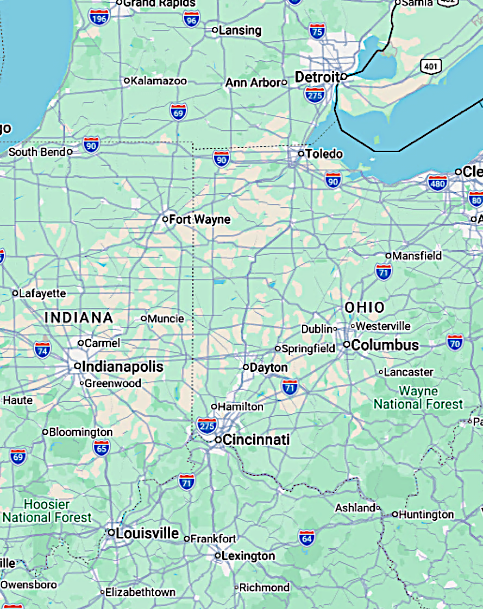
The initialism “GPS”, which also stands for the Global Positioning System that powers our navigation tools, should emphasize for students that we are looking for paths from one place to another. You can show them a map and pick two locations and ask how they would get from one to the other. For example, to get from Louisville to Ann Arbor in the map at right, one would not just look at the many routes that leave Louisville, one would also work backwards from Ann Arbor and look for promising ways to approach it and then see where your options meet in the middle. You might also look for landmarks along the way. I love sharing this analogy for thinking about proofs with students. It emphasizes that there is more than one answer, that is, more than one path for a proof. The Pythagorean Theorem Proof Project (makingmath.org/geometry) is a great example of this idea as it presents over one hundred different proofs of the same theorem for students to analyze.
Some Ways Proofs Are Not Linear
Compound Conditional Statements
The most common cause of parallel strands in a proof’s structure is a justification that has more than one component for its premise. These justifications are conditional statements in the form if A and B (and C), then D. In geometry classes, triangle congruence theorems and the transitive property of equality appear frequently and require multiple strands of deduction before they can be employed.
Suppose you are using the SAS Theorem to show two triangles congruent. The proof must establish:
- a pair of corresponding congruent sides,
- another pair of corresponding congruent sides,
- and corresponding congruent included angles.
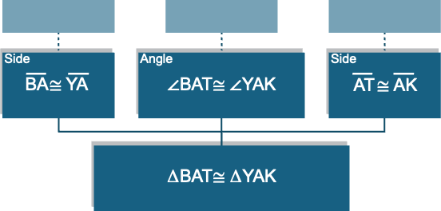
Those three facts may arise from completely different sources: segments might be congruent due to a midpoint, another side pair might follow from a prior triangle congruence, and the angles might be vertical angles. These three premises are not a single logical chain. They are three strands gathered together when SAS is invoked.
The linear presentation might be:
$\overline{BA}≅\overline{YA}$ since A is a midpoint. $\overline{AT}≅\overline{AK}$ by CPCTC. $∠BAT≅∠YAK$ because vertical angles are congruent. Therefore, $∆BAT≅∆YAK$ by SAS.
This format can make the statements look more sequentially dependent than they really are. A flowchart diagram, as shown above, reveals that none of the three congruence facts is related to the others.
Case-by-case Proofs
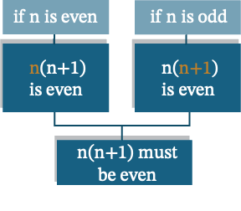
Some arguments require considering different possible starting points. Each premise in a theorem involves a set of objects, and subsets may have distinct characteristics that require special attention. For example, a claim about quadrilaterals may require consideration of both convex and concave instances. When there is a case-by-case proof, those cases are considered separately and then merge in the final conclusion. Here is an algebraic example:
For every integer $n$, the product $n\left(n+1\right)$ is even. We consider the two possibilities: $n$ is even or $n$ is odd;
- If $n$ is even, the first factor of $n\left(n+1\right)$ is even, so the product is even.
- If $n$ is odd, $n+1$ is even, so the product is even.
A conventional proof presentation lists the cases one after another, but logically they sit beside one another. No case depends on the case preceding it.
Claims with Multiple Conclusions
Just as streams of logic frequently merge in a proof, they can also split and head in different directions. Many theorems can support multiple new claims. Just as triangle congruence requires three pieces of information, it also produces three new congruences (the three not used to prove congruence) through the theorem that corresponding parts of congruent figures are congruent. I present this bonanza to students as the “Get Three Free!” pattern.
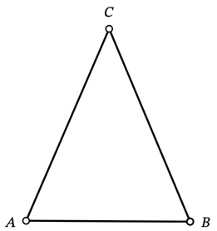
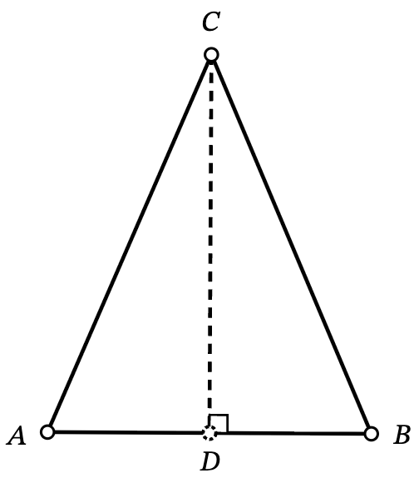
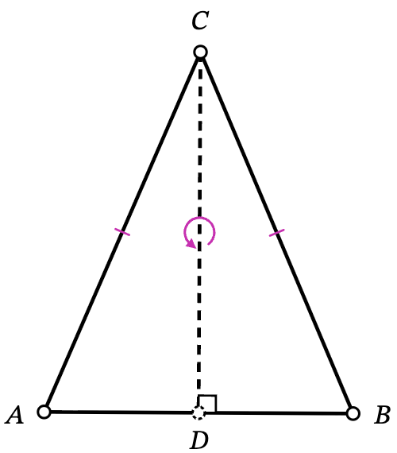
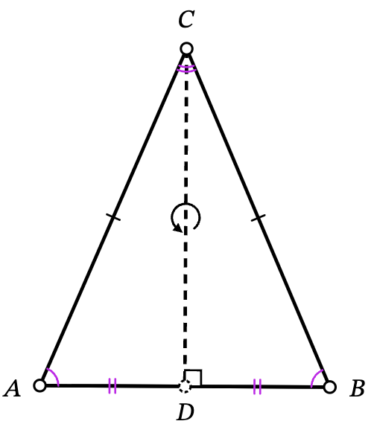
In the diagrams below, we see the steps in proving the Base Angles of an Isosceles Triangle Theorem. We start with an isosceles triangle and drop an altitude. In the middle diagram, we see that we have the information needed for the Hypotenuse Leg Triangle Congruence Theorem, so ∆ACD $≅$ ∆BCD. Given that congruence, we have (by CPCTC, CPCFC, or whatever your preferred initials are) three new congruences: the base angles we sought to prove, segments $\overline{AD}$ and $\overline{BD}$, and the two angles at the apex C.
Those final two congruences provide the opportunity to make two corollaries. Because the congruent segments make D a midpoint, the altitude is also a median. Because the angles at the apex are congruent, the altitude is also an angle bisector. A corollary is an extra result that can be readily demonstrated from another theorem. Teach students about corollaries and lemmas (discussed below) as theorems that have a particular relationship to the theorems that they consider their main results.
Here we see the proof fanning out toward three different deductions:
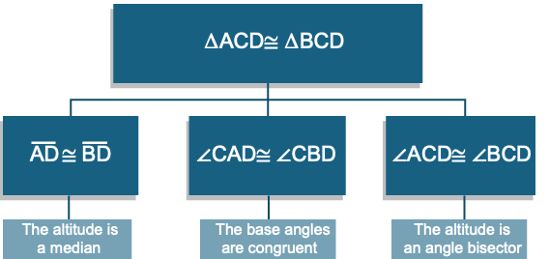

The Nonlinear Nature of Our Thinking
Even if the finished product for a proof is linear, the process is rarely so straightforward as “start at the given and work unidirectionally toward the conclusion.” As the Louisville to Ann Arbor analogy demonstrated, we often work backwards from our goal. We may hop around to guesses about intermediate steps that we can’t yet connect to either our givens or conclusion. In Proof Mode, students are required to enter their Givens and To Prove(s) first, but, after that, they can proceed in any direction. Encourage them to:
- Consider which claims might immediately precede their conclusion (what roads might lead into Ann Arbor?). Then back up one more step from those possibilities. They can drop claim boxes in the next-to-last column, even if they don’t know what justification will be needed. Justifications, connections, and even claims can be left incomplete. GPS requires some text in the claim, but “hmm” or a note is allowed.
- Anticipate what might be important milestones and add columns and drop claim boxes in the middle. If these prove to be useful, they will shorten the distance between claims that need to be linked, creating, in essence, a few mini-proofs.
- Add claims that follow directly from the givens. A search in the justifications library can help provide ideas (e.g., if they are given parallelism, many possible claims could follow). If some of these Column 2 claims end up unused, they can be deleted later on. Being willing to brainstorm and branch out yields more possible paths to success.
When writing proofs, mathematicians have ways to capture the nonlinear structure of their argument when it diverges from a simple chain of reasoning. They can include lemmas, put connected portions into separate paragraphs, label different cases, or point out how parallel arguments are being organized with phrases such as “it remains to be shown next…” and “combining these results…”.
Lemmas
A lemma is a theorem that is not the main purpose of a project. It is a helper result needed in the service of a theorem that is of greater interest or importance. Lemmas serve a number of purposes. As with any theorem, once they are proven, we no longer have to lay out the argument in their favor each time we use it – it is a reusable tool. For example, the claim that two congruent angles forming a linear pair must be right angles has a short, straightforward proof. That result might be needed more than once in the course of a proof involving perpendicularity. Rather than repeat the steps of the argument each time it is needed, the writer can name and cite the lemma in a single step. Lemmas make proofs more readable and allow readers to focus on the larger structure of the proof while avoiding losing track of the main ideas attending to smaller details.
If a student needs a result that has already been proven (by the student or a classmate), then it can be added to the Justification Library with a name that gives credit to the creator of the proof (e.g., “Malik’s Lemma”). It is an exciting moment in a classroom when one student can use another student’s work in their own. It is not cheating! It is how mathematics works with each mathematician building on the discoveries that have come before. Building this kind of mathematics community in your classes leads to positive and uplifting interactions that further everyone’s mathematics understandings and accomplishments.
Templates For Customizing GPS For Your Classes
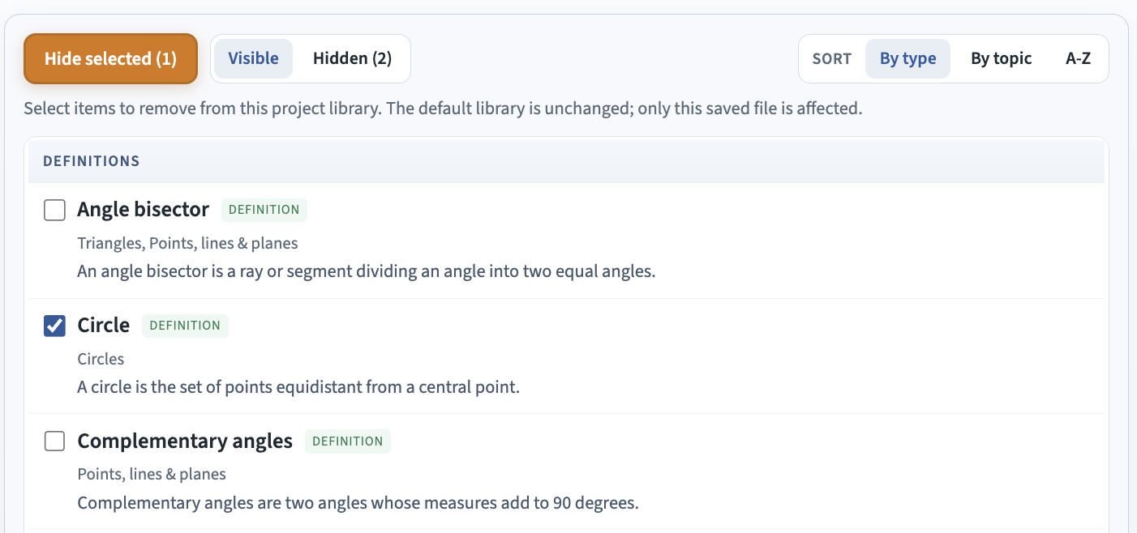
GPS comes with a library of definitions, postulates, properties, and theorems that reflect a certain set of goals and sensibilities. While it includes many standard triangle congruence proofs, a friend of mine and her colleagues at St. Mark’s School (Southborough, MA) base all triangle congruence claims on triangle similarity postulates with the scaling proportion equal to 1. This approach puts the often-underemphasized ideas and applications of similarity front and center while greatly reducing the number of theorems students need to sort through. With an approach like this one, teachers would want to go into the Justification Mode, search for the congruence theorems that they don’t want in their core list and hide them. Likewise, if your class has not studied certain topics and you simply want a smaller library, you can also use the Hide Items button in the Justifications mode. To do so, scroll through the entire list of justifications and check off any you want to remove. You can sort the list by type, topic, or alphabetically using the buttons in the upper right corner of the window. Be sure to click the orange “Hide selected (#)” button to finalize your choices. Hidden items are never permanently removed. If you want to review the hidden items, click the “Hidden (#)” button (circled in blue above). You can then see what is hidden and unhide items by checking them off and clicking on the Restore selected button that will appear.
The list of hidden justifications will be saved in .geoproof files. Students are able to unhide items, but that is not the point. The purpose is to declutter what they search through as they work or to hide versions that you have replaced with similar results with language that matches the text or work your class is doing. You may also want to hide theorems that the class is going to discover and prove themselves. Remind students to open any provided template file prior to starting each proof effort – there is no way to transfer a diagram or a proof after the fact, so working within a template file and then saving it to a new name specific to the work they are doing is essential.
Just as a teacher may want to hide certain results that they would like their class to discover for themselves, they may also want to add in items that were omitted from GPS (e.g., the many circle theorems that you might want students to discover). There is a lot of flexibility in terms of how to craft a starting library that works for your classes’ specific needs at different times in a course. You can share a new starting template that includes students’ theorems once there are a number of them.
Templates for Activities
Saved .geoproof files can also serve as practice exercises. Share an incomplete proof with students and ask them to complete the missing components.
- You can provide a file that contains a proof and ask students to provide the diagram that fits the proof. To make this file, you will need to make a diagram, enter the proof, and then delete the diagram with the Clear All button.
- You can provide a file that contains a diagram and parts of a proof. You can include all claims and justifications, but no connections and ask students to make the right connections. They will need to attend to type and meaning. The file IsoscelesTriangleAltitudeTheorem-NoConnectors.geoproof is an example of this kind of task.
- You can make a task more challenging by switching a few of the claim boxes in the middle columns around, so students need to reorder the claims. The file IsoscelesTriangleAltitudeTheorem-NoOrder.geoproof takes this idea to extremes. The Givens and To Proves remain in place, but the intermediate claims are all stacked in a single column.
- You can provide a file that containsa diagram and proof sequence of claims but without any justifications or connections as shown in IsoscelesTriangleAltitudeTheorem-NoJustifications.geoproof.
- You can share a proof with mistaken claims, some identified by GPS (such as incorrect/out-of-order angle or triangle labels) and some not caught (e.g., just the wrong claim or justification altogether), and ask students to find and fix the errors. You can let them know how many errors there are to catch.
- You can come up with all sorts of partial and mixed versions of the above ideas.
Notes:
- If a proof is incomplete (lacking justifications and/or connectors), the 4-column format will show those gaps with a “--” and you can share that format as a paper-and-pencil version of the fill in the gaps tasks described above.
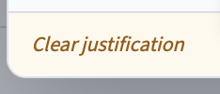
- Once you have made a complete proof to use for an exercise with missing parts, you can remove a connection by clicking on its right endpoint; move a claim box with its grab bar; or remove a justification by clicking on the claim box and then the current justification and then the “Clear justification” button in the lower left corner of the Choose Justification window. You can remove several justifications without clicking the Save changes button. Once a justification is removed, that change is automatically saved, so you can just click on the next claim box and keep removing justifications efficiently.
Proof Practice and Projects
For practice proofs, you can provide a sequence of proofs that build on each other that students can work on individually or in pairs. Possible sequences are:
- Prove that the opposite sides of a parallelogram are congruent (hint: draw a single diagonal as an auxiliary line).
- Using 1), prove that the diagonals of a parallelogram bisect each other.
- Prove the converse of statement 2): if the diagonals of a quadrilateral bisect each other, then it is a parallelogram.
Or:
- Prove that an altitude to the hypotenuse of a right triangle creates two triangles similar to the original.
- Using 1), prove that the square of the length of the altitude equals the product of the lengths of the two segments determined by the point where the altitude hits the hypotenuse.
Or:
- Prove that the base angles of an isosceles triangle are congruent.
- Using 1), prove that every point on the perpendicular bisector of a segment is equidistant from the segment’s endpoints.
- Prove the converse of statement 2): every point equidistant from the endpoints of a segment lies on its perpendicular bisector. Hint: you can’t draw the perpendicular bisector through the point, since that would be assuming what you are trying to prove, so you need to only construct a segment that is a candidate for the perpendicular bisector (e.g., either a median or an altitude) and prove that the other property results.
- Using 2) and 3), prove that the three perpendicular bisectors of a triangle’s sides are concurrent (meet at a single point). Hint: you cannot draw all three bisectors mutually intersecting, because that would mean you are assuming that they are concurrent before you have proven that. So, you need to draw two (how do we know those two must intersect and are not parallel?) and then show that the segment from that point of intersection to the third side can be the perpendicular bisector.
Coordinate Geometry establishes relationships based on coordinates, equations for lines, and other algebraic methods. Some theorems are much easier to prove using coordinates, while others lead to ghastly and unwieldy algebra. Synthetic Geometry does not use coordinates (as it was the geometry of Euclid long before Descartes and coordinate systems existed). Instead, it relies on triangle congruence, similarity, parallel-line relationships, and other geometric tools. For many theorems, it provides the more elegant approach. Some theorems, such as the midsegment theorem for triangles, can be readily proven with either system.
Triangle congruence proofs have three distinct premises and so naturally require parallel strands of reasoning that GPS is designed to highlight. GPS is not particularly structured to support coordinate geometry proofs (it does not have tools for presenting roots and rational expressions). Teaching both synthetic and coordinate geometry gives students a powerful and varied toolkit that they can bring to geometry proofs. Students don’t need to be told which to apply. Let them try one and if it does not yield a proof, they can try the other system. Making these decisions themselves will help them build up their understanding of the strengths of each and their intuition about which to try first.
The Pythagorean Theorem Project and Quadrilateral Properties projects described in the MakingMath.org Geometry page both provide numerous opportunities at different levels of difficulty allowing you to help students work at the level that they are next ready to tackle. They are authentic differentiated instruction where the curiosity of the student and sophistication of their conjectures automatically present them with the next challenge with which they can succeed.
Teaching the Program
There are different class activities that you can use to introduce students to using GPS. For Diagram Mode, you can start by asking students to create a picture (not a geometry diagram) that uses as many tools as possible with at least this breakdown:
- At least 3 tools from among the basic and triangle clusters
- At least 2 quadrilaterals
- At least 2 constructions
- At least 1 mark (they will have to be creative to make it a meaningful part of the theme of their picture)
- Use the paint tool to introduce at least 2 other colors into the picture
- Use the text tool to rename points so as to spell a word (they can even add points and make a sign with their labels)
After this productive play time, you can hand out sample diagrams that you have made in GPS and ask them to recreate them. Have them save their efforts. Note that saved files will typically automatically download, but can be renamed as needed after the fact. Because GPS runs in a browser, clicking on files will not launch the program. Files need to be loaded using the Open buttons in GPS.
For proof Mode, you can give them an image of a proof based on one of the diagrams that you had them replicate and give them practice entering the claims and making connections.
For the Justifications library, have students find one theorem or definition that they are familiar with and one that the class has not explored yet and share out what they find.
Once students are comfortable enough with the program, they are ready to start working on exercises and their own proofs. Be sure to emphasize the importance of starting a new file by entering the Theorem Name and Theorem Statement at the top of Proof Mode.
Additional Notes
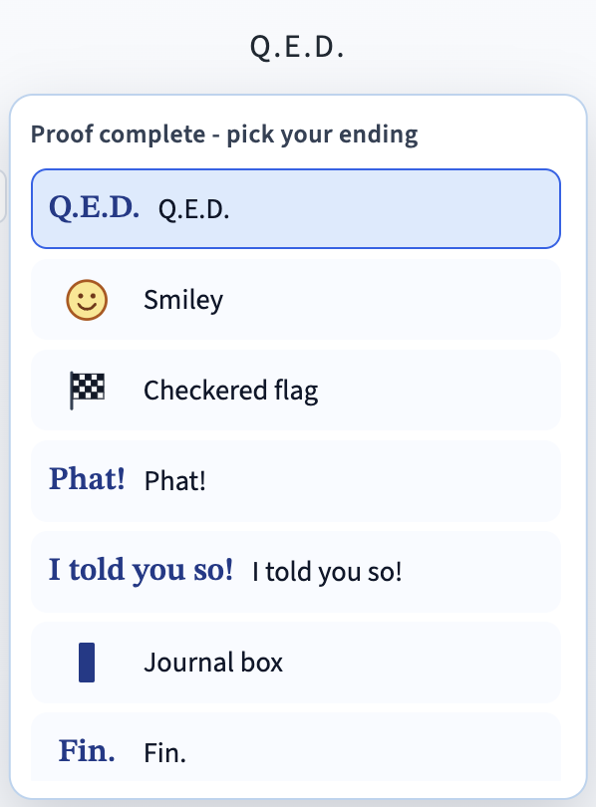
- When a student has completed all justifications and connections to premise ports, they are offered the option to add Q.E.D. at the end of their proof (at the bottom of the final column). Q.E.D. stands for "quod erat demonstrandum", which means "that which was to be demonstrated". It means you had a goal and you reached it. Q.E.D. is a celebratory notation and students should be encouraged to feel like they are putting a stamp of approval on their work (at least once their peer mathematics community agrees that the reasoning is all sound). For most of the history of formal mathematics, Q.E.D. was the standard note that the proof was finished. Later in the 20th century, the custom in mathematics literature shifted to ending a proof with a black rectangle, , but that strikes me as a dry, typographic ending. One of my students once ended a proof with “Phat!” (which means “excellent”) and I liked that personalized approach and encourage my students to develop their own ending style. In GeoProof Studio, once the Q.E.D. ending is added, the user can click on it and the menu at right appears and provides other options for concluding the effort. If a student has a good idea for any addition to the menu, please submit it to Making Math and we will consider an update.
- When reviewing a student’s proof:
  - Be sure to discuss any dashed override curves. There are situations when the type of the information between claims is confusing and the shift from one type of information may be acceptable. The dashed lines only show on the screen and print out as solid.
  - If a student labels objects without lining up the corresponding points, ask them to tell you the correspondences out loud (A↔D, B↔E, C↔F) before writing triangle, angle, or segment congruence claims.
  - One of the mantras of mathematics is “an example is not a proof.” Similarly, a diagram is not a proof, even if it is carefully constructed and dynamic. A dynamic construction is moveable and provides numerous examples – but see the first sentence of this paragraph. Those examples offer evidence for a conjecture; they do not prove it. Nonetheless, it is still worth constructing accurate diagrams, so that there will be more visual clues as to which segments or angles might be congruent, but that doesn’t mean they will always be. Let a diagram provide hints, but don’t make assumptions (e.g. that an altitude seems to hit a midpoint doesn’t mean it has to be a median).
  - Students will often, in written proofs, declare auxiliary lines with multiple properties (“construct the angle bisector through the midpoint of the opposite side”). GPS helps them avoid this tendency, because, as they enter that construction step in their proof, they are unable to find a justification that matches it. The justifications available for constructions are all about a single property (a line that is parallel, a line that bisects an angle, etc.), but not more.
- Students can export four-column PDFs and then print them out for their notebooks or portfolios. They can save Proof Mode, multi-column PDFs for printing and taping together for posters and wall displays. They can save Proof Mode HTMLs and print single-page versions from a browser.
- When a definition is added to the Justifications library, it is preferable to add the language for both directions of the definition. For example, “If a figure is a chevron, then it is a concave kite” and “if a figure is a concave kite, then it is a chevron.” If you do not provide both directions, then the program will also add “Converse of: the original statement” as the second option.
- A segment is indicated by two points with a bar above them, $\overline{AB}$. That is a geometric object. Without the bar, AB indicates the length of the segment or the distance between A and B. AB is a number. Often, geometry proofs shift to an algebraic claim and need to go from congruence (with a conclusion port that is a segment) to an equality (with a generic conclusion port that usually represents a number or equation). In GPS, the conversion from congruence to equality can be compressed with CPCPE – corresponding parts of congruent polygons are equal. This provides a convenient shortcut.

Fonts used in this guide
The main text uses Aptos. Arrows and geometry symbols (→, ↔, ∠, △, ≅, ∥, ⊥, and ∼) are set in Cambria Math.

This work © 2026 by Joshua Abrams/Making Math is licensed under CC BY-NC-SA 4.0.

An initialism is like an acronym, but we say the letters individually and not as a word.
Note that incidence proofs (ones that claim three lines or segments meet in a point) are sometimes very hard. The first challenge is not setting up a diagram that shows what we are concluding. As soon as a student does so, it is very difficult to ignore relationships that may not be true. For example, proving that the angle bisectors of a triangle are concurrent is going to seem natural if you draw them that way from the start. For the concurrence of the altitudes or medians of a triangle, coordinate geometry does allow a more direct approach (find the equations for the three lines and use systems to show that they all intersect in the same place).

