3-D Computer-Aided Design (CAD) Tools Name___________

How to Identify Extrusions and Revolutions

First some definitions:

Congruent – same shape and size. (Note: all two segments need in order to be congruent is to be the same length.)

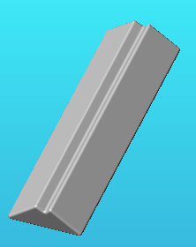
Similar – same shape and proportions, but not necessarily the same size. Any two squares or two spheres are similar. Not all rectangles are simila since their sides may not be in the same ratio. Similar figures are an enlarged or reduced version of each other. Congruent figures are also similar.

The basic forms:

Simple extrusion: These are cylindrical or prism-like shapes. Does the shape have two parallel congruent sides and is each parallel cross section between them the same shape?
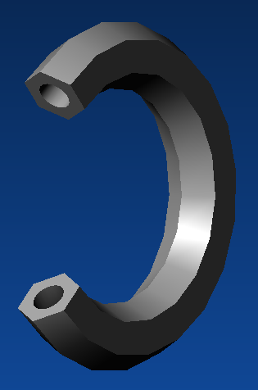
Extrusion with draft: These are pyramid or cone-like shapes. Does the shape have two parallel similar sides and is each cross section similar?
Simple Revolution: We can diagnose if a shape has been made by revolution in two ways:
- Does the figure have rotational symmetry (if we spin it, does it still occupy the same region)? Is there an axis through the middle such that turning the figure around that line leaves it appearing unchanged? If so, use the Revolve tool.
- Is there a direction in which all planes produce cross sections that are circles, disks (circles plus their interior), and or rings (disks with a circular hole in the middle)
Part of a Revolution: Some figures may be part of a full revolution. They don’t have symmetry, but you can imagine the rest of the figure. Once you start a Revolve, change the menu “Full” to another option and change the angle to less than 360º.

What shape would you revolve to make a sphere? _________________

What shape would you extrude to make a cylinder? ________________

What shape would you revolve to make a cylinder? ________________

For each of the following pictures:
- Identify it as a volume of rotation, an extrusion, or an extrusion with draft (angling in or out as it extrudes). Some can be done in either way (revolve or extrude). Circle E or R or both (in which case star the one whose cross-section you sketched).
- Neatly sketch the 2-D cross-section shape that would be revolved or extruded to make it the object. For the rotations/revolutions, indicate the line that serves as the center of rotation (where would it need to be relative to the cross-section you sketched?).
- For the final page, pick 3 objects from the object table and sketch their cross-section.
E or R
E or R
E or R
E or R
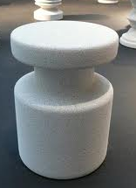 | 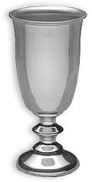
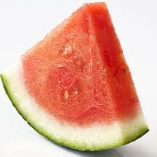

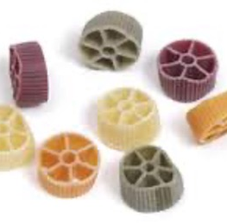 | 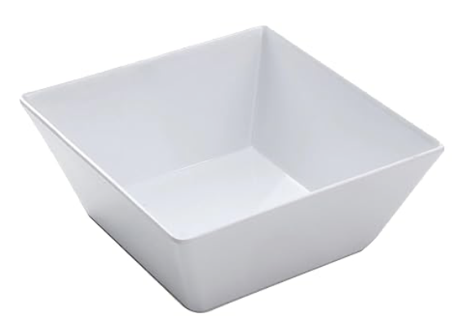
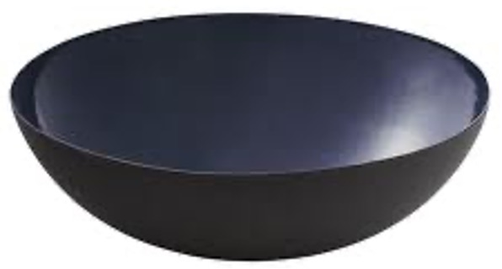 | 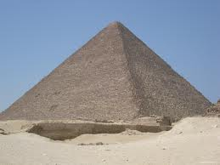
E or R
E or R
E or R
E or R
E or R
E or R
E or R
E or R
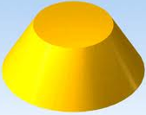 | 
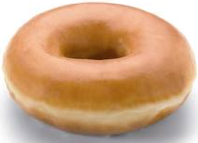 | 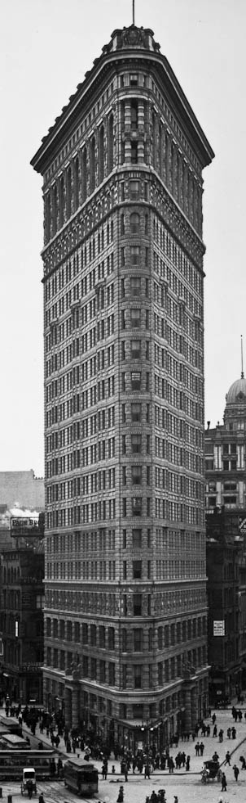

E or R
E or R
E or R
E or R
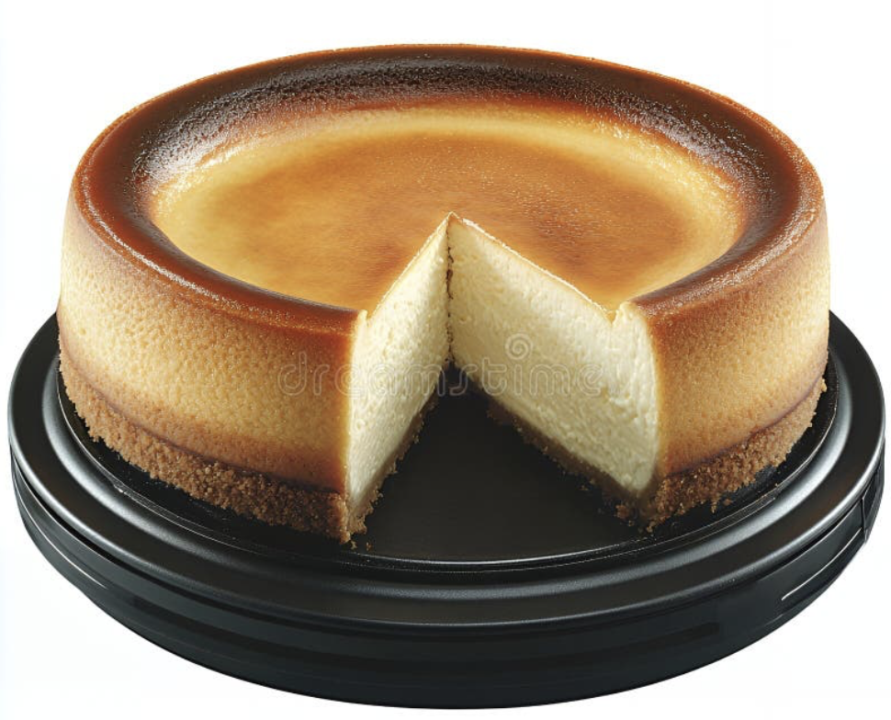 | 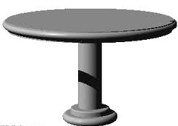
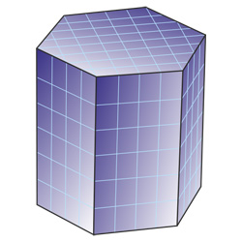 | 
E or R
Pick one of the above balusters
Pick another baluster  E or R | 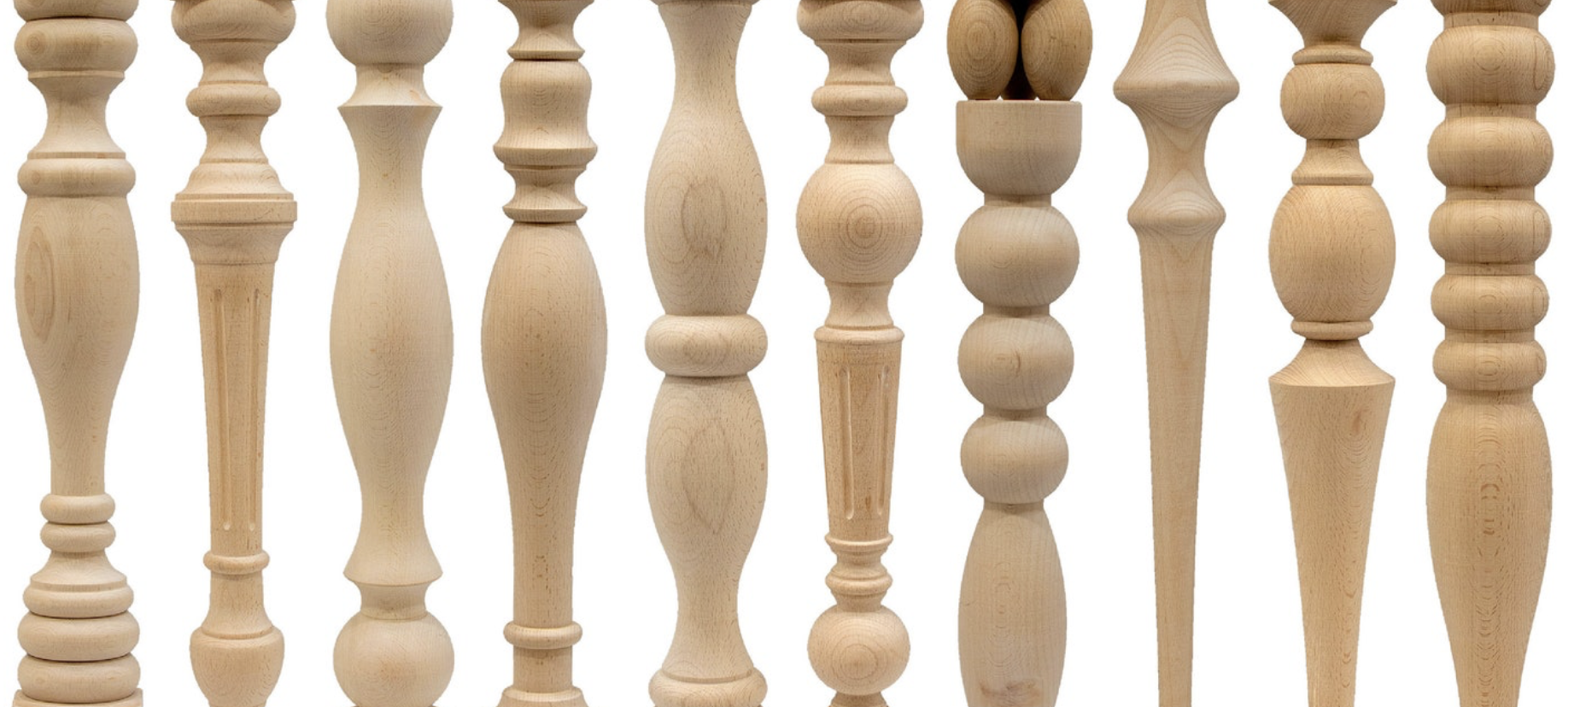  E or R
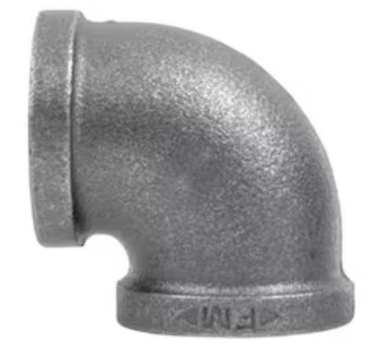 | 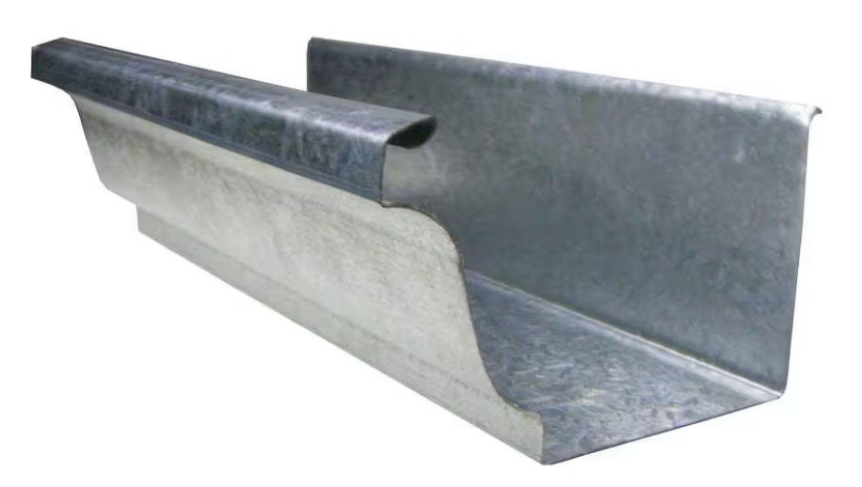  E or R
E or R
E or R
E or R
E or R
E or R
E or R
E or R
E or R
