GEOPROOF STUDIO
What is the purpose of this program?
GeoProof Studio (GPS) is designed to help students understand the multiple strands that make up the structure of most proofs and to help them clarify their thinking as they prove their own geometric conjectures. Proofs are typically presented in a linear fashion – GPS provides a flowchart or multi-threaded display of the connections between conclusions that merge to make a proof. This layout makes evident the ways we can work both forward from the premise of our theorem and backward from our conclusion. GPS also gives students two different ways to present their proofs and teachers a tool for creating exercises that provide practice identifying the justifications in an argument.
User Guide
This guide explains how to construct figures, explore justifications, connect claims, make logical arguments, and share results.
Contents at a glance
- Workspace overview (page 2)
- Diagram Mode (pages 3-11) – Tools for drawing, constructing, and customizing your geometric setting.
- Proof Mode (pages 12-17 and 20-24) – Build your proof as you enter claims, connections, and justifications. Saving and opening files. Printing and exporting PDF options.
- Justifications Library (pages 17-20) – Search for helpful postulates, theorems, and definitions. Add your own theorems and definitions!
- 4-Column Format (page 24) – A linear format that captures your logical connections.

This guide is available as an editable Word file (.docx). Feel free to edit and update it, add your own examples, and distribute according to the terms of Creative Commons license BY-NC-SA 4.0.
This work © 2026 by Joshua Abrams/Making Math is licensed under CC BY-NC-SA 4.0.

Welcome to GeoProof Studio
GeoProof Studio is a browser-based geometry workspace for developing proofs.
The four workspace modes
In Diagram Mode, you construct a labeled figure of your claim (which may start out as a conjecture, but will end as a theorem, once you have proven it).
You then build up your proof in Proof Mode providing claims, justifications, and connectors that link your claims. You may move back and forth between these two tools if you find a need to construct auxiliary segments or add other figures to your original diagram.
The final two modes are resources. There is a Justifications Library of built-in conditional statements consisting of definitions, theorems, and axioms and postulates that commonly arise in geometry work. You can scan this library for justifications that match the needs of your proof.
Lastly, there is the 4-Column Format version of your proof that GPS makes for you which “flattens” your 2-dimensional layout into a linear format. The four-column representation still captures the links between each claim’s premises and conclusions with premise numbers replacing the connectors used in the Proof Mode.
Switch modes using the centered buttons in the top navigation bar. The diagram and proof are linked as one project – you do not lose work when you change modes.
Getting Started
Step One: Begin in the Proof Mode briefly to enter both a name for your theorem and your conjecture in English (typically as an if-then statement).
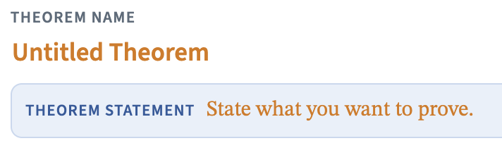
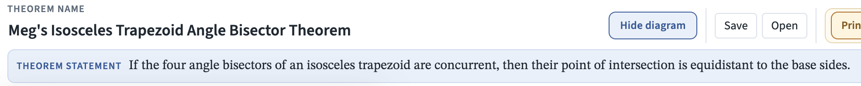
Step Two: Go to the Diagram Mode and draw and construct figures that match the description in the premise (the if part) of your theorem. Use the more specific construction tools (those which constrain the shape) when a relationship matters.


Step Three: Return to the Proof Mode and click on the button in the column for the GIVENS and enter the if parts of your conjecture in symbolic form using the labels from your diagram and the insert symbol buttons. Do the same for the TO PROVE column and the then part of your conjecture. So, for Meg’s theorem above, the givens would be “Isosceles trapezoid ABCD” and four statements such as: and the to prove would be two congruent segments.

A Tour of Diagram Mode
Diagram Mode is a tool for drawing and constructing an example setting for a proof. While it might look a bit like Geogebra’s powerful geometry program (geogebra.org/geometry), which I highly recommend for wonderful opportunities for student investigation and conjecturing, the scope of GPS’s Diagram Mode is focused on making usable diagrams. GPS’s constructions are retained when you move points, but there are no measurement tools.
For every mode, the top navigation buttons switch between Diagram, Proof, Justifications, and 4-Column Format modes. No work is lost when changing modes. In the second line of the Diagram Mode are view and drawing options, file buttons, and undo and clear buttons. The third and fourth lines are the tool palettes, and below the tools are the canvas for your diagram with zoom and pan controls on the right. Near the top left corner of the canvas, tips on using each tool will appear when you select each tool.

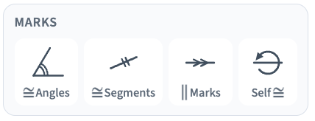
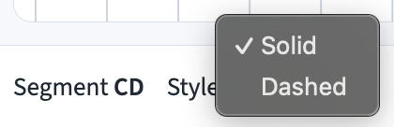
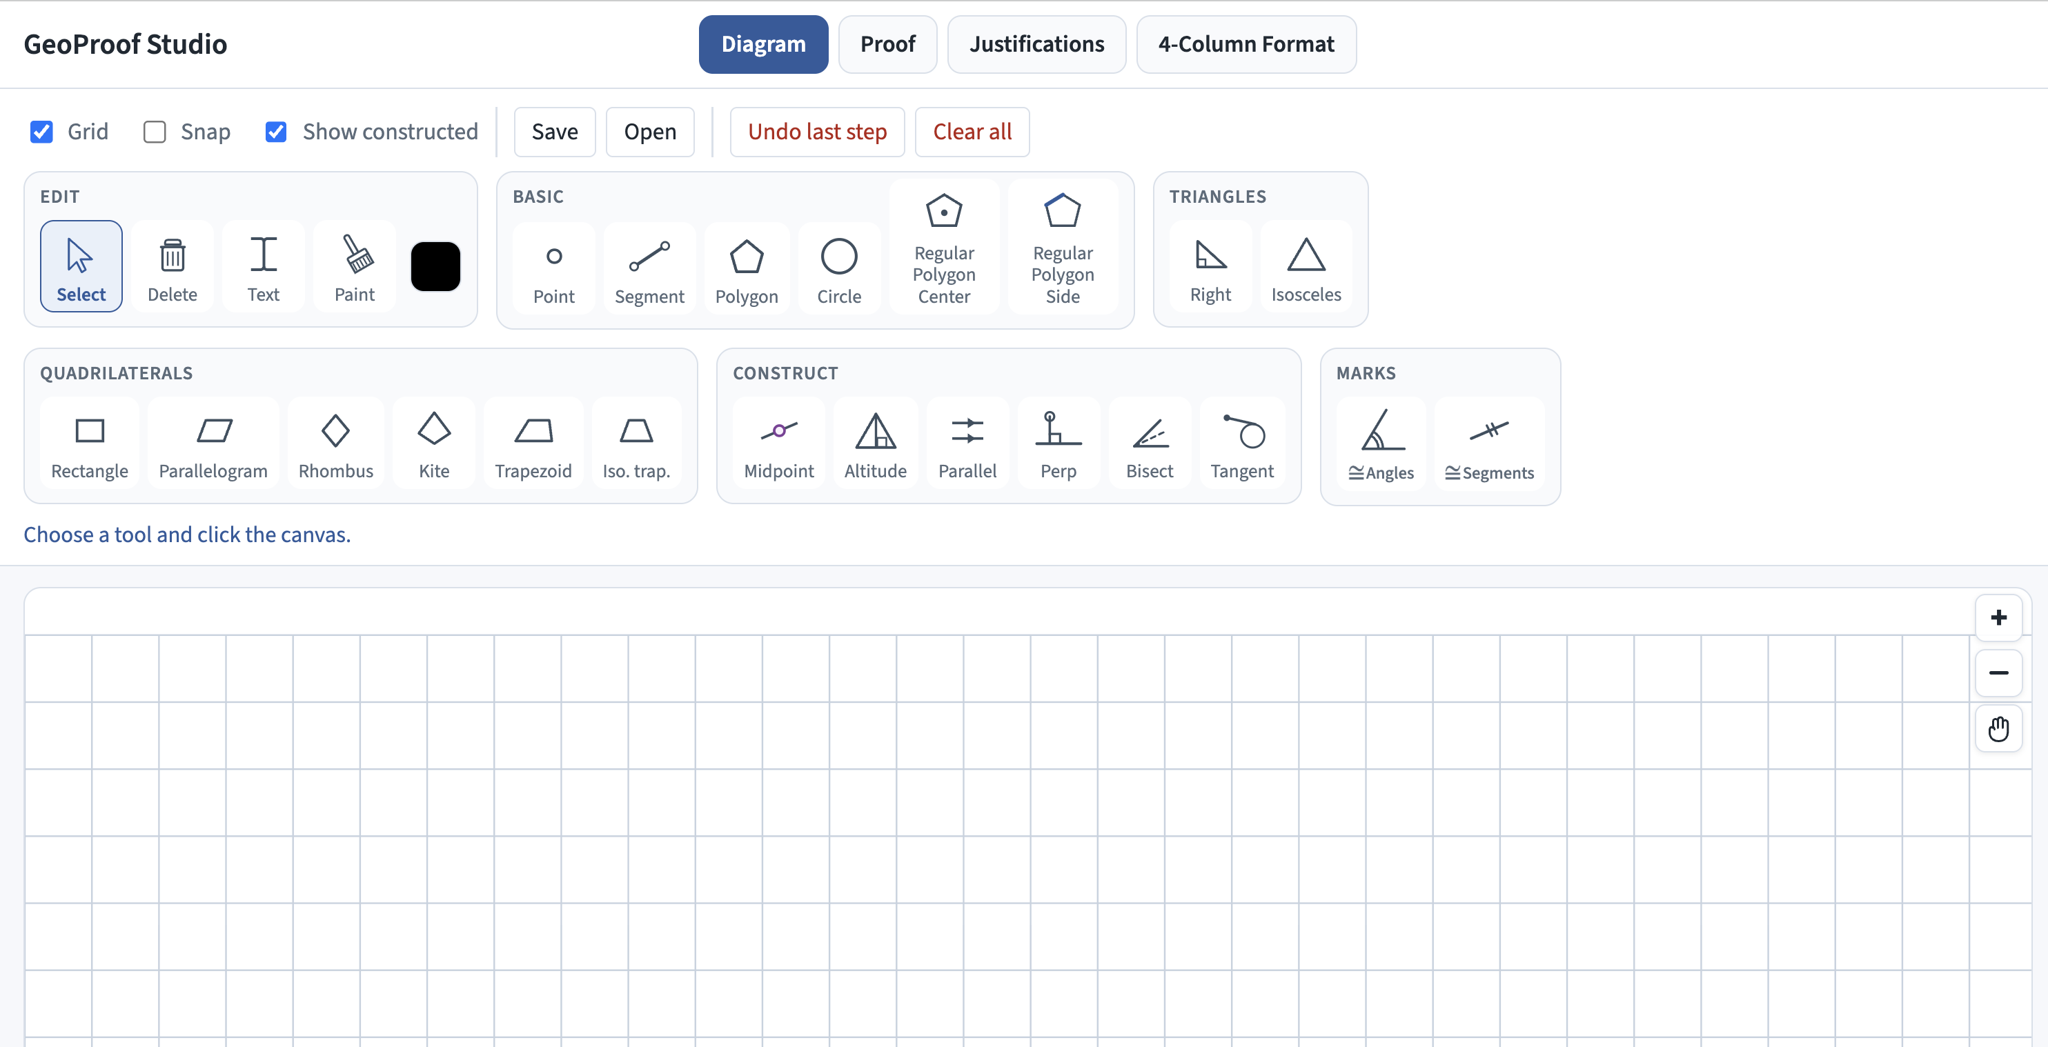
Tool Tips
ID & Style Menu
Navigation Buttons
Canvas View
Zoom In
Zoom Out
Pan
Draw & Construct Tools

Figure A1. Diagram Mode with an empty canvas

Program Tip — One project, two (or three) parts
When you save or open a file in any of the modes, the diagram and the proof are combined in one .geoproof file. Changes to the Justifications Library are also preserved in the file as well. You can (and should!) save your project regularly as you work. In most browsers, any save request will download automatically. You should give each version a meaningful name (e.g., Trapezoid-Ramon1, TrapezoidRamon2, etc.) and keep the files together in a project folder.

View and file controls
View and file controls and undo.
Control | What it does
Grid | Show or hide the background grid.
Snap | Snap placements to the grid and to common segment fractions (1/2, 1/3). Also helps create intersection points near crossings.
Show constructed | A point whose location is dependent on constructions (or on relationships created by its placement when it is drawn) is a derived or constructed point. When this option is checked, these points are dashed. Dashed points cannot be dragged with the select tool, but they can move in response to changes to the objects on which they were placed or constructed. Tip: you may want to see constructed points while developing a diagram and then click that option off and have all points look the same when you export your work.
Save / Open | Store or load the full project (.geoproof), including diagram, proof, and additions to, and items hidden from, the Justification Library. You cannot launch .geoproof files from their folders. They must be opened from within GPS using the Open button.
Undo last step | Reverse recent drawing and construction steps (also Cmd/Ctrl+Z). Up to 50 steps may be undone.
Clear all | Remove every object from the diagram and reset the grid view.

Canvas View
The Zoom In (+) and Zoom Out (-) buttons and Pan tool () are on the right edge of the canvas. These tools allow you to center your diagram in the canvas in all modes. If a part of your diagram extends off the canvas, you can zoom out or pan to center and show all relevant portions.

Tool Palettes
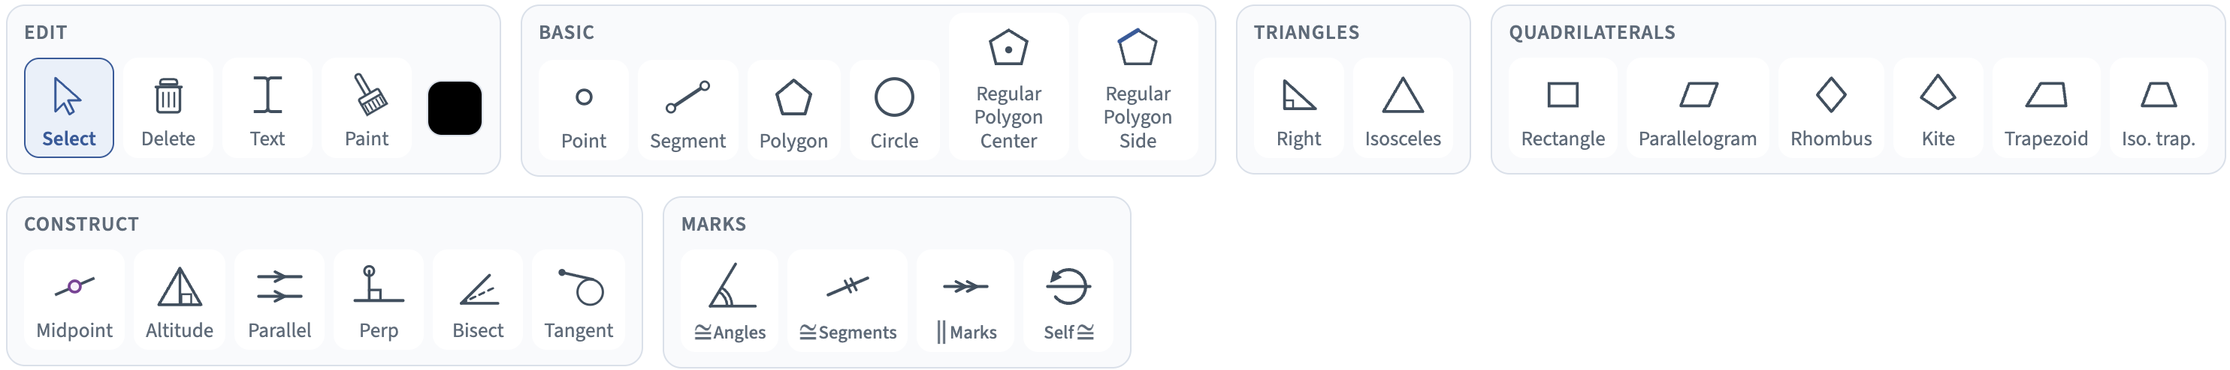
Figure A3. Edit, Basic, Triangles, Quadrilaterals, Construct, and Marks palettes.
All tools remain selected until a different tool is chosen.

Edit Tools

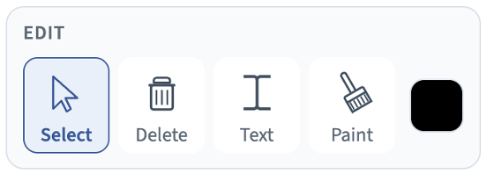

Select
The selection tool is used to move pre-existing points around. Any pre-existing shape determined by a point will also move accordingly. The selection tool can also reposition the labels for points – click on the text and drag it around the point until it is in a position that doesn’t cover anything up.
The selection tool can be used to choose points, segments, rays, lines, and circles.
- When a point is selected, its coordinates are displayed in the ID area below the canvas. The coordinate system uses (0, 0) for the default view’s upper left corner (which changes with panning or zooming). The y-coordinates get bigger as you go down the screen – the flip of a typical graph, but standard for how we typically think about computer screen coordinate systems.
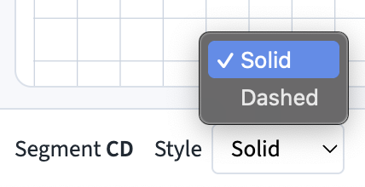
- When a segment or circle is selected, the related points are noted and a style menu appears at the lower left corner of the canvas allowing you to make the shape solid (the default) or dashed. Dashed shapes often represent auxiliary (helper) figures introduced during a proof (as opposed to givens that are part of the theorem statement).
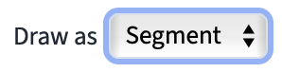
- When a constructed perpendicular, parallel, or angle-bisecting segment/ray/line is selected, style menus appear providing options to switch between solid and dashed formats and also between displaying a segment or line (for parallel and perpendicular constructions) or segment or ray (for angle bisectors).
Delete
When the delete tool is chosen, clicking on any point, segment, ray, line, or circle will remove it. An object can also be removed by selecting it and pressing the Delete key.

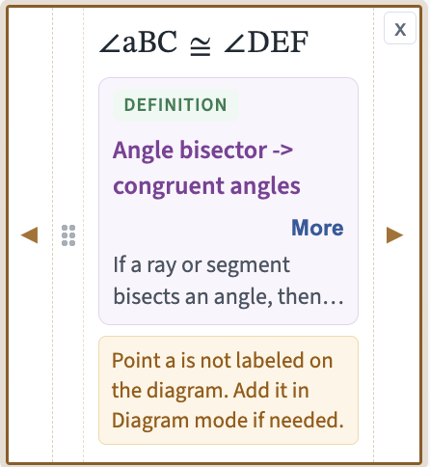
Text tool (point labels)
Each point in your diagram has a label that is a single letter (A–Z, a–z). These labels are variables just as they are in algebra – they represent a location that can vary. As points are created, they are assigned the next available letter starting with “A” and going through “Z” followed by lowercase “a” through “z”. Case matters: point “A” and point “a” are not the same, so when you enter claims, the program won’t recognize a lowercase “a” as a point if that is not in the diagram and will include an error message in the dialog as shown in the example at right.
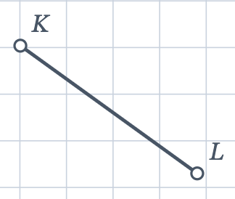
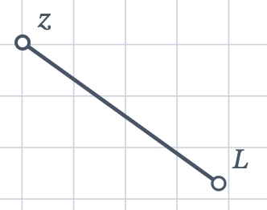
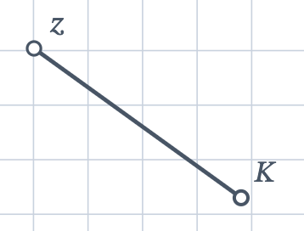
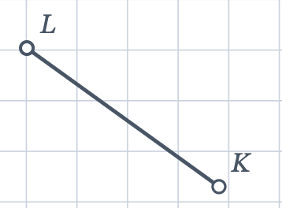
To change a label from what was assigned, choose the Text tool and click on either the label or the point. A pop-up window will allow you to enter a new choice. It must be in the A-Z, a-z range and must not include a value currently assigned to a different point. If you want to swap the labels for two points, first give one some third value (e.g., “z”) and then change the other point to what the first point was, and then swap the “z” for the second point’s original label.

Tip — Label before you prove
The proofreading tools in the Proof Mode warn when a claim uses a label that is not in the diagram. When you can, finish the diagram and set the labels before entering Givens, To Prove claims, or intermediate claims. You can also have some fun with labels: a main shape can spell a name or another word, as long as no letter repeats. I am partial to quadrilateral JOSH.

Paint
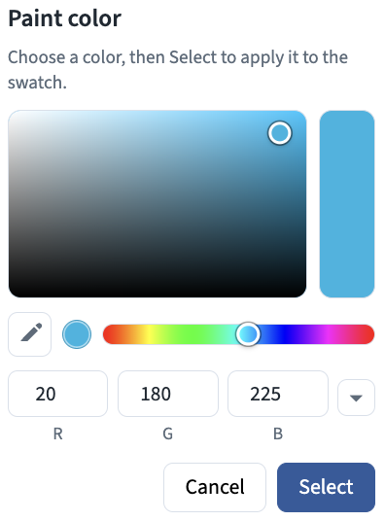
Before using the Paint tool, make sure the color swatch (the rounded rectangle to the right of the Paint tool) is set to the color you want. Once the swatch is as you wish, choose the Paint tool and click an object to change its color. You can use color to highlight corresponding parts, constructions, starting shapes, stages of a proof, etc.
Setting the Swatch Color
- Click on the rounded swatch rectangle at the end of the Edit tools.
- Click on the rainbow bar to get to the approximate color you want.
- Click on the large gradient rectangle above the rainbow to choose the precise shade and brightness that you want.
- There are four other ways you can pick your color:
  - Use the color dropper tool (see the orange arrow) and click on any portion of your screen (even outside of the GPS window) and the color of the pixel on which you click will be your new color.
  - Use the down triangle (see the green arrow) to choose RGB, HSL, or Hex mode.
    - For RGB, enter the values (0-255) for the intensity that you want for the red, green, and blue (RGB) components for your color choice. This gives you 16,777,216 colors to choose from!
    - For HSL, enter hue (0-360), saturation (0-100), and lightness (0-100).
    - For Hex, enter the hex code for the color. Hex codes involve three pairs of base-16 values that correspond to the RGB intensities. A two-digit base 16 number is equivalent to the base 10 range 0-255.
    - For all three-color formats, each time you enter a choice, the other two will adjust to make the same color (so you can compare how their representations work).
Basic Drawing Tools
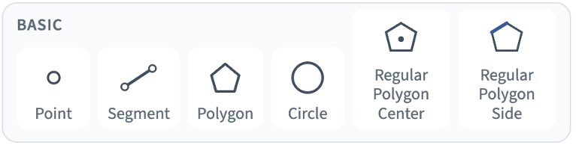
Point
To add a free point that you can move anywhere on the canvas, click on an empty location in the canvas. To add a constrained point, which will only be able to move on a pre-existing segment or circle, click on that object. For a constrained point, the select tool will be able to slide the point on that object, but not off it. To add a fixed point to a segment, click on the midpoint (you will see a “1/2” label as the mouse passes nearby the midpoint) or either of the trisection points (you will see a “1/3” label). The selection tool will not be able to move these points directly. Changes to the segment will adjust their position so as to retain their status as a midpoint or third-of-the-way point. Lastly, you can add a point at the intersection of two segments and it will remain constrained to their intersection (or the intersection they would have were they lines).
Segment

Click where you want to place each endpoint of the segment. Endpoints may be free, constrained, or fixed points as described above.

Polygon

Click the vertices in order and close the figure by returning to the first point. Polygons may be entirely free or include constrained points and build on earlier constructions.

Circle

Click the location of the center and then a point on the circle’s circumference.

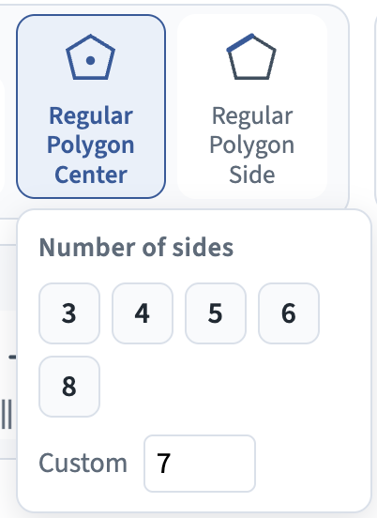
Regular Polygon Center

Click the location of the center of the polygon and then a vertex. You can change the number of sides of the polygon from 3 to 20 using the pop-up window. With 3 or 4 sides, the two regular polygon tools produce equilateral triangles and squares.

Regular Polygon Side

Click the locations for two adjacent vertices and then click on either side of the segment defined by those two points to reflect the polygon in the direction that you want.

Triangle and Quadrilateral Tools
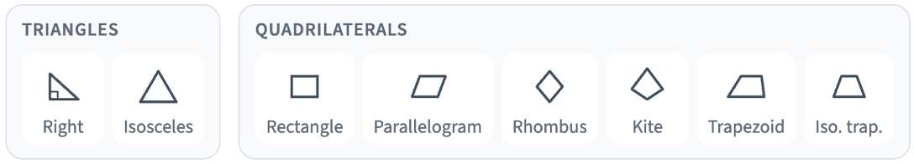
These tools create shapes that remain constrained to keep their specific properties. Whenever a theorem involves a specific type of triangle or quadrilateral, these options should be used.

Right Triangle
Click on an endpoint for the hypotenuse, then the vertex of the right angle and then the final vertex.

Isosceles Triangle
The first two clicks are for the endpoints of the base. The third click sets the apex of the triangle.

Rectangle and Parallelogram
The first two clicks set the endpoints of one side. The third point completes an adjacent side. The rest of the figure is determined by those three choices. If you want a square, hold down shift before your third click and the sides will all be congruent (but the square is not constrained as such and can be turned back into a regular rectangle if you use the Select tool).

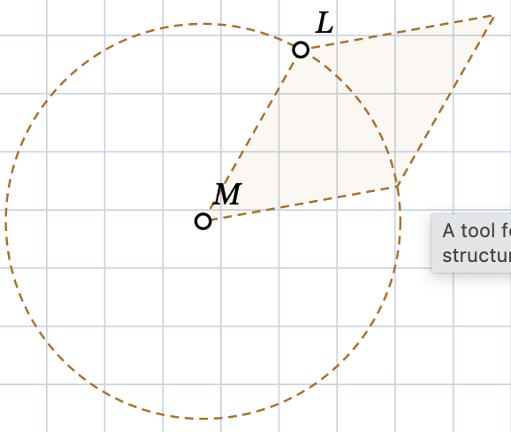
Rhombus
The first two clicks set one side. This side determines the lengths of all of the sides. Click a third point to determine the angle along the dashed circle to complete the figure.

Kite
The first two clicks set the endpoints of one side; the third point completes an adjacent side. The rest of the figure is determined (by symmetry) by those three choices.

Trapezoid
The first two clicks set the endpoints of one side. The third point completes an adjacent side. The fourth point is constrained to a line parallel to the first side.

Isosceles Trapezoid
The first two clicks set the endpoints of one side. The third point completes an adjacent side. The rest of the figure is determined (by symmetry) by those three choices.
Tip — Constraints are better than freehand
If the proof needs a parallelogram, use the Parallelogram tool instead of four drawn segments. The figure stays a parallelogram and will better represent the relationships being explored.

Construction Tools (CONSTRUCT)
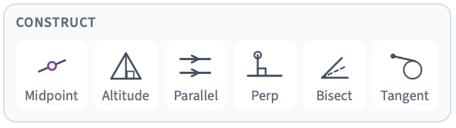

Midpoint
Click on a segment to add its midpoint. If you hover near a trisection point, that point will be added.

Altitude
Click on a vertex and then a segment, ray, or line to construct the segment from the vertex perpendicular to the chosen figure. Depending on the location, the perpendicular may meet the extension of a segment rather than its visible portion.

Parallel
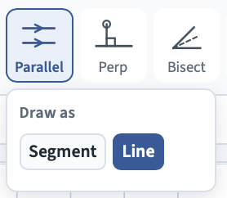
From the drop-down menu, choose whether you want your constructed figure to be a segment or a line. Click on a segment and then the point you want the parallel line to pass through. If you have constructed a segment, you can adjust the endpoints. If you want to switch between a line or segment, use the selection tool to choose the new figure and use the menu at the bottom of the canvas to change between the two options. Tip: if your diagram has a segment that you have drawn or that is part of a polygon and you want a line in its place, you can use the parallel tool choosing Line, clicking on the segment, and then one of its endpoints.

Perpendicular
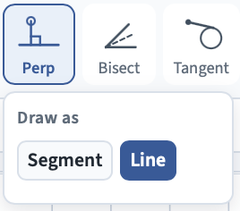
From the drop-down menu, choose whether you want your constructed figure to be a segment or a line. Click on a segment and then the point you want the perpendicular to pass through. If you have constructed a segment, you can adjust the endpoints. If you want to switch between a line or segment, use the selection tool to choose the new figure and use the menu at the bottom of the canvas to change between the two options.

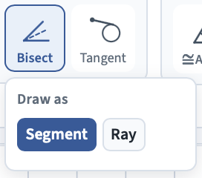
Angle Bisector
Click on a point or side for one ray of the angle to be bisected, then the vertex of the angle, and then a point or side of the other ray. Lastly, click again to determine the endpoint of the bisector if it is a segment or a point on the ray.

Tangent
Tangents to circles are segments or lines that intersect the circle in just one point (without passing through it). They have the property that they are perpendicular to the radius of the circle to the point of intersection. To construct a tangent, pick a point external to a circle. Click on the point first and then near one side of the circle (there are two tangents possible). When you are close to where the tangent would touch the circle, the segment will snap to the circle, and you can click to finish the construction.

Marking Tools
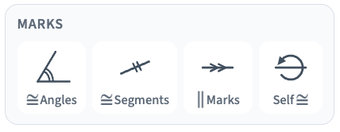
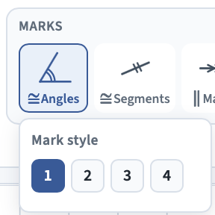
Diagrams are essential to our ability to discover, and then keep track of, geometric relationships. Once objects are shown to be congruent or parallel, we can use an accepted mark to record that information visually. For congruent angles and segments and for parallel lines, we may have more than one pair that needs to be indicated, so the norm is to add more arcs, cross hatchings, or arrowheads. If two segments are congruent, they each get a single matching mark. If a second distinct pair is shown to be congruent, they each get two marks (using the Mark Style menu), and so forth. The first three marking tools allow up to four marks. A mark’s number can be changed after it is made by redoing the marking process. If there are more than four pairs, the markings can be given colors using the paint tool to differentiate further.

Congruent Angles
Choose the desired angle by clicking a point on a ray of the angle, the vertex, and then a point on the other ray.

Congruent Segments
Choose the desired segment by clicking the segment or both of its endpoints. The segment must have been drawn or constructed.

Parallel Segments or Lines
Click on a segment, ray, or line to add a parallel mark.

Self-Congruence
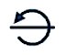
There are many cases where two triangles that are being shown to be congruent share a side. That side may be useful as a corresponding side that is congruent between the two triangles. In the proof, we would have a claim such as 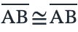 with the reflexive property of congruence as the justification. But how do we mark in our diagram that we are using that segment as one of the premises for triangle congruence? To do so, we present the original Making Math invention of the Self Congruence mark (free to use without royalties as with all of our materials). It is a circle turning back and pointing to the segment showing that the segment is congruent to itself.

Tip — More room for your canvas
You can use the Zoom Out button to make more room on your canvas. The tool menus take up a fair amount of screen space. If you type Control/Command (CTR/Cmd) and – (control minus), the entire browser window will zoom out, shrinking the tool menus. If you do this once or twice, the menus will fit on one line and give you more canvas space. Alternatively, Control/Command and + will make your tools bigger and easier to read.

Checklist before moving to Proof Mode
- Are all of the premises in your conjecture represented in your diagram?
- Are the relationships in your theorem constructed and not just sketched/approximated (e.g., is a parallelogram built with its properties)?
- Are any constructions and auxiliary lines that you think will assist in your proof in place? You can always come back to Diagram Mode if, as you work on your proof, you recognize the need for additional segments and notations.
- Are the points in your diagram labeled the way you want?
Next steps — Building your proof
Steps One through Three (see page 2) established your goal and a matching diagram. Now you start to add pieces of your proof (until they connect your givens to your conclusion).
Step Four: Add deduction claims in the middle columns. For each claim, choose a justification from the Justifications Library.
Step Five: Connect each supporting conclusion port to the matching premise port of the claim it supports.
Step Six: Read any orange proofreading notes and correct the issues noted.
Step Seven: When every required premise has a connection, GPS can mark the proof Q.E.D. This means the structure is complete — not that GPS has verified the mathematics.
Step Eight: Save your .geoproof project. When you are ready to share it, export the proof as a PDF or HTML document or view the 4-Column Format.
- Have you added marks and painted or dashed any shapes to guide you and your readers in understanding the diagram?
- Have you saved your work as a .geoproof file in a folder for this project? When you do, give it a meaningful name such as “Title-name-version#.geoproof”. For example, “TrapezoidBisectors-Rafi1.geoproof”. If you save new versions as you work, you will be able to backtrack to a good starting point should a direction you are pursuing not work out.
Proof Mode
Proof Mode is a two-dimensional board with columns numbered from left-to-right. Premises are placed to the left of the claims they support. Colored connector curves show the argument structure at a glance linking conclusions of proven claims to serve as the premises of new claims. Proofs involve syllogisms – connections from one if-then statement to the next. Proof Mode supports you in developing those connections rigorously and communicating them visually.
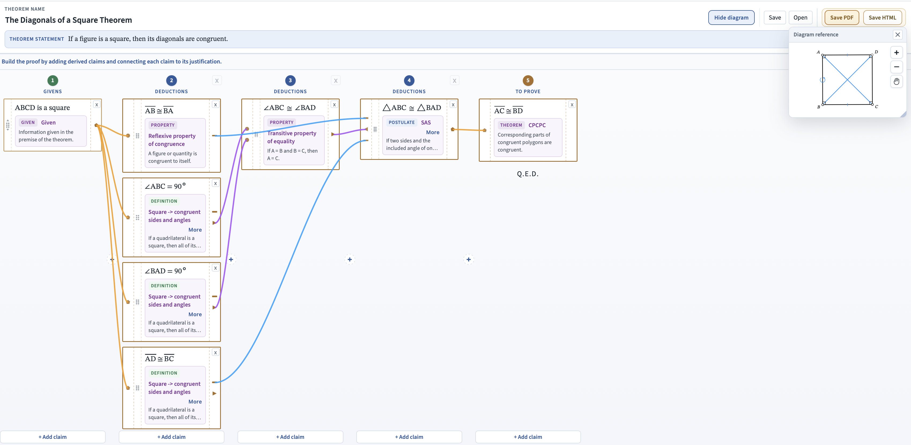
Proof Mode with givens, claims, the theorem’s conclusion (To Prove), connectors, and the diagram reference.
An Outline of Working in Proof Mode
- Once you have completed a diagram, click Proof at the top of the GPS window.
- If you have not done so already, name your theorem in place of “Untitled Theorem” and write the theorem statement in English in place of “State what you want to prove.” (see the bottom of page 2 for an example).
- In the first column, click the button (or the  header) for each of the premises in your conjecture. State all givens and claims in terms of the points and figures labeled in your diagram. For each given, you will need to identify the type of information.
- In the final column (), add the To Prove claim(s) in terms of the points and figures in the diagram.
- You must enter the Givens and To Prove before you will be allowed to enter any intermediate claims. In the middle columns, add deduction claims that follow from the givens and lead to your To Prove. Add new columns with the plus symbols () by each column when you need room for new claims that follow from or precede others. Claims that build on earlier ones must be to the right of the claims that support their premises. For each claim, choose a justification from the library.
- Drag connectors from conclusion ports to matching premise ports.
- Read proofreading notes that GPS adds in orange and fix the noted issues.
- When all of your premises have a connection, you will be prompted to add “Q.E.D.” or some other celebratory indicator.
Proofs are made up of connected claim boxes
In proof mode, claim boxes are added and then linked together into a logical argument that justifies the conclusion of your conjecture (which, if your work is correct, graduates to become a theorem!). Here is an example of a claim box and its components:
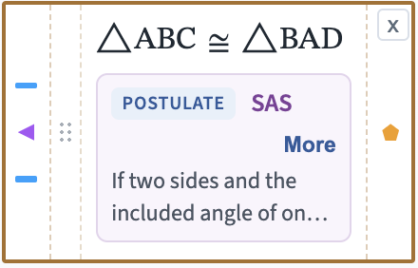

The claim
Premise ports
Delete box
Conclusion port
Grab bar
The justification

The claim is new information based on preceding claims in columns to the left.
The justification is a theorem, definition, or postulate from the library. The premise of the justification must, by the time your proof is finished, match the conclusion(s) from a prior claim or claims. The conclusion of the justification must match the claim it is justifying in turn. Claim boxes can be thought of as functions that take input claims and turn them into new output claims.
The purple justification area displays whether the conditional statement is a theorem, definition, or postulate. It shows the name of that statement in purple and the text of the statement in gray. If the justification statement is long, there will be a More button that shows the full text.
The premise ports match the number of conditions in the premise of the justification and the type of information that each represents (e.g., congruent angles or perpendicular lines). For claims listed in the Givens column, there is no premise port, because givens are not justified – they are the starting point (see the claim box in the first column in the proof one page back).
The conclusion port represents the claim itself (e.g., congruent triangles, parallel lines, etc.) and the type of information that it represents. For claims listed in the To Prove column, there is no conclusion port, because the proof is done (see the claim box in the fifth column in the proof one page back).
The grab bar allows you to move claims up and down within a column to help tidy up connectors or between columns to make room for needed premises or conclusions once you have added columns. If the program is not allowing you to move a deduction to a different column, that is because a claim it is connected to would violate the left to right order of the proof – you can’t put a premise after (to the right of) the claim that relies on it. Given and To Prove claims can only be moved up and down within their column. They cannot be moved into a deduction column.
The delete box deletes the claim and removes any connectors attached to its ports.
Creating a Claim
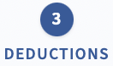


Click the button at the bottom of the column to which you want to add a claim box.
You can also mouse over the column header, and it will turn into a plus sign. Click it to add a claim to that column. This is the easier method when there are many claims in a single column and the Add Claim buttons have scrolled down out of sight.
To edit a previously created claim box, just click anywhere in the box.
Lastly, once you are in the claim window, there is a drop-down menu on the right to direct your claim to a different column than the one you chose at first.
Entering a Claim
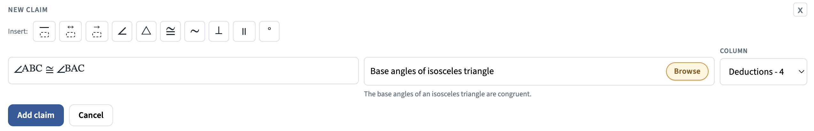

Type the claim in the text box. Be sure to use the symbols from the Insert list above. For example, write “△DOG” and not “triangle DOG”. The symbols make your claims more compact and are used by the program to help note any discrepancies between your claims and their justifications. For the first three symbols (segment, line, and ray), you can add them by typing two labels (e.g., “BD” or “JK”) and clicking the button (it will add the symbol to the two letters prior to where the cursor is) or by selecting two adjacent labels and clicking the button. | Choose a justification.  Click anywhere in this box to launch the Justifications Library. Once there, you will be able to search by keywords (e.g., “triangle”, “parallel”, “similar”, etc.) or select a topic (such as “Circles”) and justification type (such as “Theorems”).

Once you have a claim and justification, click the Add Claim button.
Ports Come In Different Types
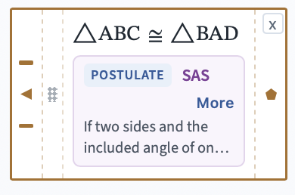
One of the goals of GeoProof Studio is to help make sure that claims really are logically connected. To do so, every premise and conclusion port has a type that is indicated by its shape. For example, in the claim box at right, the premise ports show two segment ports and one angle port. The conclusion port is a figure or polygon. The premise ports are based on the if part of the justification. In this example, that is the Side Angle Side Triangle Congruence postulate which starts, “if two sides and the included angle of one triangle are congruent to the corresponding sides and angle of a second triangle…”. To satisfy these conditions, this claim box needs two pairs of congruent sides and one pair of congruent angles connected to it, which is what the ports show. The then part of the postulate is, “then the two triangles are congruent” and the figure port means just that, that you have shown two figures to be congruent.
Port types, shapes, and colors
Port shape and color | Type | Typical meaning | When you see it
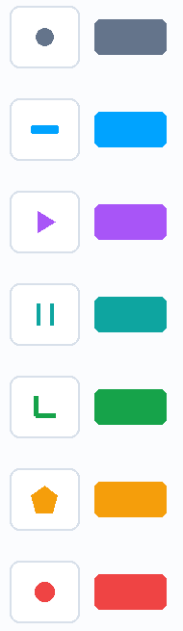 | Point | A named point | Constructions that need a point (“through point P”), midpoints, points of intersection.
 | Segment / line / ray | Congruence of two segments | AB ≅ CD, construction of a line.
 | Angle | Congruence of two angles or a claim about a single angle | ∠ABC ≅ ∠DEF; ∠BAC = 90°.
 | Parallel | A parallel lines relationship | 
 | Perpendicular | A perpendicular lines relationship | 
 | Triangle / figure | A polygon or congruence or similarity between two polygons | △ABC ≅ △DEF; ABCD is a parallelogram
 | Generic / number / measure | Equations, lengths as quantities, angle measures, etc. | m∠BAC = 40°; AB = CD (lengths); algebraic steps
Entering Givens
The if part, or premise, of your conjecture goes in the Givens column (column 1 on the left). Click the + Add claim button (or the header).
Givens are entered in a special version of the claim panel. Givens do not require a justification, other than “Given”, which the program provides automatically.
What counts as an individual given and how many premises do you have? Here are some examples:
- If a figure is a parallelogram, then its opposite sides are congruent (or the opposite sides of a parallelogram are congruent, but that form makes it less clear what your premise and conclusions are). This conditional statement has a single given “ABCD is a parallelogram.”
- If a median is constructed in an equilateral triangle, that segment is also an altitude. This statement has two givens, “△ABC is equilateral” and “is a median.”
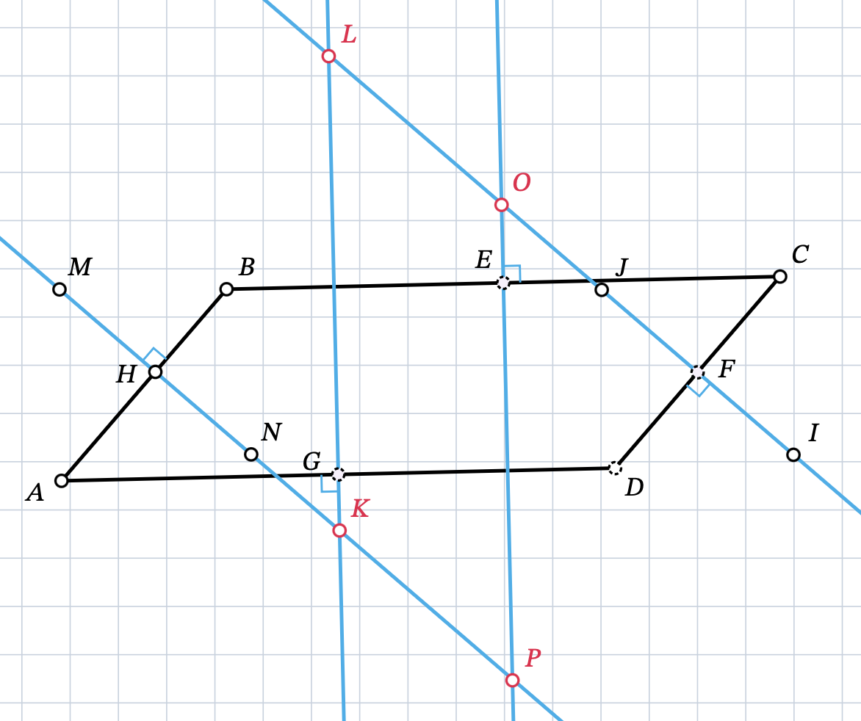
- The perpendicular bisectors of the sides of a parallelogram intersect at points that define a parallelogram (illustrated at right) has five givens:
  - “ABCD is a parallelogram”
  - “segment HN perpendicularly bisects segment AB”
  - “segment EP perpendicularly bisects segment BC”
  - “segment FJ perpendicularly bisects segment CD”
  - “segment GL perpendicularly bisects segment AD”
Alternatively, each of the perpendicular bisector givens could be entered as a midpoint and a perpendicular line (making nine givens!).
There are two main differences between entering claims for the Givens column and the other columns:
- The justification is automatically entered as “Given”.
- Because there is no specific justification, the program doesn’t know what type of information is being claimed, so there is an extra list for selecting the needed conclusion port(s):
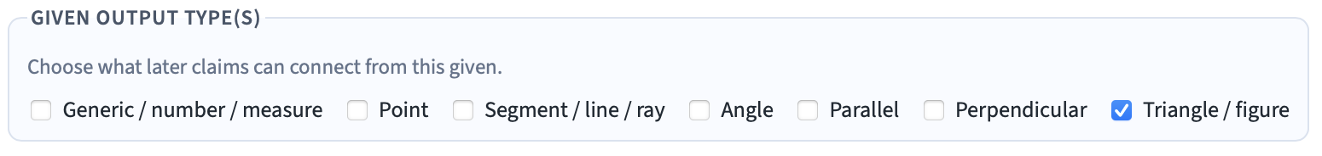
As you enter your given, use the symbol palette as much as possible (as you should for all claims). As you do, the program will check off any conclusion ports that match your statement according to these rules:
If this symbol is used: | This box will be automatically checked:
​△ | Triangle / figure
  or or | Segment / line / ray
∠ | Angle
∥ | Parallel
⊥ | Perpendicular
= or ° | Generic / number / measure

If a box is checked and you remove the associated symbol, the program won’t automatically uncheck the box. You can uncheck it, if it is not relevant. The program cannot identify every possible claim automatically. For example, a given such as “ABCD is a trapezoid” won’t result in a checked box. You would need to click the “Triangle / figure” option manually. If you don’t plan to use one of the automatically checked boxes or need another that is justifiable, you can check and uncheck to make changes as needed.

Tip — Proofs develop in different directions
You cannot add middle (deduction) claims until Givens and To Prove each contain at least one claim. This requirement helps you focus on your starting points and objective. Once in place, you can then consider ways to move forward from your givens and also backward from your To Prove.
As you explore options, you are looking for ways to shrink the distance between the claims that build on your Givens and the claims that you think might lead to your To Prove. If you are not finding connections, save a current version of your work and start a new version. Then, try removing some claims and considering alternative paths that follow from your Givens and might lead to your To Prove.
Sometimes, you may have an idea for a sequence of steps that might occur somewhere in the middle of your proof. Add more columns and add those ideas (even with no justification initially) and then work to fill the remaining gaps on either side. If your idea is a workable option, you have just shrunk the gaps you need to bridge.

Justifications
The third component of GeoProof Studio is a library of geometry definitions, postulates, theorems, and algebraic properties (which are also postulates). When you click on the Choose justification… field or Browse button, the Justifications Library, shown below, will appear. If you know which justification you want, search by keyword (such as “SSS” or “exterior”) to see which theorems, postulates, or definitions are a match. You may not know which justifications might meet your needs. In this case, choose a topic from the Topic menu below the search bar and then narrow down by type (Definitions, Postulates, Theorems, and Properties). Click on a justification in the list on the right and you will be returned to Proof Mode with that choice in place for your claim.
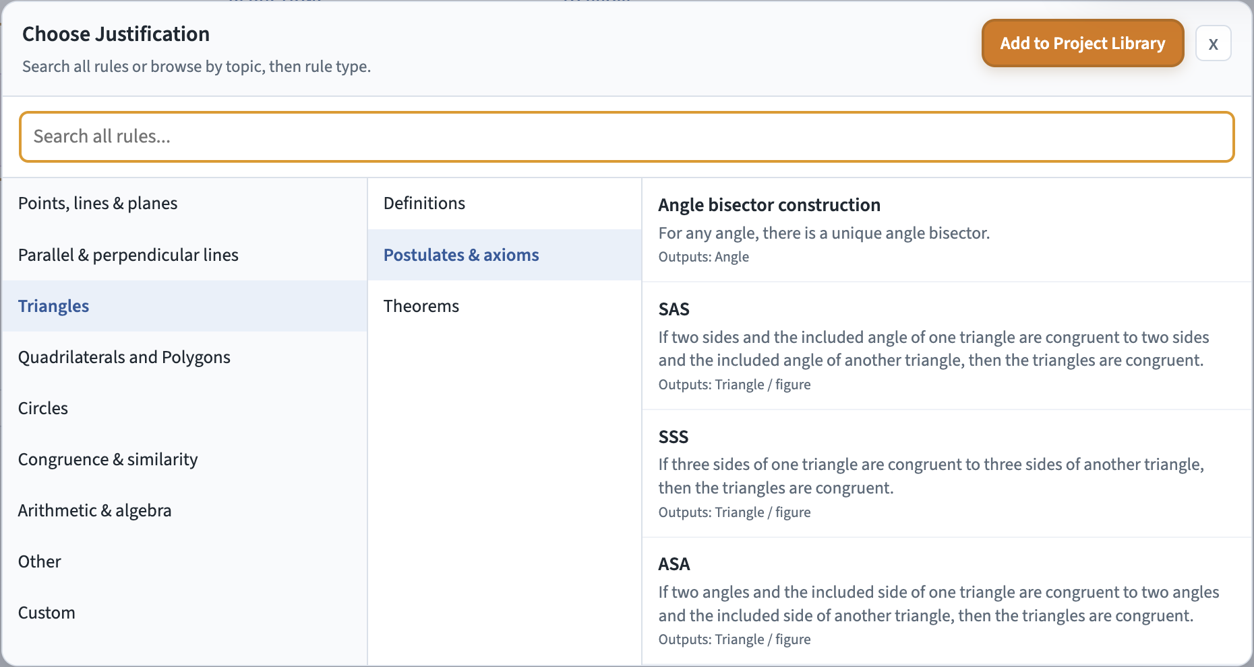
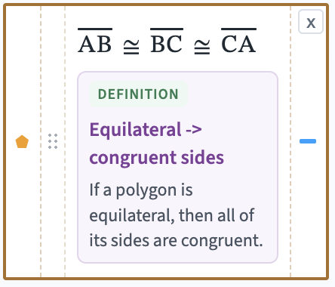
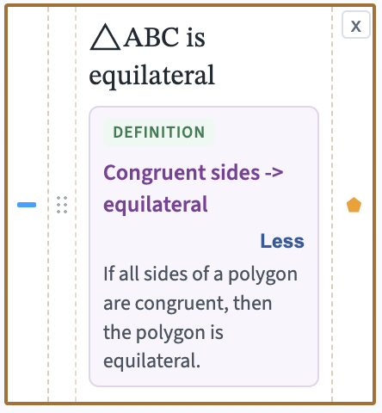
Theorems and postulates are unidirectional: from if a, then b, you cannot automatically conclude its converse, if b, then a, is also true. But definitions, by definition, work in both directions. If we define a shape based on a specific property, such as if a figure is equilateral, then its sides are all congruent, then we automatically have if a figure’s sides are all congruent, then it is equilateral. If the justification that you pick is a definition, you will first be asked to choose which direction is needed before returning to proof mode. This choice flips which ports are in place for the premise and the connection as shown at right.

Custom justifications, hiding items, and templates
There is not a unique version of Euclidean geometry. We can make different choices about which statements we make postulates and which we think will then emerge as theorems. Definitions can also differ. For example, do we want to define a square as equiangular* or as having four 90° angles? To support different starting points, GPS lets you customize the Justifications Library.
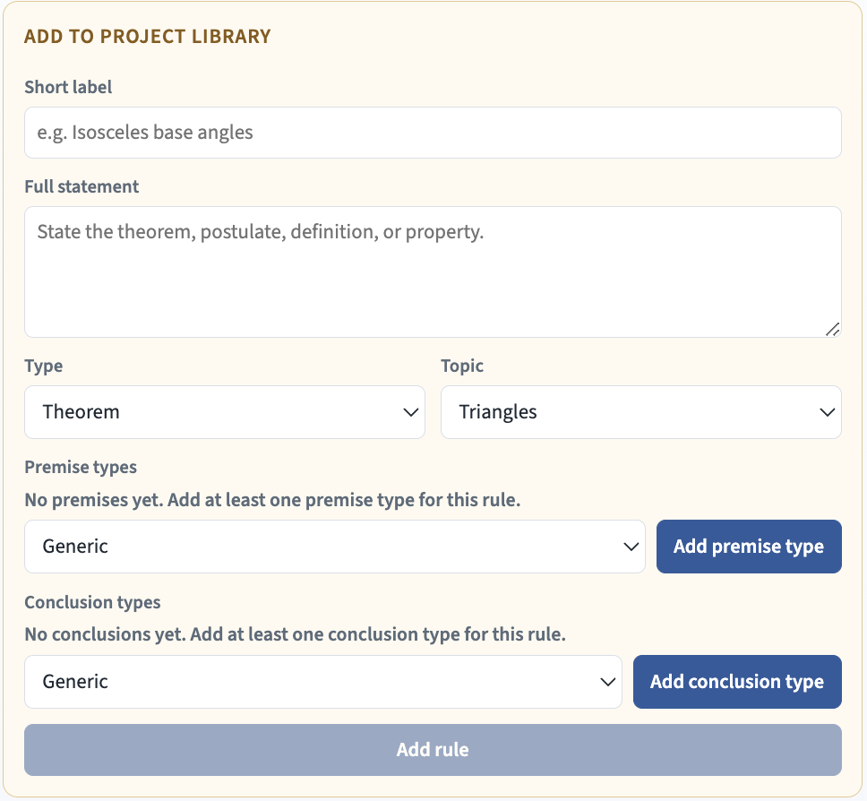
To add a justification, open Justifications from the main navigation bar and click the orange Add to Project Library button. You will see the interface at right. Give the statement a short, recognizable label and enter the full result in if-then form. Then classify it by Type and Topic so it appears in the right place in the library.
The final two menus control the premise and conclusion ports that will appear on a claim box using this justification. For each part of the premise, choose the type in the dropdown menu and click the blue Add premise type button. For example, if you were adding the quadrilateral congruence theorem ASASA, you would need to add three Angle premises and two Segment premises. If the premises have a natural order, as they do in this example, create them in that order.
Most justifications have only one conclusion, but some have more (e.g., the definition of a square has both angle and segment conclusion ports). As with the premise ports, choose the needed type from the menu and click the Add conclusion type button.
When all entries in the window are complete, click on the Add rule button.
Below is the window showing the ASASA theorem being added. Note the five premise types listed in order. If a premise is added incorrectly, click on the x button to remove it and add back what is needed. At least one premise must appear in the list above the premise menu. The claim box at right shows an application of this theorem. Note the many premise ports and one conclusion output.
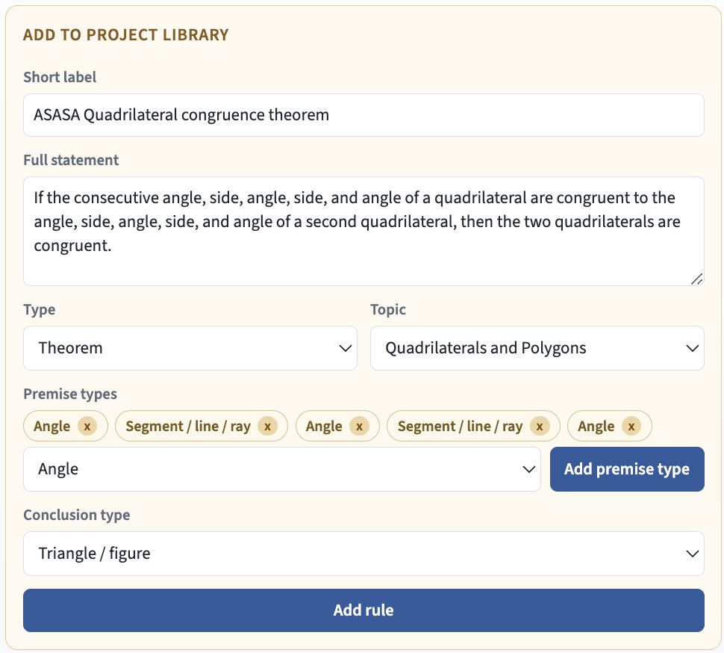
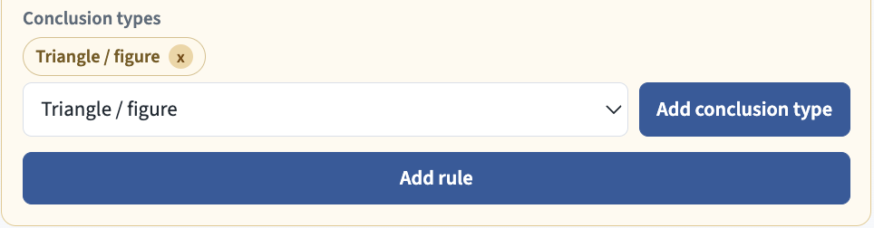
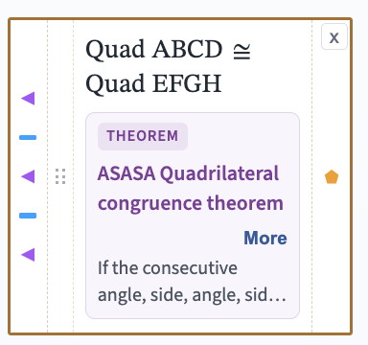

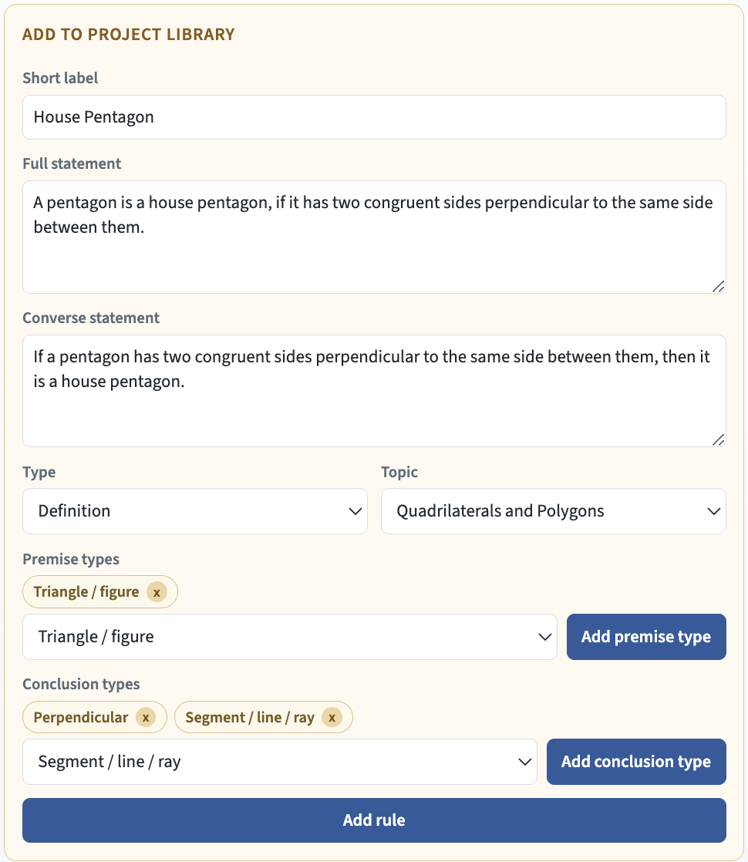
If you are adding a definition to the library, there is one extra entry needed that covers both directions of the definition. Make the Full statement in the form:
if word-being-defined, then properties
and make the Converse statement of the form:
if properties, then word-being-defined
The definition of a “house pentagon” at right is an example of adding a new definition and also of a justification with two conclusion ports.
Custom justifications are marked Custom in the library. They will be saved in .geoproof project files. This feature means that students and teachers can create custom libraries as a template for individual or class work. If you have created a new definition or proven a theorem, you can make them part of the library for other proof projects that you undertake. Saving a file with library additions prior to adding a diagram or proof makes a useful starting file that can be shared (with a name such as “OurClassTemplate.geoproof”).
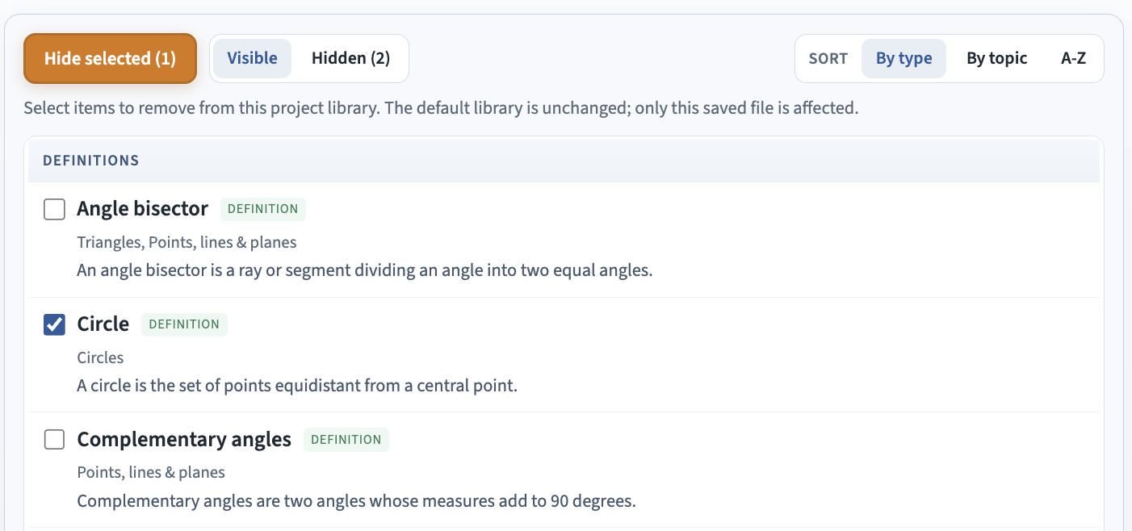
If you are adding a justification that can apply to different types the way that the transitive property of congruence does, you will need to either use generic premises and conclusions or add a specific version for each type.
Hidden items are saved with the project. Click the Hidden (#) button (circled in blue) to review them and the Restore selected button to bring any item back. Hiding can make a large library easier to search or let you substitute a version whose language better matches your work.
Connecting Claims

As you build your proof, you want to make the logical connections between claims clear. Each syllogism is shown with a visual arc connecting conclusions of one claim to the premises of another claim that builds upon it. The arcs connect a port on the right side of a claim box to a port on the left side of a claim box that follows it (is to its right). Connections should be of the same type: angles to angles, perpendicular lines to perpendicular lines, etc. Connections will match the color of their ports.

How to make a connection
- Make sure the supporting claim is in a column to the left of the claim that follows from it. If it isn’t, move the claims with their grab bar or add a new column with the plus symbol () that will allow you to position them in the correct sequence.
Connector & Port Colors | Type
 | Point
 | Segment / line / ray
 | Angle
 | Parallel
 | Perpendicular
 | Triangle / figure
 | Generic / number / measure
- Make sure that the port types you are connecting are the same shape and color.
  - In a few cases, such as constructions, you may need a point, segment, or angle that is a part of a figure from a given or other conclusion. In this case, the program will prompt you to make sure that point, segment, or angle is a part of the figure and then allow you to connect from that figure to the port for that component of the figure.
  - If you connect two incompatible ports, the program will ask you if you are sure and then show it as a dashed connection suggesting there might need to be an intermediate claim to justify the connection.
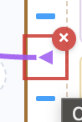
- Click on the conclusion port and drag to the matching premise port. Valid targets to the right of the starting claim box will highlight when you drag near them. You cannot make a connection from right to left.
- Release to link. The connection arc will match the color of the port type.
- To remove a link, mouse over and click the x icon on the premise port.

Ultimately, all premise ports for each claim box must have a connection for a proof to be complete. If a premise port is empty, then there is an unsupported gap in the reasoning. Premise ports may only have one connection. Conclusion ports may be used to justify multiple claims (see column 1 to column 2 in this example).

What "generic" means
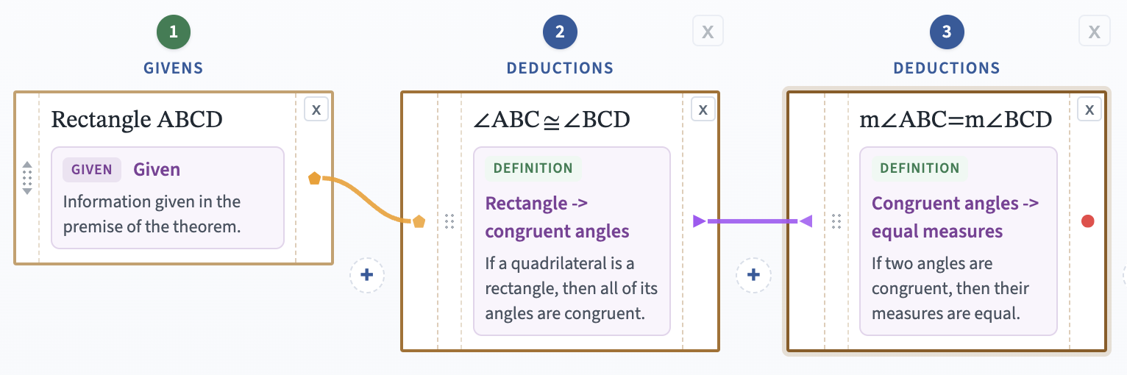
Generic is the catch-all port for things that are not geometric shapes or relationships. Generic is for values and equations. So, for example, $\overline{AB}≅\overline{CD}$ will use a segment port, but $AB=CD$, which represents the lengths of those two segments, will use a generic port. A similar distinction is made between ∠ABC and m∠ABC. The first is an angle (angle port) and the second is its measure (generic port). Some rules use generic ports to be intentionally flexible. Algebraic properties, such as the transitive property of equality, use generic ports as well. Often, we need to move between congruence (a geometry perspective) and measure (an algebraic perspective).
At right is an example of how to move between these types. While generic conclusion ports can be connected to other types (by nature of their generality), the extra step shown here is more rigorous.

Connector Teaching Tips
- Keep each premise in a column strictly to the left of the claim it supports. You cannot connect backwards. This requirement reinforces that reasons come before conclusions in your argument.
- Prefer congruence connections rather than generic ports when the next justification needs segments or angles as geometric objects.
- Use generic types intentionally for measures and algebraic statements — not as a default for everything.
- Treat a dashed override connection as a flag to review that logical step carefully.
Q.E.D.
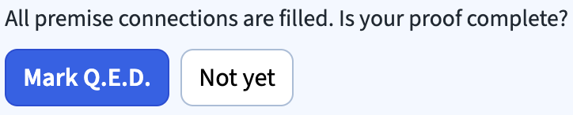
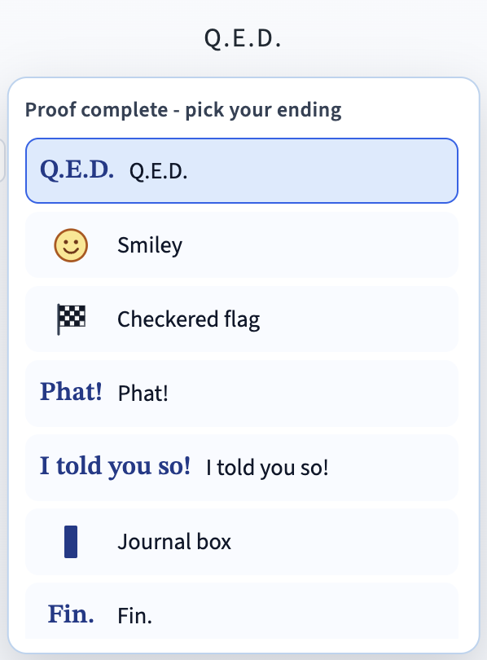
When every deduction and To Prove claim has a justification and all premise ports are filled, GeoProof Studio asks whether the proof is complete. Click Mark Q.E.D. to place a Q.E.D. mark ending the proof under the To Prove column. If any connections are subsequently removed, the Q.E.D. notation is removed. Important: the offer to add Q.E.D. means the structure of the proof is complete; GPS has not verified that the mathematics is correct.
Q.E.D. stands for “quod erat demonstrandum,” meaning “that which was to be demonstrated.” It is a celebratory stamp: you had a goal and reached it. Mathematics journals now use a black square instead, and GPS lets you choose other endings as well if you click on the Q.E.D. label.
You may also occasionally see a proof end with “Q.E.A.”, which stands for “quod est absurdum” and means “that which is absurd.” Q.E.A. is the preferred ending for a proof by contradiction in which one assumes the opposite of what you want to prove and then show that that assumption leads to an irreconcilable contradiction. It is that contradiction that is absurd and proves that your original claim is the only remaining possibility.
Proofreading Support — what GPS does and does not check
GeoProof Studio is not a formal proof checker. It will point out some common kinds of mistakes, but it is not checking logic and language in any deep way. Even when it offers the Q.E.D. finishing claim, that does not mean the proof is correct. It just means that all premises have connections. Some claims and justifications may still be wrong. Ultimately, mathematics is a communal activity – have peers and/or a teacher review the proof for mathematical rigor (all connections are logically correct). GPS will flag certain issues with an orange warning message in the claim box. These messages do not appear in the PDF or HTML output. Here are some of the issues it will point out:
- If there is no justification chosen yet.
- If points named in a claim are missing from the diagram (remember that “b” ≠ “B”).
- If an angle is just referenced with a single point (e.g., ∠A). GPS requests a three-letter angle name (such as ∠BAC) so that the angle is unambiguous.
- Betweenness claims are checked (is the point actually between the other two in the diagram?).
- The correspondence of vertices in a triangle congruence claim if they don’t follow from the corresponding order of vertices in the linked segment and/or angle premises. Note that sometimes the program will produce multiple messages as shown below when only one input (the top claim in column 2) is wrong, because any one incorrect correspondence yields many possible conflicts.
- Checks that CPCTC / CPCPC claims follow the correspondences in the figures in their premise input.
- If nothing in a claim corresponds to the justification (as in the “hmm” claim below).
- If a justification involves angles, parallelism, perpendicularity, similarity, or congruence, then the corresponding symbol from the insert symbol buttons should be in the claim.
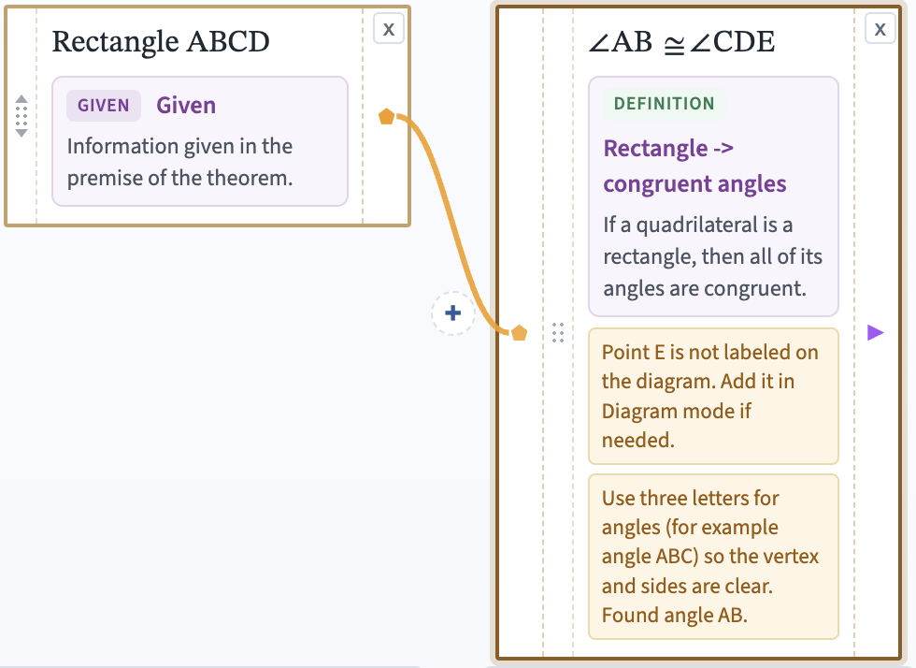
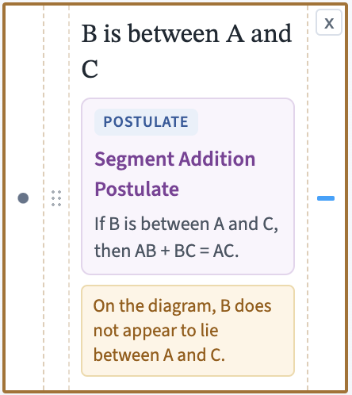
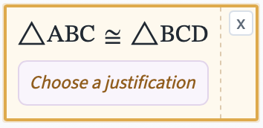
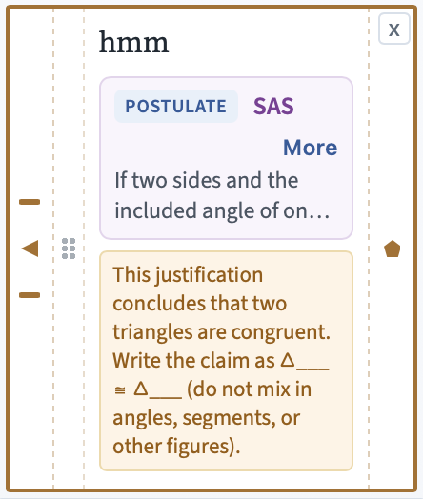
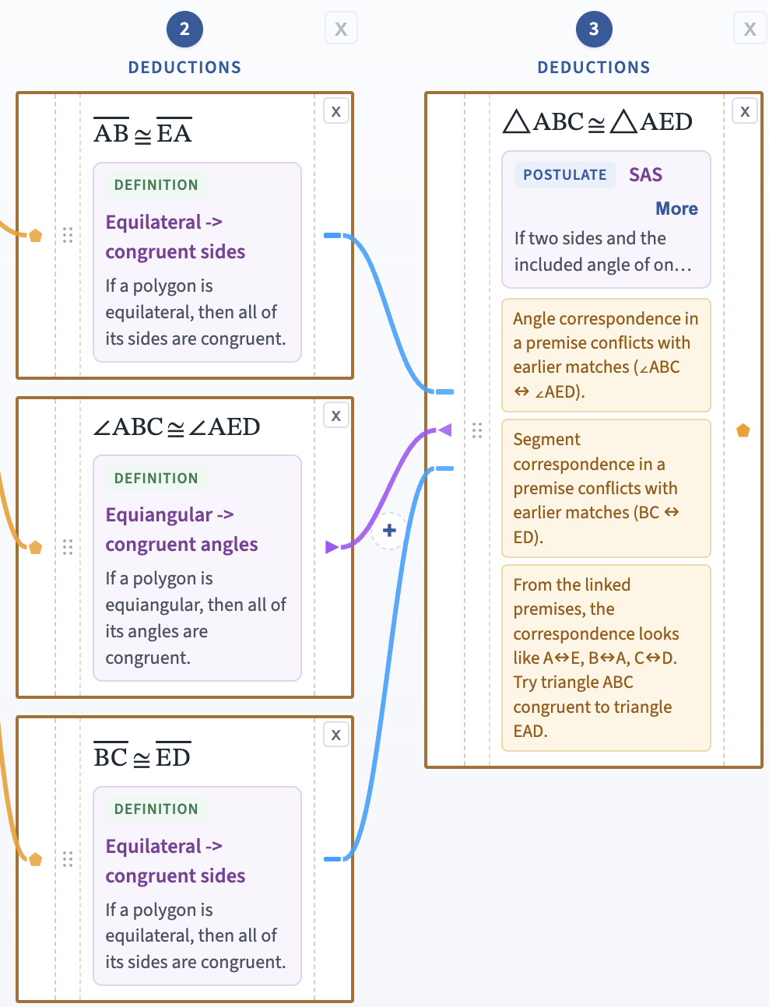
Sample Error Messages

Notation Tip — The correspondence symbol
Proofreading messages use ↔ to mean “corresponds to,” for example A↔D or B↔E. It is the vertex mapping suggested by the linked premises.
The diagram reference window
In Proof Mode, a floating Diagram reference window appears so you can see the figure while writing. Drag the title bar to move it, resize from the corner, zoom/pan inside the window, or use the Hide diagram / Show diagram button in the proof header.
PDF and HTML export and Printing
When in Proof Mode, the Save PDF and Save HTML buttons download a file showing the diagram and proof layout.
To make a full-size print out of the proof, use the Save PDF option. The PDF version is tiled with landscape-oriented pages showing how the pages fit together into a poster-size display of the proof. Pages will need to be trimmed with a paper cutter to align the connectors, but they line up well.
If you want a single page overview of the whole proof, export an HTML file and then, from your browser, save the page as a PDF and it will appear on a single letter-size page that you can print.
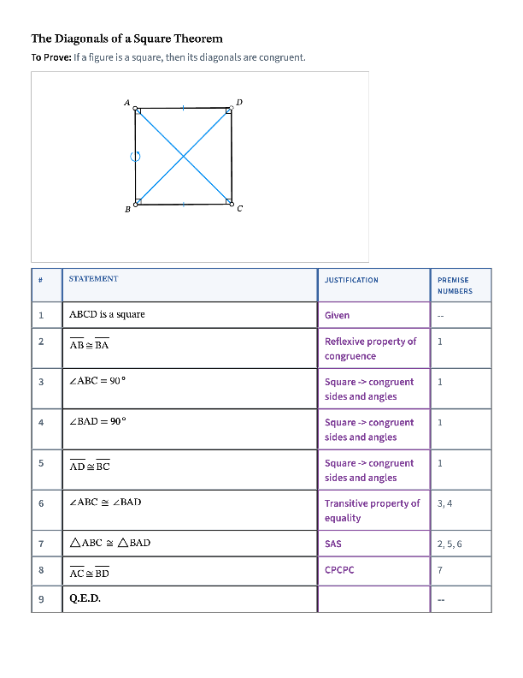
4-Column Format
You may be familiar with a 2-column proof format that pairs each claim with its justification. This linear approach does not show which earlier claims support a later one. GeoProof Studio’s 4-Column Format adds line numbers and a column listing the earlier lines that directly support each claim (satisfy its premises). The premise numbers convey the same relationships shown by connector arcs in Proof Mode. The 4-column view is not interactive; it turns the Proof Mode information into this alternative “linked linear” format. The diagram appears above the table and its view is adjustable. If you click Save PDF or Save HTML in this mode, you will download a file for just this format.
If your proof is incomplete, the 4-Column table marks missing justifications or connections with “--”, making the remaining gaps easy to spot.

* Note that the equiangular version works in non-Euclidean settings as well, while the 90° version does not. If the definition is the equiangular one, then in Euclidean geometry you may also need a theorem that shows those equal angles to also be right angles.

