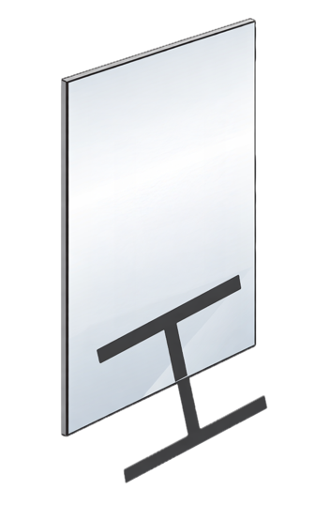
Mirror, Mirror On the Desk Name ______________________

Begin with blank paper and a mirror. For each question, the goal is to draw as little as possible while still being able to create the target image using one or two mirrors. In the example at right, half of an “H” is drawn on the paper and then the mirror is placed upright on (perpendicular to) the paper to create what looks like a complete “H”. When you are figuring out where you might place the mirror, you are determining where a line or plane of reflection divides the figure in half.

- Make a drawing of part of a square that you can then use to make an image of a whole square.

- Make a different drawing that can be used to make a whole square (squares have many lines of symmetry).

- Draw as little as you can to make a square using two mirrors. Is there more than one way to do this?

- Can you make an equilateral triangle with one mirror? With two?

- Which capital letters of the alphabet have symmetry. Which can be made with one or two mirrors (at least 3 can be done with two mirrors)? Which ones have symmetry that is not reflection symmetry?
A B C D E F G H I J K L M
N O P R S T U V W X Y Z

- Draw a single segment on paper and then use two mirrors to make a pentagon, hexagon, etc. What is the angle between the mirrors in each case?

